SSEF3 Specialization and voluntary exchange

LVL I Answer the following questions as you read

- Define specialization.

a. Explain how and why individuals and businesses specialize, including division of labor.
Specialization is can be observed when individuals or businesses concentrate on a single activity or an area of expertise when producing a good or service. In economics, specialization is important because it boosts the overall productivity of a business or country. For example, a firm might use specialization by creating division of labor in the production of a good or service. An example of division of labor at a fast food restaurant might be when one employee takes drive-thru orders while another employee makes the food. Both employees get better at their tasks through repetition and can do the task more quickly with fewer errors. The fast food restaurant which has chosen to specialize in convenient, ready-made meals would probably not try to offer gourmet, fine dining at the same time and lets other restaurants specialize in this type of cuisine.
Specialization can also be observed when students choose to pursue a particular major in college. The farther into their college years, the more specialized their classes become. A business major may start out taking courses in economics, marketing, and management, but ultimately focus in the field of accounting and become an accountant. The student with specialized training in accounting will often be able to perform accounting tasks more quickly and with fewer errors than someone trained in another field. The accountant can then voluntarily exchange his or her labor for payment and use the money earned to purchase the goods and services produced by individuals and businesses specializing in other areas.

b. Explain that both parties gain as a result of voluntary, non-fraudulent exchange.
Voluntary exchange occurs when two economic actors willingly trade one item for another because the value of the item they are receiving is greater at the time than the item they are giving up to receive it. While voluntary exchange can happen through barter, trading one good or service for another good or service, it is usually facilitated through money. Buyers can be household consumers, firms or governments while sellers can also be household consumers, firms or governments. The chart below gives some examples of gains from voluntary exchange.

Type of Voluntary Exchange | Party One | Party Two | Party One Gain | Party Two Gain
Exchanging an Apple for a Cookie at Lunch | Person with the Cookie | Person with the Apple | A healthier snack | A tasty dessert
Exchanging $5.00 for a Combo Meal at a restaurant | Buyer with $5.00 | Seller with the  Combo Meal | The satisfaction of consuming a meal and no longer being hungry | The additional revenue the restaurant gains from selling the meal
Exchanging one hour of labor for $8.00 of wages | Seller of one hour of labor | Buyer with $8.00 to pay for labor | Wages to use to pay for other goods and services | A labor hour to help produce a good or service
Exchanging $8.58  million for an  Abrams tank | Buyer (the U.S. government) with $8.58 | Seller (Lima Army Tank Plant) with a tank | The U.S. gains a weapon for National Defense | The Lima Army Tank Plant receives revenue

LVL II Consider the following questions
- Why does specialization increase productivity?
- What is one method of specialization?
- Provide a real world example of specialization.
- When does voluntary exchange occur?
- How is voluntary exchange facilitated in most situations?
- Provide an example of voluntary exchange and its results.
LVL III Do the Following

SSEF6 Productivity, economic growth, and future standards of living: influenced by investment in factories, machinery, new technology, and the health, education, and training of people.

LVL I Answer the following questions as you read
- Define productivity.
- Define standard of living.
- Define human capital.
- What does the production possibilities model illustrate?
- What does point E on the graph illustrate?

- Define productivity as the relationship of inputs to outputs.
Productivity looks at the relationship between inputs and outputs. An input is something that goes into making a good or service. For example, to make a cookie, a bakery must have ingredients like flour and sugar that come from natural resources like wheat and sugar cane. The baker must have capital resources like ovens and mixers to process the cookie dough. The baker needs labor resources to run the machines and serve the customers. The labor resources must have the appropriate human capital such as the ability to read the recipe, make decisions about when the baking of the cookies is complete, and how to package the cookies for sale to customers. If the baker is the owner of the bakery, he or she is the entrepreneurial resource who must choose to take a risk and decide how best to run the business. An output is the amount of a good or service produced. In the case of the baker described above, the cookie is the output. The baker wants to produce the right amount of output at the right price so he can make a profit. Increases in productivity occur when producers can produce more output with fewer inputs. This could occur because an entrepreneur finds ways to use his inputs more efficiently. For example, productivity might increase by using a recipe that requires less sugar, rearranging the production line to be more efficient, training labor resources to specialize in specific jobs, reducing the amount of inputs that are wasted in the production process, adding new, more efficient machinery or technology, or finding ways to motivate labor resources to produce more quickly.

Productivity Using Conventional Oven | Productivity After Introducing High Tech, Large Capacity Oven
Productivity = Number of Cookies Baked  Number of Minutes to Bake Cookies  Productivity = 24 cookies = 2 cookies per  12 minutes minute | Productivity = Number of Cookies Baked  Number of Minutes to Bake Cookies  Productivity = 48 cookies = 8 cookies per  6 minutes minute
The investment in the high tech, large capacity oven increased productivity from 2 cookies per minute baked to 8 cookies per minute baked. This is a 400% increase in productivity.

- Explain how investment in equipment and technology can lead to economic growth.

For the purposes of this element, investment refers to the introduction of machines and equipment, the building of new factories, and/or the purchasing and implementation of new production technology. Both firms and government entities invest in equipment and technology leading to economic growth. Consider again the example of the bakery from the last element. The productivity increase from the new oven applied only to the bakery. Imagine the effect on the economy if many firms made similar investments leading to large increases in productivity. Consider a scenario in which governments also invest in equipment and technology, increasing productivity in public goods and services. If this increased productivity across the economy happens while keeping prices of goods and services relatively stable, there will be economic growth. Remember, we measure economic growth by the change in the real GDP from one period to the next. If the total value of final goods and services produced within the country’s borders and adjusted for changes in the price level increases from one period to the next, there is economic growth in the country.

C. Explain how investments in human capital (e.g., education, job training, and healthcare) can lead to a higher standard of living.

Standard of living refers to the material well-being people in an economy enjoy. Usually, the higher the real GDP per capita a country has, the higher the standard of living of the people in that country will be. Remember, real GDP per capita is the value of final goods and services produced per person in an economy in a particular time period. As the output per person in the country increases, an economist would expect the amount of goods and service each person can consume to increase. In market leaning economies, the benefits of increases in real GDP per capita, are unequally distributed among the population of the country. The change in the standard of living for individuals in the economy will often depend upon the amount of human capital the individual members of the economy possess. Healthy, skilled, and well-educated participants in the economy are likely to enjoy a greater share of any increases in standard of living. For example, the chart below shows the relationship between educational attainment, weekly median wages, and unemployment. In most cases, the higher the education level, the higher the wage and lower the likelihood of unemployment. Since wages play a large role in determining the amount of goods and services individuals can consume, it is clear that more education means a better material well-being.
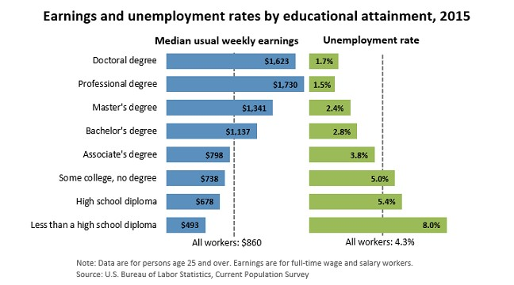
Bureau of Labor Statistics. (2016, March 15). Earnings & Unemployment Rates by Educational Attainment, 2015
[Digital image]. Retrieved April 10, 2017, from https://www.bls.gov/emp/ep_chart_001.htm

- Analyze, by means of a production possibilities curve: trade-offs, opportunity cost, growth, and efficiency.
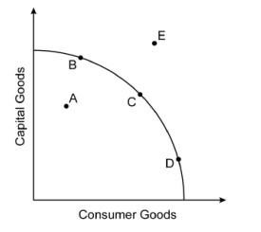
A production possibilities curve is an economic model used by economists to illustrate all possible combinations of efficient production available to an individual, firm, or country given the resources available to produce the two goods or services shown on the graph. The model shows the amount of one good or service sacrificed to produce additional units of the other good or service. The model also shows the production combinations that are inefficient or impossible given current resources. The example below demonstrates the analysis required.
Figure A
- On Figure A, points B, C, and D indicate examples of efficient production combinations of capital goods and consumer goods. Any point on the curve falls into this category.
- On Figure A, point A is an example of an inefficient production combination of capital and consumer goods. This point also represents unemployed resources and/or recession in the economy. This combination is possible, but undesirable given underutilized resources.
- On Figure A, point E is an example of an unattainable production combination of capital and consumer goods because there are not enough factors of production to produce at this point.
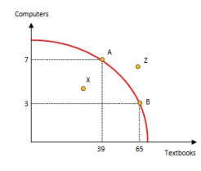
- Figure B shows the opportunity cost of choosing a particular combination of textbooks and computers over another possible combination. The opportunity cost of choosing point A over point B is 26 textbooks. The marginal benefit of moving from point B to point A is 4 computers.
Figure B

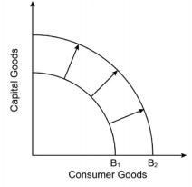
Figure C illustrates economic growth on the production possibilities model. Curve B1 shows the economy’s original efficient combinations of capital and consumer goods production. Curve B2 shows the production possibilities curve for the economy following investment in physical capital and technology. For example, the U.S. economy experienced a shift outward like this after the construction of the interstate highway system in the 1950s. The interstate system was a government investment in physical capital that allowed more production of other capital goods and consumer goods. This happened because interstates made the transportation of inputs and outputs cheaper and faster for firms in the economy. Large-scale adoption of computers by industry in the 1990s would be another example of investment in physical capital and technology leading to economic growth.
Figure C

LVL II Consider the following questions
- What is an example of an input and an output?
- How does technology and capital investment increase productivity and overall economic growth?
- How does one typically increase their standard of living?
- What is the relationship between level of education, earnings, and unemployment rate?
- Where on the graph do you see efficient levels of production? Inefficient production?
- Why do investments in capital and human capital push the production curve outward?

LVL III Do the Following

