Modern Politics 12.1

SSUSH22 Analyze U.S. international and domestic policies including their influences on technological advancements and social changes during the Nixon, Ford, and Carter administrations.
a. Analyze the international policies and actions taken as a response to the Cold War including the opening and establishment of diplomatic relations with China, the end of U.S. involvement in Vietnam, the War Powers Act, the Camp David Accords, and Carter’s response to the 1979 Iranian Revolution and hostage crisis.
Richard Nixon Presidency: Visits China
Most remember Richard Nixon as a president whose greatest accomplishments were in foreign policy. Before 1968, U.S. presidents traditionally took a tough, militaristic stance towards the U.S.S.R. and China. Nixon, however, took a new approach. He introduced a policy called detente. Under detente, Nixon sought to use diplomacy rather than intimidation to ease tensions that existed between the U.S. and communist nations. Nixon became the first president to publicly acknowledge the Communist government of China and even visited that nation during his first term. Nixon also realized that, although both the U.S.S.R. and China were communist, the two nations disagreed with one another on some major issues. For this reason, Nixon believed that good relations with the Chinese would give him more bargaining power with the Soviets. In 1972, after extensive talks with Soviet leader, Leonid Brezhnev, the U.S. and the USSR signed the first Strategic Arms Limitation Treaty (SALT I). The treaty limited development of certain nuclear weapons and was a diplomatic triumph for Nixon.
Richard Nixon Presidency: War Powers Act
One key action taken in the United States following the Vietnam War was to redistribute power concerning military action among the federal branches of government. The President had been given immense unilateral power through the Gulf of Tonkin Resolution to take any measures he deemed necessary to protect the United States. The Congress had been powerless through much of the Vietnam War to adjust the level of troop commitment to the region because of the Gulf of Tonkin's unlimited provisions. Once the war was over, the Congress passed the War Powers Act in 1973. The provisions of the new policy require the Congress to authorize troop commitments within a certain time frame. The measure redistributed power to conduct military operations between the executive and legislative branches.
Richard Nixon Presidency: Watergate Scandal
Despite some of the social conflicts and economic woes facing the nation, most citizens felt far more positive about Nixon than they did the liberal Democratic candidate, George McGovern, in the 1972 presidential election. As a result, Nixon easily won re-election to a second term. War protests and social unrest, however, left President Nixon and those close to him fearing the possibility of political conspiracies (plots to undermine the government). Prior to the 1972 election, officials loyal to the president devised a number of schemes meant to protect him. One such plan involved wiretapping phones at the Democratic National Committee headquarters. The attempt failed, and police arrested five men for breaking into the Watergate office complex (site of the Democratic headquarters). What followed came to be known as the Watergate scandal. Nixon had not known about the plan; but he did participate in the cover-up. Washington Post reporters Bob Woodward and Carl Bernstein pursued the Watergate story and played a major role in revealing how high up the scandal went. In 1973, the U.S. Senate formed a Watergate Committee to investigate the scandal. Key points in the hearings came when the president's personal counsel, John Dean, testified that Nixon knew about the cover-up. Later, an additional aid revealed that a secret taping system in the president's office recorded conversations that proved the president's involvement. Nixon refused to release the tapes, claiming that he was not required to do so by law. The Supreme Court ruled that Nixon had to deliver the tapes, however, and he finally complied. Although the released transcripts had an 18 1/2 minute portion that was suspiciously missing, there was still enough on the tapes to seriously damage the president. Four days later, Richard M. Nixon became the only president in history to resign from office. Had he not done so, he would have been impeached by the House of Representatives and likely found guilty by the Senate. Nixon’s Watergate scandal lowered the general public’s opinion of the Presidency and led to a decrease in voting during presidential elections.
Document Analysis 1
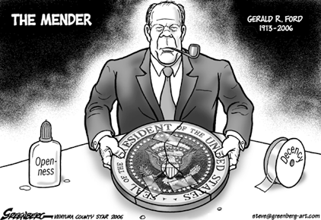
Gerald Ford Presidency
Nixon's resignation meant that Gerald Ford became president in 1974. Ford had only been vice president a short while. Gerald Ford became the only man in history to serve as both vice president and president without being elected to either office. In 1974, President Ford faced a number of tough challenges. First, Ford needed to mend the American society by pardoning(forgiven of offenses) Nixon. Then, Ford was able to remove U.S. troops from Vietnam on April 30th 1975.
Jimmy Carter Presidency: The Camp David Accords
Still blamed by many for the nation's economic troubles, Ford barely survived a stiff challenge from former California governor Ronald Reagan to win the Republican nomination. He then faced Democratic nominee Jimmy Carter in the 1976 presidential election. Formerly the governor of Georgia, Carter ran his campaign as a "Washington outsider" who had not been "corrupted" by national politics. The strategy worked well so soon after Watergate and helped Carter to defeat Ford in a relatively close election.
President Carter devoted much attention to the Middle East. For centuries, Arabs and Jews have fought bitterly over the region of Palestine. A new chapter in this conflict opened in 1948 after the United Nations formally recognized the Jewish state of Israel in the disputed territory. Jewish people welcomed the decision and felt that such a homeland was needed after the horrors of the Holocaust. Arab nations, however, were furious! They believed the land given to the Jews rightfully belonged to an Arab people called the Palestinians. As a result, many of these Arab nations and Israel soon fought a series of wars against one another. One of the countries that fought Israel was Egypt, which was widely viewed as the most powerful and influential Arab nation at the time. In November 1977, Egyptian President Anwar Sadat shocked everyone when he flew to Israel to meet with that country's Prime Minister, Menachem Begin. It was the first time any Arab leader had acknowledged Israel, much less visited the country. Many in the Arab world hated Sadat for going to Israel, but Sadat felt it was necessary to improve Egyptian and Israeli relations. Soon after, President Jimmy Carter invited the two leaders to Camp David (the president's personal retreat) to continue their talks. Initially, the meetings proved unproductive. Through Carter's tireless efforts to broker a peace deal, however, both nations ended up signing the Camp David Accords on September 17, 1978. The agreement called for a peace treaty between the two nations and meant that Israel would withdraw from territories taken during the Yom Kippur War. A few years later, President Sadat was assassinated in Egypt, in part because of his willingness to negotiate with Israel.
Jimmy Carter Presidency: Iran Hostage Crisis
Most viewed the 1978 Camp David Accords as a stroke of diplomatic genius by Carter. The following year, however, in the Middle East went from being an area of great accomplishment for the president to being his worst nightmare. For years, the U.S. enjoyed close diplomatic relations with the Shah of Iran. Iran was an important ally because of its abundant oil supply and strategic location between the rich oil fields of Saudi Arabia and the dreaded Soviet Union. In 1979, however, a Iranian Revolution in Iran forced the Shah to flee. In his place, a government based on strict Muslim law and led by an Islamic cleric known as the Ayatollah Khomeini took over the country. When President Carter allowed the Shah to enter the U.S. to undergo medical treatment, an enraged Iranian mob stormed the U.S. embassy in Tehran (Iran's capital) and took all those inside hostage. In exchange for their release, the Iranians demanded that the US government hand over the Shah to stand trial. The Iranian Hostage Crisis began on November 4, 1979, and lasted the remainder of Carter's time in office. Carter refused to surrender the Shah and attempted diplomatic negotiations to win the hostages release. When this failed, he authorized an attempted military rescue five months into the crisis. The mission failed when bad weather caused a military helicopter to collide with a transport plane, killing eight U.S. soldiers. In late 1980, after the death of the Shah, the two sides finally reached an agreement and the Iranian government released the hostages on January 21, 1981. That same day, Ronald Reagan became the new president. As one final act of defiance against Jimmy Carter, the Iranians waited until Reagan officially took office before allowing the hostages to leave Iran.
b. Connect major domestic issues to their social effects including the creation of the Environmental Protection Agency, the emergence of the National Organization for Women, Nixon’s resignation due to the Watergate scandal, and his pardon by Ford.
Document Analysis 2
…There was a strange stillness. The birds, for example—where had they gone? Many people spoke of them, puzzled and disturbed. The feeding stations in the backyards were deserted. The few birds seen anywhere were moribund [dying]; they trembled violently and could not fly. It was a spring without voices. On the mornings that had once throbbed with the dawn chorus of robins, catbirds, doves, jays, wrens, and scores of other bird voices there was now no sound; only silence lay over the fields and woods and marsh.…
The roadsides, once so attractive, were now lined with browned and withered vegetation as though swept by fire. These, too, were silent, deserted by all living things. Even the streams were now lifeless. Anglers [fishermen] no longer visited them, for all the fish had died.

In the gutters under the eaves and between the shingles of the roofs, a white granular powder [DDT] still showed a few patches; some weeks before it had fallen like snow upon the roofs and the lawns, the fields and streams.…
Source: Rachel Carson, Silent Spring, Houghton Mifflin, 1962 (adapted)
Creation of the Environmental Protection Agency
Although calls for government action to protect the environment date all the way back to the late 1800s, the modern environmentalist movement began thanks largely to scientist/writer, Rachel Carson. Carson published a book in 1962 entitled Silent Spring, in which she argued that mankind's use of certain chemicals (notably pesticides) was poisoning the environment. Despite protests from several chemical companies, Carson's book won critical acclaim and led to the banning of DDT (a common pesticide) and more government restrictions on various chemicals. More than that, its message, combined with the activist atmosphere of the '60s, fueled an entire movement. As more and more people flocked to the cause, the United States celebrated its first Earth Day in April 1970. Earth Day eventually became an annual event meant to encourage concern for the environment and draw attention to environmental issues. That same year, President Richard Nixon established the Environmental Protection Agency (EPA) as a federal agency for the purpose of enforcing laws aimed at maintaining a safe and clean environment. Today, the environmentalist movement continues to gather momentum. Many scientists and citizens agree with Rachel Carson's theory that men and women directly affect the environment based on how they live, what they drive, how they dispose of waste, etc.
Document Analysis 3
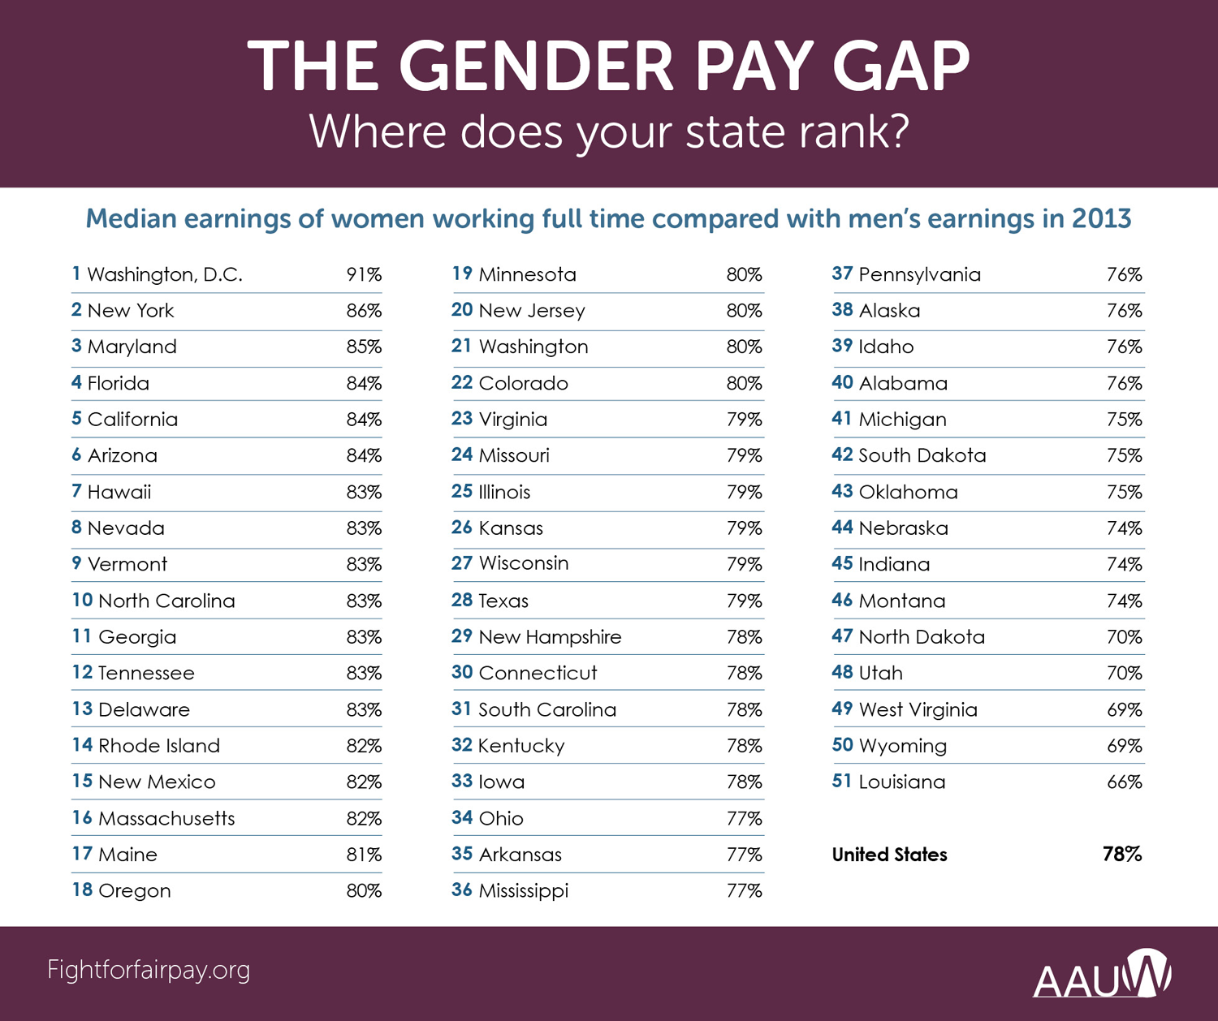
National Organization of Women
Women in the 1950's and early 1960's were expected to get married, raise a family rather than pursue a career, and adhere to strict societal rules regarding behavior and sexuality. Then, in 1963, Betty Friedan wrote a book called The Feminine Mystique. In it, she talked about her own experience in giving up a career to be a homemaker. She suggested that the idea of women being nothing but happy and fulfilled at home was a myth. Her views helped launch the women's movement of the 1960s and 70s. This movement often referred to as "Women's Liberation" or "Women's Lib," rejected traditional gender roles and advocated equality between men and women. Advocates of such positions were labeled "feminists." Friedan also founded the National Organization for Women (NOW), which devoted itself to political activism and promoting feminist causes. One of the biggest issues facing NOW was equal pay for women in the work force. Not all women flocked to the women's movement, however. Conservative Phyllis Schlafly campaigned vigorously against it, arguing that many women wanted to remain at home, that there was no more important role than that of a wife and mother, and that "Women's Lib" would destroy family values. Many women in the US joined her in her opposition.

