Economics – Personal Finance Domain 5.2

SSEPF4 Evaluate the costs and benefits of using credit.
Credit refers to borrowing money. People borrow money for a variety of reasons. When considering a loan, borrowers identify the benefits and the cost of using credit. If the benefits of using credit outweigh the costs, taking a loan is rational. If the costs of borrowing outweigh the benefits, the loan should be avoided.

- Describe factors that affect credit worthiness and the ability to receive favorable interest rates including character (credit score), collateral, and capacity to pay.

As a rule, we should spend only what we earn and avoid borrowing. However, some purchases are very difficult to make without the use of credit and the benefits of making those purchases using credit may outweigh the costs in the long-run.
For example, if someone cannot go to college without a student loan, the higher future income potential and lower risk of unemployment may make the student loan a wise idea. If someone lacks a reliable car to get them to a great job, the benefits of a low-interest car loan may outweigh the costs because of the higher income earned at the new job.
The key is to be wise in borrowing. Do not borrow more than you need and make sure the payments are affordable given your income. If you want to secure a loan from a financial institution like a bank, your credit rating must be good. Credit worthiness is a measure of a variety of factors used to determine whether a person will repay a loan. While there is no guarantee a person making $400,000 annually will pay a $2,000 loan, evaluation of their credit worthiness indicates they have the income required to handle the loan. Annual earned income is a major factor in determining credit worthiness. If income is high, lenders believe the borrower can use some of that income for debt repayment. However, the amount of current debt is another big factor affecting credit worthiness. Making $400,000 a year is less attractive to lenders if you already owe $500,000.
The “Three C’s of Credit” are character, capacity, and collateral. Since most lenders do not know potential borrowers personally, they evaluate a potential borrower’s character using the information on the borrower’s credit report. A credit report is available through three main private companies: Transunion, Equifax, and Experian. It details a person’s borrowing and repayment history for the last seven years reported to the company’s by a person’s previous and current lenders. Potential lenders request credit reports on potential borrowers to assess the borrower’s character and capacity.
A potential borrower who has “paid as agreed” on all credit accounts has good credit character. The credit report also shows some aspects of capacity. While income is one factor in assessing capacity, the amount it takes to service current debt is also a concern. If debt to income ratio is high, the borrower may not be able to handle additional debt payments.
Finally, collateral is something of value a borrower can use to back the loan if the borrower can no longer pay the scheduled payments. For example, a home mortgage is available to people with lower incomes because the bank can seize the home if the mortgage is not paid.
Many people obtain a credit card to start building a positive credit history. To get low interest rates for borrowing and sometimes even to get a job, people need a good credit report and good credit score. In some cases, no credit history affects people negatively just as a poor credit history does. A credit score is a number calculated by the credit reporting companies based on a variety of factors. While the exact calculation is proprietary, the companies release general guidelines about how the score is calculated. Payment history, amount of open credit used, and the number of open credit accounts are some of the factors determining a credit score. By making small purchases and paying the entire amount each month, a potential borrower shows a lender how they use credit wisely. The image below shows a general breakdown of a credit score.
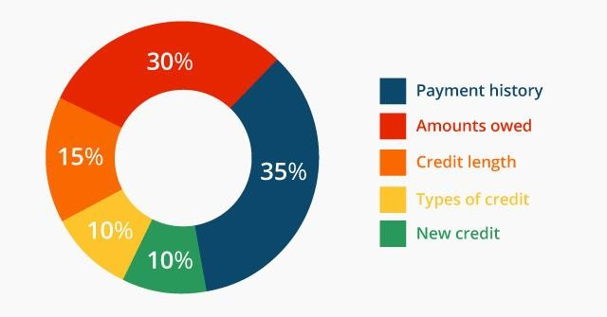
https://www.flickr.com/photos/cafecredit/29132289382

Using credit wisely and sparingly is essential to a healthy financial life. Some people find they are unable to make wise credit use decisions. Using credit cards impulsively, some find they are unable to pay the entire amount owed month and begin to accrue high amounts of interest on the unpaid balance. As the balance owed increases, it takes years to pay the loan for a small purchase. If borrowers have late payments, interest rates skyrocket and lenders charge late fees. Current law requires credit card companies to show borrowers the difference in total payments they will make if they pay only the minimum payment due versus paying the debt within three years. The image below shows an example as it looks on a credit card statement. This borrower will save $204 by paying the bill in three years and far more if paying the balance in full.
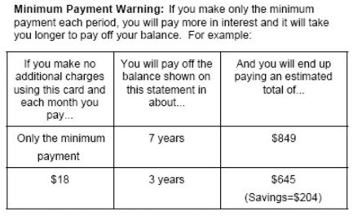
http://www.keywordsuggests.com/S917OVYzI*c*si91FqCXCl9h9WlqZKCv7JXZ*kZ2QCo/

- Compare interest rates on loans and credit cards from different institutions.

Wise potential borrowers shop for the best interest rates on loans. While the exact rate offered to a borrower will vary with the borrower’s character, capacity, and collateral, the internet allows borrowers to compare the best rates offered by different financial institutions. The table below looks at a snapshot of rates for a variety of loan products available from different lenders in April 2017.
Lender | 30-year Fixed  Rate Mortgage | 5-year Fixed Rate  Auto Loan | Home Equity Lump Sum Fixed Rate Loan | Credit Card (no annual fee)
Institution A | 4.0%  4.081% APR | 3.24% | 4.79% | 13.74% – 23.74% variable annual percentage rate
Institution B | 4.125%  4.2182% APR | 2.49% | 4.49% | 11.99% - 21.99% variable annual percentage rate
Institution C | 4.125%,  4.186% APR | 3.12% | 4.75% | 17.90% - 26.74% variable annual percentage rate
Assuming the borrower qualified for the best rates available, a wise decision would be Lender A for the mortgage and Lender B for the three remaining products.

- Define annual percentage rate and explain the difference between simple and compound interest rates, as well as fixed and variable interest rates.
The annual percentage rate (APR) is the annual rate charged for borrowing funds. Expressed as a percentage, APR represents the actual yearly cost of the borrowed funds over the full term of the loan. In the table for SSEPF4b, although the stated interest rates for Lender B and C were the same for mortgages, Lender C had a higher APR making it a more expensive loan.
Interest rates on loans are fixed or variable. A fixed interest rate on a loan will not rise or fall during the term of the loan. Obtaining a fixed interest rate when rates are low is usually desirable. When rates are high, borrowers may choose a variable interest rate in the hope that rates will fall in the future. Sometimes, lenders will only offer fixed rates to their best customers. Lenders sometimes offer risky borrowers variable rates. If the borrower proves the ability to make the payments, the person can refinance for a fixed rate in the future.
Interest is also simple or compound. Simple interest applies only to the original amount borrowed called the principal. Compound interest applies to both the principal of the loan as well as accrued interest on the principal. Compound interest makes a loan more expensive and is less desirable for borrowers than simple interest loans.

SSEPF5 Describe how insurance and other risk-management strategies protect against financial loss.
Insurance is a product purchased to guard oneself against life’s risks, specifically the financial losses associated with these risks. One may not be able to avoid dying, but one can avoid leaving loved ones in financial ruin by purchasing life insurance. The law requires people to buy certain type of insurance while other types are voluntary. The scope of this standard is to identify type of insurance and the costs and benefits associated with each type.

- List and describe various types of insurance such as automobile, health, life, disability, and property.

This course requires identification and description of five types of insurance: automobile, health, life, disability, and property. Most states in the U.S. require automobile owners to maintain a certain level of automobile insurance coverage. The required coverage is liability insurance. Liability insurance covers the other vehicle(s) when you are at fault in a car accident. If an owner wants coverage for their own vehicle, then they need to purchase collision insurance as well. Vehicles purchased with a loan from a financial institution require collision insurance until paid in full. It is important for vehicle owners to know the level of insurance required by law may not adequately cover all damages in an accident. The other driver can sue the at fault driver for any additional damages.
Health insurance pays for medical services. As of April 2017, federal law required people to have a certain level of health insurance or pay an annual penalty when filing federal taxes. Health insurance plans vary widely from those protecting against catastrophic care to plans paying for routine wellness visits.
Life insurance provides a monetary payment to a designated beneficiary when the insured person dies. The beneficiary is one who experiences financial harm from the death of the person covered by the policy such as a spouse, a parent, or a child.
Disability insurance provides people with income in case they become injured or are unable to work at a job. Many employers offer disability insurance as an option in worker benefits packages. Short-term disability covers temporary work restrictions such as the period of recovery from childbirth or surgery.
Property insurance takes a variety of forms. The most common types are homeowners and renters insurance. Homeowners insurance pays for damages sustained to your real estate property and for injuries to others that happen on your property. Renters insurance protects your personal property assets when you live in a rental property instead of a home you own.

- Explain the costs and benefits associated with different types of insurance, including deductibles, premiums, shared liability, and asset protection.

In general, all insurance policies allow a person or business to pay a relatively small amount of money (a premium) in the present to purchase asset protection against the possibility of a future financial loss caused by an unforeseen event. Assets protected range from one’s home to one’s health. Most insurance policies include a deductible stipulating the amount of money the insured must pay when filing a claim with the insurance company. In most cases, the higher the premium is, the lower the deductible is. This is true in reverse as well. Purchasing insurance involves shared liability between the insurer and the insured. This means that the insurance company assumes a pre-determined amount of financial liability for a claim that the insured might file. The insurance company is obligated to pay for the loss since the insured has paid premiums for the financial protection. In some cases, people pay insurance premiums for years and never file a claim. However, most people know they would be unable to cover a catastrophic loss themselves and are willing to pay for the peace of mind insurance provides.

SSEPF6 Describe how the earnings of workers are determined in the marketplace.
In the United States, supply and demand determine the earnings of workers. The exception is minimum wage laws at the federal, state, and local level. Minimum wage is a price floor. If equilibrium wage falls below the price floor, employers are bound to paying the legal wage. In most cases, minimum wage affects only markets for the least skilled workers. The labor market is a resource market. Employers demand workers and workers supply their labor. The intersection of the labor demand and supply curves indicated the equilibrium wage in the market. Like a product market, changes in the economy shift the supply of and demand for labor altering the equilibrium wage.

- Identify skills that are required to be successful in the workplace, including positive work ethic, punctuality, time management, teamwork, communication skills, and good character.
Successful workers practice key behaviors known as soft skills. Soft skills every worker needs include: work ethic, punctuality, time management, teamwork, communication skills, and good character.
Work ethic refers to how seriously one pursues the expectations associated employment. People with good work ethic practice all the soft skills listed above. When at work, people with good work ethic spend their time pursuing the goals of the job and producing excellent results to the best of their ability. Examples of poor work ethic include spending work hours pursuing personal interests, finding ways to avoid work, letting coworkers perform one’s assigned job functions, doing the minimum amount of work required to get by, and/or not following the rules outlined by the employer.
Actor Woody Allen once said, “Ninety percent of success is just showing up.” Punctuality means arriving on time and ready to work at the established time. Many employers of young workers lament how many lose their jobs due to lack of punctuality.
Most workers divide their work time among many different tasks and responsibilities. Workers with good time management skills efficiently organize their work hours to accomplish all objectives with minimal stress.
Today’s workplace is increasingly flat. This means rather than many layers of managers, many people work on teams lead by peers or lead teams of peers. These teams are often cross-functional meaning they are composed of people with different skill sets. Teamwork is part of most jobs. Team members need to work well with each other, support each other, and perform their assigned tasks well.
Excellent verbal and written communication skills help workers perform their jobs well. This means knowing how to get your ideas across to someone else and using appropriate style, grammar, and/or spelling. These skills help everyone understand what is expected and keep people motivated. Poor verbal and written communications skills cause workers to be viewed negatively and can cause conflict. In dangerous or high-risk environments, poor communication skills could put lives at risk.
Good character refers to doing the right thing every time. Today’s workers often enjoy a lot of freedom in how and where they work. Working remotely requires discipline to stay on task and meet goals. Employers need workers who behave ethically. Poor character traits include stealing from an employer, lying, plagiarizing the work of others, and treating coworkers or customers poorly.

- Explore job and career options and explain the significance of investment in education, training, and skill development as it relates to future earnings.
Since societies are constantly changing, and their economies— and marketplace demands— change as well. At some point in the 20th century, people who excelled at selling typewriters could probably have demanded a high salary for their work. Today, this expertise is no longer in demand, so work would be hard to get and at a much lower wage than it once was.
In general, the three factors determine the wage a worker can expect. The strength of demand for workers in the market, the number of workers supplying their labor in the market, and the amount of specialized knowledge, skills, training, and licenses are required to do the job.
As a rule, the more knowledge, skills, education, and training a worker has, the higher the wage the worker can expect assuming their education applies to a field with strong employer demand. The chart below from the Bureau of Labor Statistics shows the correlation between level of education and median weekly wages. It also shows how likely people in each education level are to be unemployed.
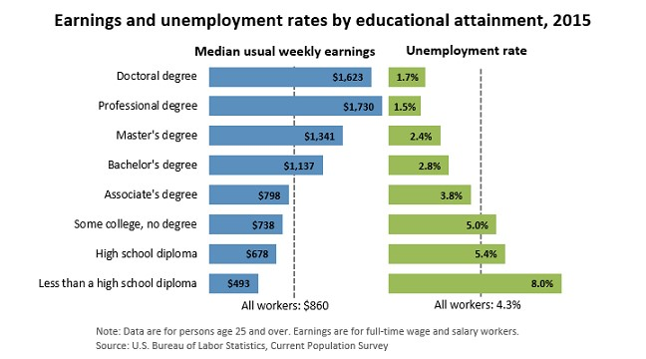
The Bureau of Labor Statistics provides a tool called the Occupational Outlook Handbook. Students can research careers using this online guide.

