Economics – Personal Finance Domain 5.1

SSEPF1 Apply rational decision making to personal spending and saving choices.
A rational decision making model refers to a process individuals, firms, and governments use to evaluate the costs and benefits associated various options when making a choice. The model consists of the possible options evaluated against a set of desirable criteria identified by the decision maker who chooses the option most closely aligned to the criteria. Two life choices demanding a rational decision making model include major spending decisions and major saving decisions.
- Use a rational decision making model to evaluate the costs and benefits of post-high school life choices (i.e., college, technical school, military enlistment, workforce participation, or other option).
All high school students choose a post-high school path. Using a rational decision making model makes the costs and benefits of this choice easier to evaluate. For example, a hypothetical student chose his or her own criteria and assigned a score based on his or her own research. The student also should chose the weights for the criteria according to his or her own values and priorities. The results will vary greatly from student to student.

b. Create a budget that includes a savings or financial investment plan for a future goal.
A budget is a document listing all the income a person makes each monthly and the expenses a person must pay each month. A budget allows people to make a plan for the money they earn, keep track of their spending, and plan for future expenses. The original template contained additional categories and was modified to reflect the expenses of a hypothetical college student. As you can see the student has budgeted 10 percent of income for general savings to use in case of unexpected expenses and has a specific savings goal category, his or her spring break trip.
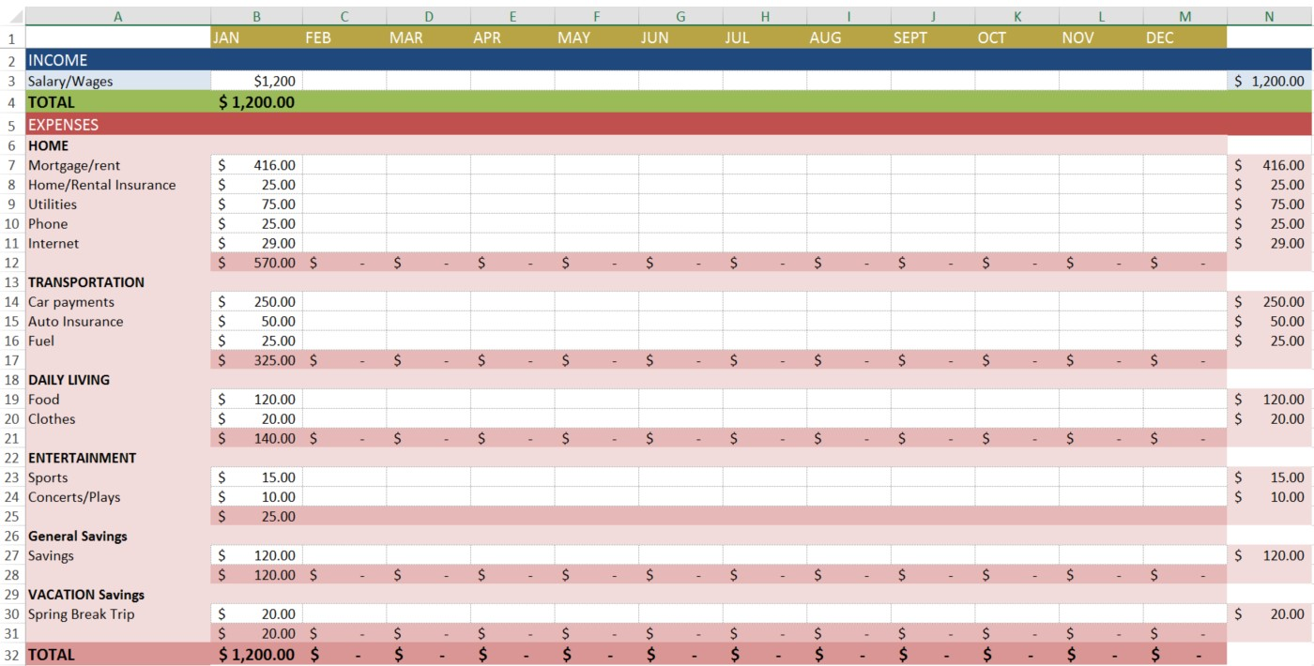

SSEPF2 Explain that banks and other financial institutions are businesses that channel funds from savers to investors.
Banks and other financial institutions are businesses. Like other businesses, banks must be profitable to operate. While banks collect revenue from a variety of activities, their traditional source of revenue comes from their role as a financial intermediary. This means taking the deposits from one group of customers and loaning a portion of deposits to other customers. Banks make revenue by charging borrowers a higher rate of interest than they are paying to depositors. This is called the “spread”.
a. Compare services offered by different financial institutions, including banks, credit unions, payday lenders, and title pawn lenders.
There are many types of financial institutions and they offer a variety of services. Potential customers must compare services to determine which option fits their needs. The financial institutions detailed in this course include banks, credit unions, payday lenders, and title pawn lenders.
Bank—For most consumers, banks provide a safe means to store earnings. Typically, banks also offer direct deposit (where a person’s paycheck goes directly into his or her account), check-writing services, debit and credit cards, loans of all sorts (personal, home equity, business), and a host of other services.
Credit Union—Credit unions provide services similar to a bank; the main difference is that a credit union only provides these services to its members. Members own and control the institution. Credit unions often offer higher interest rates on deposits and lower interest rates on loans than banks.
Payday Loan Company—Suppose you need $50 on Wednesday but won’t get paid by your job until Friday. To solve this temporary problem, a payday loan company will give out small loans in return for a portion of the upcoming paycheck. This means the person will get $50 on Wednesday, but come Friday, $55 of his or her paycheck will go to the payday loan company. Payday loan companies generally charge much higher interest on loans than other institutions.
Title Pawn Lender – Title pawn lenders provide short-term loans to individuals facing a gap between their income and expenses. Usually, those accessing loans through title pawn lenders lack access to other types of short-term loans like credit cards. Title pawn lenders make loans based on an individual’s collateral. Collateral is an item of value one owns like a car. Lenders can sell the collateral to cover the value of an outstanding loan if the borrower cannot repay. Like payday loans, the fees associated with title pawn loans are usually much higher than those a bank would charge. In the case of title pawn loans, the inability to repay the loan could result in the loss of the vehicle put up as collateral.

b. Explain reasons for the spread between interest charged and interest earned.

Commercial banks, and other financial institutions offering loans, are businesses. They must make a profit if they expect to continue operating. One primary way banks make profits is by taking the money deposited by bank customers and loaning out a portion to people who want to borrow. By charging interest on the loans, banks make money. The more money on deposit, the more loans they can make, which is why some banks offer very generous checking account services. The interest on the loans is always more than the interest paid out to depositors. If banks did not have this “spread” between interest earned and interest charged, they would go out of business very quickly. NOTE: As provisions of the Glass-Steagall Act have eroded, commercial banks have increasingly added very lucrative investment banking services to the traditional role of taking deposits and making loans. Banks also earn interest on required and excess reserves they deposit with the Federal Reserve.

c. Give examples of the direct relationship between risk and return.

The relationship between risk and return is that the higher the potential return offered by a savings or investment opportunity, the more risky the savings or investment usually is. Therefore, if someone offers a 20% return and no risk, the person is most likely not being very honest. The options below give an idea of the relationship between risk and return:

- Evaluate the risk and return of a variety of savings and investment options, including: savings accounts, certificates of deposit, retirement accounts, stocks, bonds, and mutual funds.

Savings Accounts - Savings accounts are bank accounts in which people put savings to which they need easy access. The Federal Deposit Insurance Corporation (FDIC) most types of bank deposits up to $250,000. There is virtually no risk that the depositor will lose his or her money. The only risk comes from inflation risk. This means that the interest earned on the savings is less than the rate of inflation. Therefore, money held in a very low interest savings account is likely to erode in value over time. Since savings accounts are very low risk, the rate of return is very low as well. Most bank pay less than 1% interest on savings.
Certificates of Deposit – Certificates of Deposit (CDs) are products offered by banks. Buying a CD means you will earn a higher rate of return than on a regular savings account. The higher rate of return results from the saver agreeing to keep the funds in the CD for a specified period, usually between 1 months to 10 years. The longer the period, the higher the interest rate. People who save in CDs and need to withdraw their funds early will pay a fee for early withdrawal.
Retirement Accounts – Saving for retirement is a key goal for many people in the United States. Very few employers offer traditional defined benefit pensions and most retirees will need to live off their savings to maintain their standard of living. There are a number of retirement account options for workers. The most common account is a 401K. This is provided through an employer which will sometimes offer a percentage of matching funds. Individuals can also establish their own Individual Retirement Accounts through an investment bank. They usually have a choice between a Roth IRA and a traditional IRA. Roth IRAs allow contributors to pay taxes today and withdraw the funds they contributed tax-free in the future. The contributor will still have to pay taxes on any “gaines” they withdraw from their account in retirement. A traditional IRA allows contributors to put money away before taxes are paid. The taxes are paid on the money when it is withdrawn during retirement. All of these retirement account options offer portfolios with mixed investment options. People can chose high risk, high return stock funds or low risk, low return bond funds. Finally, the U.S. government has a program called MyRA for workers whose employers do not have a 401K. It allows workers to contribute up to $15,000 before having to roll it over into an account with an investment bank. The funds can be withdrawn as needed without penalty and are guaranteed by the U.S. government, causing the return to be small.
U.S. Treasury Bonds – Purchasing a U.S. Treasury Bond means you have loaned the U.S. government money. The government pays you a guaranteed rate of return. Since the U.S. government repays its debts, the rate of return is low. For example, the interest rate on a 5-year treasury bond on April 27, 2017 was 1.822%. The interest rate on 10-year treasury bonds was 2.3%. Bonds are safe but also carry an inflation risk if interest paid is not higher than the inflation rate.
Stock Mutual Funds – While individual company stock is relatively risky, many people choose to play the stock market by purchasing mutual funds. Mutual funds provide more protection against loss because the investment is spread across many different companies rather than just one company. You may also select funds that reflect specific levels of risk or your values. Long term investing tends to give a greater return in the stock market than short-term investing. Over a 20-year period, the stock market returns on average 7-8%. However, when holding stocks for only 5 to 10 years, the average rate of return drops to 1- 2%.
Stock – Purchasing stock of individual companies is one of the more risky ways to invest. When purchasing stock in large stable companies (blue chip stocks), your investment could be safer, but your rate of return is likely to be lower. If you invest in companies with a shorter history or a brand new product, the potential return is generally high if the company succeeds, but you are much more likely to lose your investment because of the high rate of new business failures.

SSEPF3 Explain how changes in taxation can have an impact on an individual’s spending and saving choices.
Government assesses taxes on individuals and firms in an economy to pay for public goods and services. Some common taxes paid by individuals include income, property, and sales tax. When the government increases taxes, individuals will have less of their income to save and spend. When government decreases taxes, individuals will have more income to save and spend.

- Define progressive, regressive, and proportional taxes.
Taxes can fall into three categories: progressive, regressive, and proportional. The category into which a tax falls determines how it will affect people who make higher or lower incomes.
A Progressive tax rate increases as income increases, meaning the wealthy pay a higher percentage of their earnings than people less financially well-off. The U.S. federal income tax is a progressive tax. For example, a progressive tax might have a tax rate of 1% for every $10,000 earned annually, with a maximum tax rate of 50%. This system would lead to the following example.

Progressive Income Tax Example
Income |  | Tax Rate | Calculation | Total Tax
$10,000 | 1% |  | $10,000 X .01 | $100
$30,000 | 3% |  | $30,000 X .03 | $900
$200,000 | 20% |  | $200,000 X .20 | $40,000
$500,000 | 50% |  | $500,000 X .50 | $250,000
In the example, people earning $30,000, or three times as much as those earning $10,000, would have to pay nine times the amount in taxes ($900 compared to $100). Those earning $200,000, more than six times as much as those earning $30,000, would have to pay more than forty-four times as much in taxes. While this may seem excessive, the rationale is that a progressive tax takes more money from those who can afford to pay it. Opponents of progressive taxes argue that higher tax rates for high income earners is a disincentive to engage in productive activity.
A Regressive tax is a tax rate that decreases as income increases. Consider a tax that imposes a flat rate of $1,000 annually regardless of income. For someone earning only $3,000 a year, this tax would be huge, accounting for one-third of all earnings. To someone earning $50,000 a year, the tax rate is not as large, accounting for only 2% of annual income. Most sales taxes are regressive because lower income people tend to spend a greater proportion of their income on sales taxed items than higher income people.
A Proportional tax, also known as a flat tax, does not change with respect to changes in income. If the proportional tax rate is 15%, then everyone pays 15%, regardless of whether he or she makes $10,000 or $570,000. The FICA tax workers pay to fund Social Security and Medicare is proportional. Everyone pays the same percentage of their income to this tax up to a specified income cap.
- Explain how an increase in sales tax affects different income groups.

Sales tax refers to a consumption tax levied on people when they make certain kinds of purchases, such as buying a book or eating out at a restaurant. Not all goods and services are subject to a sales tax; doctor visits, for example, are free of taxes. Like the different types of income taxes, a change to the sales tax affects different income groups in different ways. Since all consumers purchase essential goods like food, a high sales tax on food would affect poor people more than wealthy people because both groups will be paying the same tax rate for the same good. For this reason, economists usually classify sales tax as a regressive tax because it takes a greater percentage of income from a low-income person than from a high-income person. This is one reason why food is often not subject to a sales tax.
However, food served at a restaurant typically is subject to a sales tax, since eating out is a luxury.

- Explain the impact of property taxes on individuals and communities.

Property tax refers to a tax on real estate people own. The tax, levied by local governments like counties or cities, is on the value of the real estate. Periodic appraisals of a property’s value indicate whether the tax on the property will rise or fall. Increases in property value are cause for celebration by those ready to sell their property. However, for those who wish to remain in their homes, increased property values translate to increases in property taxes. If property taxes increase drastically, lower income people may no longer be able to afford the taxes on their homes. Delinquent taxes accrue interest and fees increasing the total bill owed. Various entities can use the delinquent tax bill to start the foreclosure process even properties fully owned with no mortgage. For this reason, owners of previously low value properties can lose their homes as property values rise and they are unable to afford the tax bill. This is gentrification. Gentrification occurs when high-income property owners replace low-income property owners in an area. Since taxes assessed on the property’s value are without regard for the income of the owner, these taxes are regressive.

