Economics Study Packet 2017-18
Unit 1- Economic Fundamentals
SSEF1 Explain why limited productive resources and unlimited wants result in scarcity, opportunity costs, and tradeoffs for individuals, businesses, and governments.
a. Define scarcity as a basic condition that exists when unlimited wants exceed limited productive resources.
*Scarcity: condition that exists because human wants and needs are greater than available resources (LIMITED VS. UNLIMITED RESOURCES)
Example: When hurricanes have incapacitated refineries on the Gulf Coast, oil prices increase because of the possibility of scarcity of gas for vehicles.
b. Define and give examples of productive resources (i.e. factors of production): natural resources (i.e. land), human resources (i.e. labor and human capital), physical capital and entrepreneurship
*4 Factors of production (productive resources)
Capital: tools, equipment, and facilities involved in creating goods and services and getting them to the consumers (machinery storage, transportation)
Entrepreneurship: individual who organizes the resources for production and distribution, entrepreneurs take risks
Land: the earth and all the resources coming from the land (land, forests, water resources, oil)
Labor: efforts and abilities of humans used to produce goods and services. (school teachers, janitors)
*C.E.L.L. generates W.I.R.P.- wages, interest, rent, profits

c. Explain the motivations that influence entrepreneurs to take risks (e.g., profit, job creation, innovation, and improving society).
*Entrepreneurs take the risk of starting a new business with the hope that their investment will generate large profits. This leads to job creation, innovation and creation of new products, and an overall improvement of society with a higher standard of living;
Profit: the money made after producers have paid for all of their costs

d. Define opportunity cost as the next best alternative given up when individuals, businesses, and governments confront scarcity by making choices.
*Choice: to pick out by preference from what is available
*Wants: goods and services that people would like to obtain
*Needs: items that people must have to live shelter, food, and clothing
*Trade-off: action of giving up one item or category for another (ex. Guns v Butter)
*Opportunity cost: the item or value that is lost when someone makes an economic decision; the next best alternative; the item that is not chosen

SSEF2 Give examples of how rational decision making entails comparing the marginal benefits and the marginal costs of an action.

a. Define marginal cost and marginal benefit.

*Marginal utility: the satisfaction of adding one unit in production or consumption
*Marginal benefit: benefit of an additional unit
*Marginal cost: cost of an additional unit
*When marginal benefit is greater than the cost, the marginal benefit should be obtained.
*When the marginal benefit is less than the marginal cost, the desired good is not worth the cost and should not be obtained.
*Law of diminishing marginal utility: decreasing satisfaction or usefulness as additional units of a product are acquired.

b. Explain that rational decisions occur when the marginal benefits of an action equal or exceed the marginal costs.

* “Thinking on the Margin”
ex: The first glass of lemonade on a hot day quenches your thirst, but the next glass, maybe not so much. If you think at the margin, you are thinking about what the next or additional action means for you.

c. Explain that people, businesses, and governments respond to positive and negative incentives in predictable ways.
*Incentives: positive and negative rewards that encourage economic behavior such as making purchases or working to increase productivity.
ex: Restaurants use coupons, buy-one, get-one deals, Kid's Eat Free Night, and other incentives to encourage people to choose their restaurant.
ex: Police officers use speeding tickets and parking tickets as incentives to keep people safe.
ex: Tax deduction for charity donations motivate people to donate money or items to charity
*Human behavior motivated by wants and needs
*Prices serve as an incentive; ex: If a car costs $20,000, you will work hard to save up and buy it.

SSEF3 Explain how specialization and voluntary exchange influence buyers and sellers.

a. Explain how and why individuals and businesses specialize, including division of labor.
*Productivity: the measure of the amount of output produced by a given amount of inputs in a specific period of time.
*Specialization: individuals do specific tasks in the production of goods and services.
*Also regional specialization ex: peaches in Georgia, grapes in California
*Division of labor: breaking productive tasks into smaller and more specialized acts. ex: assembly line
*Specialization leads to an increase in productivity!

b. Explain that both parties gain as a result of voluntary, non-fraudulent exchange.

*Voluntary exchange: is when individuals and businesses freely choose to exchange goods, services, and resource for something else of value.
*Benefits of voluntary exchange
-Encourages increase productivity and efficiency
-Encourages inventions and innovations

SSEF4 Compare and contrast different economic systems and explain how they answer the three basic economic questions of what to produce, how to produce, and for whom to produce.

a. Compare traditional, command, market, and mixed economic systems with regard to private ownership, profit motive, consumer sovereignty, competition, and government regulation.

*4 types of economic systems
Traditional economies: Economic activity stems from the rituals, habits or customs.
-Strengths: Everyone knows their role. There is little uncertainty about WHAT to produce, HOW to produce. All is based on customs and traditions.
-Weaknesses: New ideas are discouraged. There is little variety of goods, services, and ideas about producing them. The tendency away from progress leads to lower standard of living in traditional systems.
Command economies: the central authority or government, makes most of the economic decisions.
-Strengths: Changes can be made quickly and efficiently, because the government has control of all resources and makes all decisions about WHAT, HOW and FOR WHOM to produce goods and services.
-Weaknesses: This system provides few incentives for workers to give their best effort workers have no say in what is produced and how it is produced (their jobs) and may have no interest in quality of their products. The government must have many workers to carry out its work---to many people making decisions can slow the process and increase costs of production. The wants and needs of the citizens sometimes go unheeded as the government makes decisions for all. This system is relatively inflexible. New ideas rarely find their way into the economy. Entrepreneurship is squelched.
Market economies: (Free Enterprise System, Capitalism) - producers and consumers make economic decisions and the factors of production are privately owned.
-Strengths: This system can adjust to change gradually. Government interference is low, giving consumers freedom to choose what they want to buy and producers freedom to choose what and how
to produced goods. Decentralized decision making gives more people a voice in the way the economy runs. The variety of goods and services provided in a market economy is high, so consumer satisfaction is higher than in systems where there is little variety.
-Weaknesses: People who cannot work-because they are too old or young, to sick, or otherwise physically unable to do work– are at a disadvantage, because this system rewards productive resources and does not protect non-productive resources. Without some government involvement, these people suffer.
*Success of the market system relies on these conditions:
-Competition-producers must be competing with one another to offer the best value for the cost
-Flexibility of resources- for example a worker must have the freedom to change jobs, if she is dissatisfied with her work.
-Access to information should be equal across the economy
It is difficult for an economic system to guarantee that these conditions are met without government regulations.
*Consumer Sovereignty: the idea that individuals are the best judge of their needs and what is in their best interest and that they indicate their choices by their spending decisions
*Voluntary Exchange: buyers and sellers may engage freely in the market to sell what they want, invest their money to sell what they want, invest their money how they want, etc.
*Private Property: people have the right to control their possessions as they wish.
*Profit Motive: people are free to invest in business ventures with the hope of making a profit or being better off at the end of a period than they were at the beginning.

*Command Economy vs. Market Economy:
-Private Ownership: Command has little to no private ownership, Market has protections that allow for private ownership
-Profit Motive: Market allows for investment to try and generate profits, Command does not allow for it.
-Consumer Sovereignty: Market system based consumer freedom to buy what we want (with some regulations), There is little to no freedom in a Command system.
-Competition: Command allows for little to no competition because government owns all factors of production, Market system encourages competition which leads to innovation and lower prices.
-Government Regulation: Market system has little interference from the government, Command system the government controls the economy with strict rules. Mixed economy is a blend of market and command economies. Today, there are no pure market economies. The United States is the closest to a market but is considered a mixed economy. Socialist nations like Germany are more mixed, whereas North Korea is a command system.
*Mixed economies: An economy which has the characteristics of a market economy with some government intervention and regulation. Because of this government interference, the United States is said to have a mixed market economy.

b. Analyze how each type of system answers the three economic questions and meets the broad social and economic goals of freedom, security, equity, growth, efficiency, price stability, full employment, and sustainability.

*3 basic economic questions or allocation of resources- 1) What will be produced? 2) How will it be produced? 3) For whom will it be produced?
*Allocation: the way society deals with scarcity; prices, government regulation, rationing
*Command Economy- government decides how to allocate resources
*Market Economy- individuals and businesses decide how resources are allocated

*Economic/Social Goals in the Market (U.S.)
-Economic freedom: the right to make your own economic decisions about where to work, what to buy, etc.
-Economic Efficiency: using resources wisely because they are scarce so that more wants and needs can be satisfied in the long run.
-Economic Equity: justice and fairness for all. (example: no job discrimination)
-Economic Security: protection from bad economic situations such as unemployment. The Social Security program was set up to help meet this goal for those people who are retired and/or disabled.
-Full Employment: to provide as many jobs as possible so that everyone has the opportunity to work.
-Price Stability: to have stable prices overall with no major inflation (a rise in the general level of prices) because many people have fixed incomes. See Federal Reserve/Monetary Policy.
-Economic Growth: to have better things in the future such as more money, better jobs, etc.
*Market/Mixed Economy more sustainable because of voluntary exchange, consumer sovereignty, flexible markets, economic efficiency.
*Command economies like the former Soviet Union were not sustainable because of inefficiency and inflexibility. Over time, they faced major shortages, and eventually, the economy began to collapse, with the Soviet Union being dissolved in 1991.

c. Compare and contrast strategies for allocating scarce resources, such as by price, majority rule, contests, force, sharing, lottery, authority, first-come-first-served, and personal characteristics

*price: resource goes to those who use market mechanisms such as trade, barter, or price; great for those who have money or a job with income; not good for those who have little or no income
*majority rule: resource goes to those who win an election; voting; consensus; largest number of people are satisfied; great for those who are popular and those who have many members; not good for the unpopular; those who don’t have the skills to form alliances
*contests: resource goes to the most competitive – winner of a race or arm wrestle; survival of the fittest; great for those who are talented and skillful; not good for those who aren’t competitive; unskilled
*force: resource goes to the one who is strongest (physical, mental, political); most forceful; great for those who are strong, powerful, bullish; not good for those who are weak, small, easily intimidated
*sharing: resource goes to multiple parties by dividing the resource; great in that everyone gets an equal part; no one is left out; not good in that some resources can’t be divided; no party may get enough; not everyone wants some of every resource
*lottery: resource goes to the luckiest; random; fair; great for those who are lucky and win things; everyone has an equal chance; random winners; not good for those who are unlucky or who “never win anything”
*command: resource goes where directed, ordered, told by another person; great for those who are liked by the commander or if the planner is always fair; not good if the planner isn’t fair
*first-come, first-served: resource goes to the early bird; first in line; great for those who are quick, willing to get ahead of the crowd; not good for the procrastinator; those who are late in planning/ preparing
*personal characteristics: resource goes to the one with the greatest tenure, the longest hair, the oldest, the youngest, the bluest eyes, etc.; great for those who are able to set the personal characteristic to be awarded the resource; not good for those unable to influence the selection of the characteristic category

SSEF5 Describe the roles of government in the United States economy.

a. Explain why government provides public goods and services, redistributes income, protects property rights, and resolves market failures.

*Public goods and services: items such as schools, defense, police and fire protection, parks roads and street lighting provided by government.
*Regulation: adding rules or laws established by the government such as taxes, tariff, and subsides.
*Deregulation: taking away rules or laws on an industry such as deregulation of transportation.
*Government plays an economic role in the free enterprise system in the protect property rights, provider of goods and services (parks, police), regulator (communication, banking) and redistribution of income (healthcare, social security).
b. Explain the effects on consumers and producers caused by government regulation and deregulation.

*Consumers and producers are directly impacted by government regulations as well as deregulation.
ex: If income taxes are increased, consumers have less purchasing power to buy goods.
ex: If corporate taxes are dramatically increased, unemployment may begin to rise.
ex: If the government deregulates environmental protection laws, companies will have the ability to pollute more which can raise public health issues.

SSEF6 Explain how productivity, economic growth, and future standards of living are influenced by investment in factories, machinery, new technology, and the health, education, and training of people.

a. Define productivity as the relationship of inputs to outputs

*Inputs: resources used in production (C.E.L.L.)
*Output: the quantity of goods or services produced
ex: A baker’s inputs are flower, sugar, milk, eggs, and the output is the cake.

b. Explain how investment in equipment and technology can lead to economic growth.

*Investment: money paid into a business with the expectation, but not the guarantee, of future rewards such as the earning of profits.
*Investments in capital and technology lead to greater production, more innovation, economic growth, and a higher standard of living.
ex: Sam Walton started out with one Walmart. He used his profits to invest in capital (more stores, distribution centers, etc.) which allowed him to grow his company into a multi-billion dollar business.

c. Explain how investments in human capital (e.g., education, job training, and healthcare) can lead to a higher standard of living.

*Human capital: the skills and knowledge of workers
*Standard of living: Standard of living generally refers to the level of wealth, comfort, material goods and necessities available to a certain socioeconomic class, in a certain geographic area. (See GDP per capita in Macroeconomics)
*Investments in education, job training, and healthcare lead to a higher standard of living with increased life span as well as more productive economy. Investments in education typically lead to higher salaries- the average dropout can expect to earn an annual income of $20,241, according to the U.S. Census Bureau. That's a full $10,386 less than the typical high school graduate, and $36,424 less than someone with a bachelor's degree.

d. Analyze, by means of a production possibilities curve: trade-offs, opportunity cost, growth, and efficiency.

*Production Possibility Curve: The production process takes inputs and uses them to produce outputs. Inputs include land, labor, capital, and entrepreneurs. The PPF curve measures the maximum combination of two outputs that can be achieved from a given number of inputs. It demonstrates the trade-off among choices, given existing institutions, resources, and technologies.

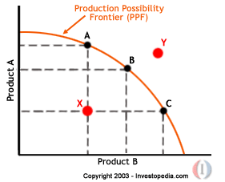

*The curve slopes downward from left to right. This represents the opportunity cost because you always have to give up some product A to get more product B. The curve bowed out to represent the principle of increasing marginal opportunity cost: in order to get more of something, one must give up increasing quantities of something else.
-Point A, B, and C represents efficiency: achieving as much output as possible from a given number of inputs.
-Point Y represents an unattainable point at the moment because of limited resources or technology.
-Point X represents an attainable point but is undesirable, showing loss or a point of inefficiency.
*Reasons for a shift in the PPF curve
-Economic growth- curve shifts outward to the right
-Economic decline- curve shifts inward to the left
-Technology (Quality of Resources)
-Land (Resources)
-Population (Resources)
-Education (Quality of Resources)

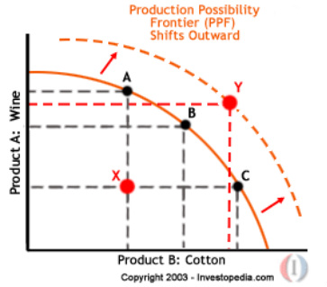

Unit 2- Microeconomics

SSEMI1 Describe how households and businesses are interdependent and interact through flows of goods, services, resources, and money.

a. Illustrate a circular flow diagram that includes the product market, the resource (factor) market, households, and firms.

*The relationship between goods and services can be shown as a circular flow. The chart shows the exchange of goods/services between the Factor Market (Resources) and the Product Market (Goods).
*Factor Market: where inputs such as land, labor, capital, and other resources are exchanged
*Product Market: where households buy finished goods and where businesses sell finished goods.
*Economic Interdependence: the reliance on business/households to provide the goods and services that people consume.

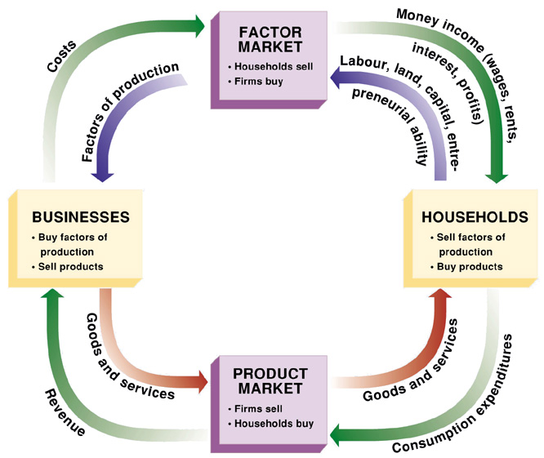

b. Explain the real flow of goods, services, resources, and money between and among households and firms.

*Households provide labor to businesses in the factor market. In return, they receive wages for their labor which allows them to purchase goods/services in the product market.
*Businesses purchase factors of production in the factor market which allows them to produce goods/services. They generate revenue when households purchase their goods/services. This allows them to invest in more capital and expand their business, if it is profitable to do so.

SSEMI2 Explain how the law of demand, the law of supply, and prices work to determine production and distribution in a market economy.

a. Define the law of supply and the law of demand.
b. Distinguish between supply and quantity supplied, and demand and quantity demanded.

*The law of supply and demand give economist basic information, but when combined they are the key to distribution in the market economy and most important price.
*Demand: the relationship between the price of a good or service and the quantity of it that consumers are willing to buy at that price.
*Law of Demand: the quantity demanded varies inversely with price.
Price Increases (P↑) then Quantity Decreases (Q↓)
Price Decrease (P↓) then Quantity Increases (Q↑)
*Demand Schedule and Demand Curve: are graphical representations of the law of demand. Both images with show a downward slope, because all else constant, the quantity demand rises as the price falls. (or the inverse)

Demand Schedule:

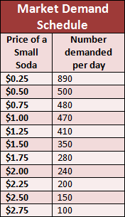
Demand Curve:

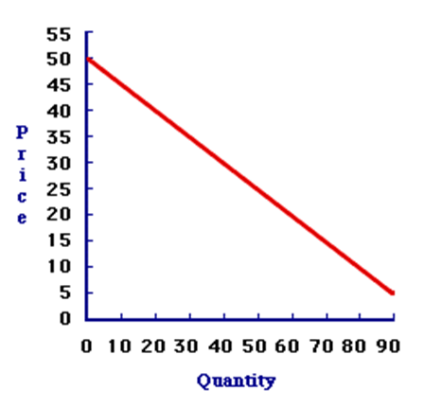

*Change in Quantity Demanded: Movement along a demand curve, caused only buy a change in a good’s own price.

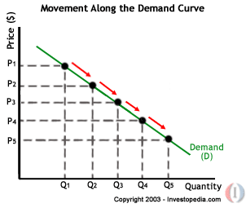

*Change in Demand: a shift in the entire demand curve, caused by a change in non-price determinants of demand.
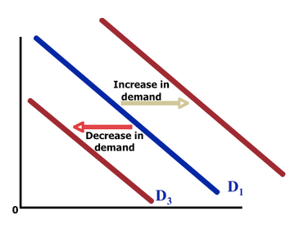
*Increase in quantity demand: move down and to the right along the curve
*Decrease in quantity demand: move up and to the left along the curve
*Increase in demand: shift the curve to the right
*Decrease in demand: shift the curve to the left
*MORE is the RIGHT, LESS is to the LEFT!
*Supply: the amount of a product that would be offered for sale at all possible prices that could exist in the market.
*Law of Supply: the quantity supplied varies proportionately with price.

Price Increases (P↑) then Quantity Increases (Q↑)
Price Decrease (P↓) then Quantity Decreases (Q↓)
*Change in Quantity Supplied: movement along a supply curve; caused only by a change in a good’s own price.

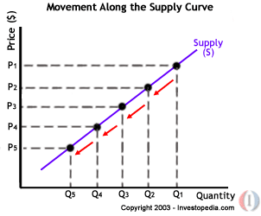

*Change in Supply: a shift in the entire supply curve caused by a change in non-price determinants of supply.

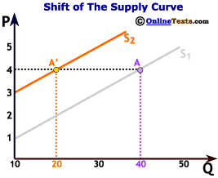
*The same principal applies for both changes in demand and supply, quantity demanded and quantity supplied: Increase is moving to the right, decrease is moving to the left.

c. Describe the role of buyers and sellers in determining market clearing price (i.e. equilibrium).

*Equilibrium Price: the place where the quantity supplied equals the quantity demanded.
*Buyers and sellers have the greatest impact in determining the market clearing price of a good/service. In general terms, sellers will establish a price based on their costs in order to generate profits. Consumers will buy the product at an agreeable price. If the price is too high, consumer demand will drop causing the demand curve for that product to shift, thus causing the equilibrium price to shift as well.

d. Illustrate on a graph how supply and demand determine equilibrium price and quantity.

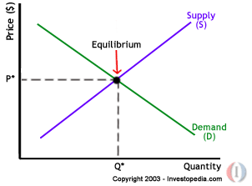

e. Identify the determinants (shifters) of supply (e.g., changes in costs of productive resources, government regulations, number of sellers, producer expectations, technology, and education) and illustrate the effects on a supply and demand graph.

*Changes in Non-Price Determinants of Supply:
1. Cost of Resources: If the cost of producing a product goes up, then the supply of the product will go down.
2. Changes in Technology: changes in producer’s technology can change the current supply of a product.
3. Changes in Prices of Other Goods: suppose a company makes plastic chair and plastic toys. If the price for plastic chairs goes up, then the result could be too increase of resources to produce chairs thus decreasing the resources used to supply toys.
4. The Number of Producers: changes in the number of sellers in a market can change the current supply of product.
5. Government Regulations: increase in taxes can lead to a decrease in supply; increase in government subsidies can lead to an increase in supply
6. Producer Expectations: producers may anticipate certain events to occur that could influence their output and profit margin.
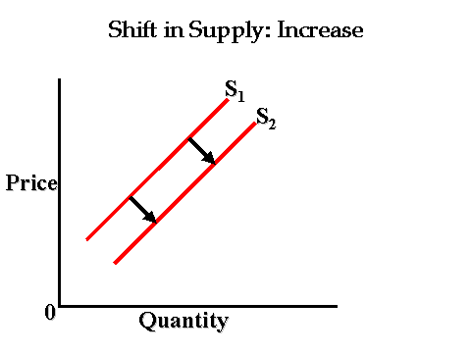

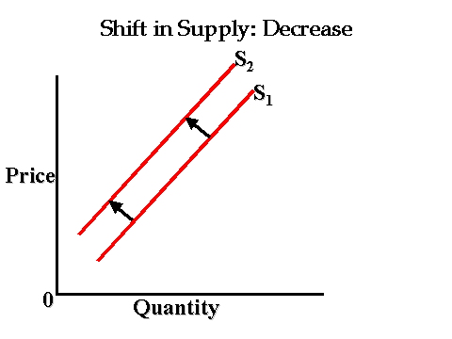
f. Identify the determinants (shifters) of demand (e.g., changes in related goods, income, consumer expectations, preferences/tastes, and number of consumers) and illustrate the effects on a supply and demand graph.

*Changes in Non-Price Determinants of Demand:
1. Consumer Expectations: The way consumers think about the future will affect the demand for a good.
2. Complementary Goods and Substitute Goods:
Complementary Goods: goods that are normally purchased with other goods. (Milk and Cereal)
Substitute Goods: goods that can be purchased to replace a similar good. (Coke and Pepsi)
3. Changes in Income: if consumer income increases he or she can buy more of a product (Normal goods vs. Inferior goods)
4. Change in Taste and Preferences: consumers buy more products when they are advertised.
5. The Number of Consumers: As population increases, more consumers are buying more products.

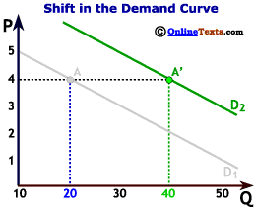

g. Explain and illustrate on a graph how prices set too high (e.g., price floors) create surpluses, and prices set too low (e.g., price ceilings) create shortages.

*Price Floors and Price Ceilings
Price Floor: when governments set a minimum price for which a product can be sold. To be effective, it must be set above the equilibrium price. However, sometimes a price floor can lead to a surplus of goods. ex: Minimum Wage
Price Ceiling: when government creates a maximum price at which a good can be sold. To be effective, it must be set above the equilibrium price. An increase in demand would then create a shortage of goods and services. ex: Rent control housing

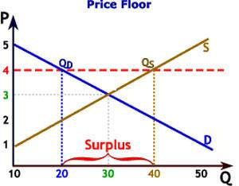

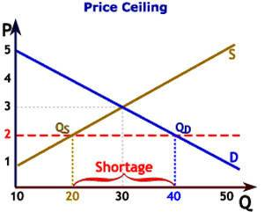

SSEMI3 Explain the organization and role of business and analyze the four types of market structures in the U.S. economy.

a. Compare and contrast three forms of business organization—sole proprietorship, partnership, and corporation with regards to number of owners, liability, lifespan, decision making, and taxation.
*Sole Proprietorship: a business owned and run by one person.
a. Benefits: All decision-making power belongs to owner and they are easy to start
b. Disadvantages: Owner faces unlimited liability (owner is responsible for loses or debt), hard to raise money and limited life (business dies with owner)
*Partnership: a business jointly owned by two or more people.
a. Benefits: Specialization of owners
b. Disadvantages: Partners face unlimited liability, decision making can be complex, owners share profits and costs
*Corporation: a form of business recognized by law as a separate legal entity having all the rights of an individual.
a. Benefits: Owners have limited liability (not responsible for loses and debt), have long life spans, and easy to raise money for business.
b. Disadvantages: Double taxation (profits that the
company make are taxed twice) and corporations are hard to start.

b. Identify the basic characteristics of monopoly, oligopoly, monopolistic competition, and pure (perfect) competition with regards to number of sellers, barriers to entry, price control, and product differentiation.

Market Structures
Five Important Features of a Market: Number of firms in the markets; Barriers of entry, or the ease in which a company enters the market; Products created, and whether or not these products are similar, identical, or different; Level of competition and control over price; Amount of advertising.
Types of Market Structures
1. Perfect (PURE) Competition
Number of Firms: unlimited
Barriers to Enter the Market: none or very little
Products: a single product that is similar throughout the market
Competition: unlimited, no control over price of good (PRICE TAKER)
Advertisement: none
Example: Farming-tomatoes, carrots
2. Monopolistic Competition
Number of Firms: a large number
Barriers to Enter the Market: low, easy to enter
Products: products are similar, but not exactly alike.
Competition: firms must remain aware of their competitor’s action, but they do have some control over their own prices
Advertisement: much
Example: Airline companies, blue jean companies
3. Oligopoly
Number of Firms: few (2 to 12 companies controlling a majority of the industry)
Barriers to Enter the Market: high, difficult
Products: similar or different
Competition: much, all firms are aware of one another’s prices
Advertisement: much
Example: soft drinks, cereal, chips.
4. Monopoly
Number of Firms: one
Barriers to Enter the Market: very high, if not impossible
Products: unique, no substitute
Competition: none, complete control over price (PRICE MAKER)
Advertisement: None
Example: local water company, diamond industry

Unit 3- Macroeconomics

SSEMA1 Illustrate the means by which economic activity is measured.

a. Identify and describe the macroeconomic goals of steady economic growth, stable prices, and full employment.

*Macroeconomics: the study of the economics of a nation as a whole.
The federal government of the United States along with the central bank known as the Federal Reserve System try and promote economic growth (see GDP), maintain stable prices (see inflation), and achieve full employment. The target rate of annual inflation is no more than 2%, and the target rate of unemployment is 5%, which is considered full employment.

b. Define Gross Domestic Product (GDP) as the sum of Consumer Spending, Investment, Government Spending, and Net Exports (output expenditure model).
*Gross Domestic Product or GDP: the market value of all goods and services produced by a country over a specific period of time, usually a year. GDP usually measures all the money spent by a country’s consumers, firms, and the government, and then factor in net exports.
GDP Formula: GDP= C+I+G+ NX
C= Consumer Expenditures
I= Business Investment
G= Government Expenditures
NX= Net Exports (exports minus imports)
*GDP per Capita: dollar amount of GDP produced on a per-person basis. GDP per Capita measures the standard of living of the people in a country.
*Standard of Living: is the rough estimate of the quality of life that people in a country are able to afford.

c. Define unemployment rate, Consumer Price Index (CPI), inflation, real GDP, aggregate supply and aggregate demand and explain how each is used to evaluate the macroeconomic goals from SSEMA1a

*Unemployment: a person who is able to work and is looking for work but cannot find a job is considered unemployed; Natural Rate of Unemployment is about 5% in the U.S.
Unemployment Formula: Unemployment rate= Number of Unemployed/Labor Force (employed + unemployed) x 100
*Consumer Price Index or CPI: takes a hypothetical basket of goods and services purchased by a typical household. It then tracks changes in the amount of money required to purchase this same basket of goods and services year after year.
CPI Formula: CPI= (Year 2 basket cost/base year basket cost) x 100
Using the Consumer Price Index (CPI)
*Inflation: rise in overall prices in an economy
*Deflation: fall in overall prices in an economy
*Stagflation: rise in overall prices and unemployment rate in an economy.
*Real Gross Domestic Product (real GDP): a macroeconomic measure of the value of economic output adjusted for price changes (i.e., inflation or deflation). This adjustment transforms the money-value measure, nominal GDP, into an index for quantity of total output.
Aggregate Supply and Demand
*Aggregate Demand: the demand for all goods and services within a country.
*Aggregate Supply: the supply of all goods and services within a country.
Shifts in Aggregate Demand
AD shift to the left: the GDP is falling (higher taxes, saving more)
AD shift to the right: the GDP is rising (lower taxes, saving less)
Shifts in Aggregate Supply
AS shift to the left: the GDP is falling and inflation (cost of production goes up) could lead to recession
AS shift to the right: the GDP is rising and no inflation (cost of production goes down, increase in technology)

d. Give examples of who benefits and who loses from unanticipated inflation.

Winners: borrowers and people who barter
Losers: savers, lenders, people who live on fixed incomes, people with long-term contracts.

e. Identify seasonal, structural, cyclical, and frictional unemployment.

Structural: unemployment occurs when you have job skill that no one wants, or when a company wants to hire somebody but can’t find anyone who has the necessary requirements. (SKILLS MISS MATCH)
Frictional: unemployment due to people leaving a job and looking for one that better fits their interests and abilities. Frictional unemployment is not entirely bad for an economy because it gives people time to find a job that suits their needs.
Cyclical: people who are laid off as a result of a contracting economy. Cyclical unemployment occurs during a recession, the low part of the business cycle.
Seasonal: regular seasonal changes in unemployment. Ex. Six Flags

f. Define the stages of the business cycle, including: peak, contraction, trough, recovery/expansion as well as recession and depression.

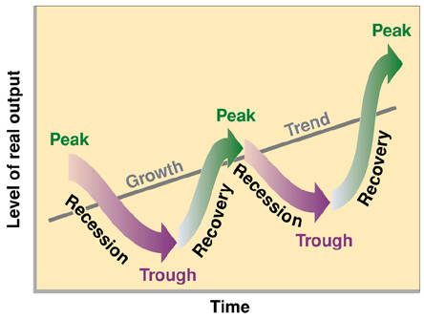
Stages of the Business Cycle:
Peak (BOOM): highest point before recession
Recession: a decline that lasts at least 6 months
Trough (DEPRESSION): the lowest point at the end of a recession and before a recovery
Recovery: the period between the end of a recession and the next peak

SSEMA2 Explain the role and functions of the Federal Reserve System.

a. Explain the roles/functions of money as a medium of exchange, store of value, and unit of account/standard of value.

*Medium of Exchange: Anything that is generally acceptable in exchange for goods and services.
*Standard of Value: allows you to understand how much something costs in terms of other items. Common measurement in which values are expressed.
*Store of Value: an item that maintains value over time. (an apple has a bad store of value)

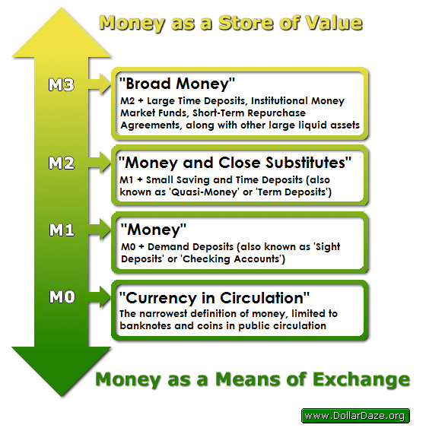

b. Describe the organization of the Federal Reserve System (12 Districts, Federal Open Market Committee (FOMC), and Board of Governors).
The Federal Reserve (also called the Fed): is the bank of banks or the bank of last resorts. The Fed influences monetary policy for two main reasons. It wishes to control inflation and it attempts to curb recessions. The Fed achieves these goals by buying and selling government securities in the open market. The structure of the Fed includes:
Board of Governors: Presidentially appointed, and independent federal government agency, seven members serving a 14-year term, oversees the operations of the Fed.
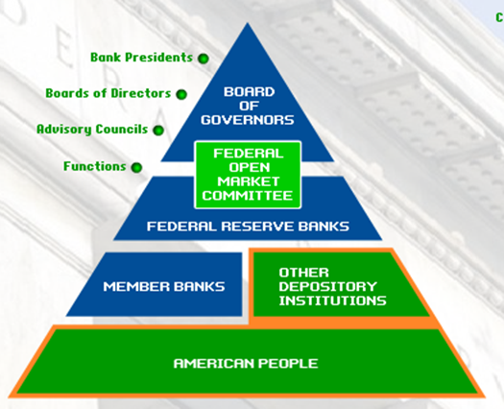
Federal Open Market Committee: The Feds key monetary policy maker, makes decisions about economic growth by determining the flow of money (and credit).
Federal Reserve Banks: 12 regional banks with 25 branches, monitors the economy and financial institutions in their districts.
Member Banks: private banks, holds stock in their local Federal Reserve Bank.

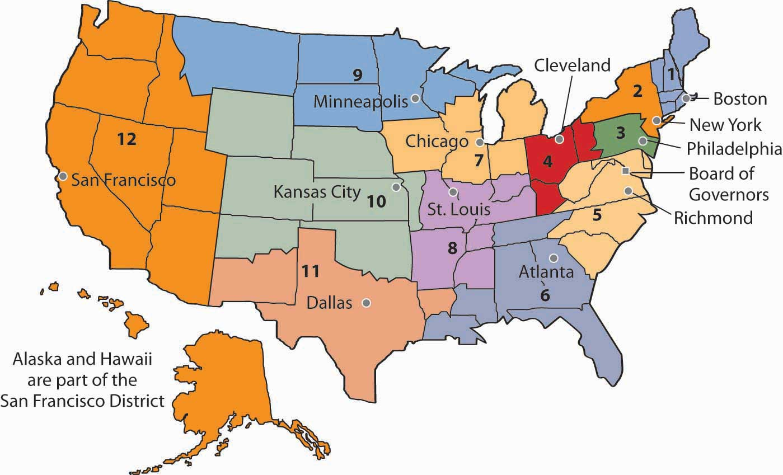

c. Define monetary policy

*Monetary Policy: refers to changes in the money supply of a nation in order to influence its economy. In the U.S. the money supply is controlled by the Federal Reserve.

d. Define the tools of monetary policy including reserve requirement, discount rate, open market operations, and interest on reserves.

Tools used to Control the Money Supply:
1. Open-Market Operations (BONDS): If the Fed wanted to stimulate the economy to reduce unemployment it could buy securities on the open market. If the Fed wanted to slow down inflation and the economy, it could sell securities on the open market.
2. Discount Rate (DR): The Fed could also manipulate the discount rate, which is the interest rate the Fed charges on loans to banks. Changing the rate affect whether or not a local bank will take a loan or not from the Fed. If the Fed lowers the discount rate, then local banks will take out more loans and the money supply will increase. If the Fed increases the discount rate, then local banks will not take out more loans and the money supply will decrease (slow down the economy).
3. Reserve Requirement (RR): the percentage of deposits a bank is required to hold in cash (Usually Around 10%). The lower the reserve requirement the more local banks can loan money to businesses and individuals, money supply increases. The higher the reserve requirement the less local banks can loan out money, money supply decreases.
4. Interest on Reserves (IOR): the rate at which the Federal Reserve Banks pay interest on reserve balances, which are balances held by depository institutions at their local Reserve Banks. One component of IOR is interest on required reserves, which is the rate at which the Federal Reserve Banks pay interest on required reserve balances. Paying interest on required reserves aims to eliminate the opportunity cost that depository institutions incur by not investing required reserves in interest-bearing assets. The other component of IOR is Interest on Excess Reserves (IOER), which is the interest paid on those balances that are above the level of reserves the depository institution is required to hold. Paying IOER reduces the incentive for depository institutions to lend at rates much below IOER, providing the Federal Reserve additional control over the FFER (see Federal Funds Rate)

How Monetary Policy Tools Effect the Money Supply
Buy Bonds= Money Supply Increase (Investment↑, GDP↑)
Sell Bonds= Money Supply Decrease (Investment↓, GDP↓)
↑RR= Money Supply Decrease (Investment↓, GDP↓)
↓RR=Money Supply Increase (Investment↑, GDP ↑)
↑DR= Money Supply Decrease (Investment ↓, GDP ↓)
↓DR= Money Supply Increase (Investment ↑, GDP ↑)
↑IOR= Money Supply Decrease (Investment ↓, GDP ↓)
↓IOR= Money Supply Increases (Investment ↑, GDP ↑)

Federal Funds Rate (FFER): The interest rate at which a depository institution lends funds maintained at the Federal Reserve to another depository institution overnight. The federal funds rate is generally only applicable to the most creditworthy institutions when they borrow and lend overnight funds to each other. The federal funds rate is one of the most influential interest rates in the U.S. economy, since it affects monetary and financial conditions, which in turn have a bearing on key aspects of the broad economy including employment, growth and inflation. The Federal Open Market Committee (FOMC), which is the Federal Reserve’s primary monetary policymaking body, telegraphs its desired target for the federal funds rate through open market operations. The higher the federal funds rate, the more expensive it is to borrow money. Since it is only applicable to very creditworthy institutions for extremely short-term (overnight) loans, the federal funds rate can be viewed as the base rate that determines the level of all other interest rates in the U.S. economy.

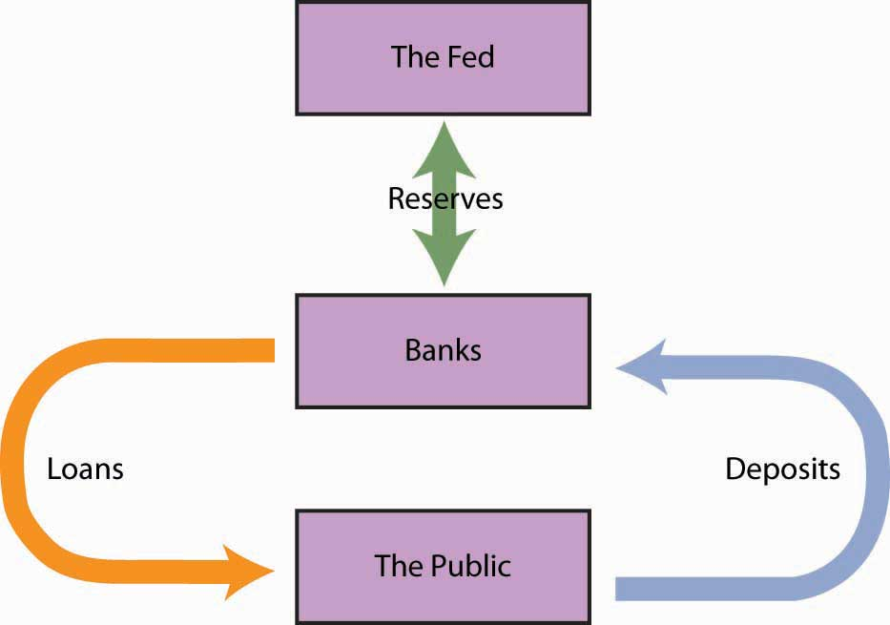

e. Describe how the Federal Reserve uses the tools of monetary policy to promote its dual mandate of price stability and full employment, and how those affect economic growth.
If the Federal Reserve is concerned about price stability, it is usually worried that the inflation rate is increasing. This means the Federal Reserve needs to use monetary policy that will decrease the money supply. Monetary policy can also be used to promote full employment and economic growth. Economists use the term full employment to describe the level of employment when all factors of production are being used efficiently. It is the same as an economy operating on its production possibilities curve. Full employment can also refer specifically to labor resources. At full employment, the
unemployment rate is equal to the structural plus the frictional unemployment rates and there is no cyclical unemployment in the economy. If the Federal Reserve wants to promote full employment and economic growth, it will use expansionary (or loose) monetary policy. It will buy bonds (securities), causing the Federal Funds Rate to fall and encouraging more borrowing activity. In some cases, it will lower the discount rate as a signal to banks to increase lending. And, finally, in rare cases, it could lower the reserve requirement ratio, allowing banks to lend more of their deposits.

SSEMA3 Explain how the government uses fiscal policy to promote price stability, full employment, and economic growth.

a. Define fiscal policy

*Fiscal Policy: the use of government expenditures (spending) and revenue collection (taxes) to influence the national economy, specifically GDP.

b. Explain the effect on the economy of the government’s taxing and spending decisions in promoting price stability, full employment, and economic growth.

How Fiscal Policy Tools Effect GDP
↑Taxes= GDP Decrease (↓Consumption, ↓ Investment)
↓Taxes= GDP Increase (↑Consumption, ↑ Investment)
↑Spending= GDP Increase (↑Consumption, ↑Investment)
↓Spending= GDP Decrease (↓Consumption, ↓Investment)

c. Explain how government budget deficits or surpluses impact national debt.
Budget Deficit: when a country spends more money than it takes in with taxes, in a year. ex: the government spends $2 trillion but only collects $1 trillion in taxes, it would have a -$1 trillion balance.
National Debt: if a government continues to operate a deficit more than 1 year. ex: the U.S., as of 2017, has a $19 trillion debt when you add and subtract all the surpluses and deficits together.
Budget Surplus: if a government takes more money in taxes than what it spends, it has money left over. ex: the government spends $1 trillion and takes in $3 trillion in taxes, it would have a $2 trillion balance.

Unit 4- International Economics

SSEIN1 Explain why individuals, businesses, and governments trade goods and services.

a. Define and distinguish between absolute advantage and comparative advantage.
*Absolute Advantage: when a country can produce more of a good than another country. For example: if the U.S. produces more wood than Canada, then the U.S. has an absolute advantage at producing wood.
*Comparative Advantage: when a country can produce a product at a lower opportunity cost than another country. Put another way, given two countries that can both produce sugar and cars, one country should specialize in producing cars and one country should specialize in producing sugar so that they can trade.
b. Explain that most trade takes place because of comparative advantage in the production of a good or service.

c. Define balance of trade, trade surplus, and trade deficit.

*Balance of Trade: records the value of all goods and services exported from a country minus the value of all goods and services imported from outside the country.
*Favorable Balance of Trade or Trade Surplus: when country A
EXPORTS more than it IMPORTS. The money flows from country B to country A, which increases country A’s GDP and decrease its unemployment rate.
*Unfavorable Balance of Trade or Trade Deficit: When country A
IMPORTS more than it EXPORTS. The money flows from country A to country B, which decreases country A’s GDP and increase its unemployment rate.

SSEIN2 Explain why countries sometimes erect trade barriers and sometimes advocate free trade.

a. Define trade barriers such as tariffs, quotas, embargoes, standards, and subsidies.

Barriers to Trade (Protectionism)
Tariff: a tax on an imported good
Quota: a limit on the amount of a good that is allowed in a country.
Standards: governments employ standards to ensure the safety of
imported goods and to make sure these goods comply with local laws.
Subsidies: a government payment to a local supplier that helps the
supplier reduce the cost of producing a good.
Embargo: when government prohibits the import of a good.

b. Identify costs and benefits of trade barriers to consumers and producers over time.

c. Describe the purpose of trading blocs such as the EU, NAFTA, and ASEAN.

Reason for Trade Organizations: since barriers to trade tend to increase prices, many nations often try to reduce the barriers with their economic partners. In theory, this will lead to lower prices for buyers (citizens) within the trading nations, as well as firms that are more competitive on the international market.

The North American Free Trade Agreement (NAFTA): eliminates trade barriers between Canada, Mexico and the United States
The European Union (EU): eliminates trade barriers between European countries such as France, Germany, Spain and Italy
Association of Southeast Asian Nations (ASEAN): eliminates trade barriers between Southeast Asian Countries such as Vietnam, Thailand, Singapore, Indonesia and the Philippines

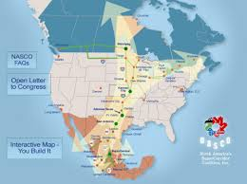

d. Evaluate arguments for and against free trade.
Free Trade: international trade without government restrictions
Protectionism: when governments protects its’ country’s industries from foreign competition.

SSEIN3 Explain how changes in exchange rates can have an impact on the purchasing power of groups in the United States and in other countries.

a. Define exchange rate as the price of one nation’s currency in terms of another nation’s currency.

*Exchange Rates: measures the price of one nation’s currency in the terms of another nation’s currency. The exchange rate between two countries depends on how much demand there is for each country’s exports at a given time. When there is more demand for a nation A’s products, then people need more of nation A’s currency to buy their products.
b. Interpret changes in exchange rates, in regards to appreciation and depreciation of currency.

*Currency Appreciation: when a nations currency is stronger than another nations currency.
*Currency Depreciation: when a nations currency is weaker than another nations currency.
c. Explain why some groups benefit and others lose when exchange rates change.

Effects of Currency Appreciation or Depreciation (For U.S.)
When the dollar is strong:
Imports increase and are cheaper for Americans to buy
Traveling to other countries is cheaper for Americans
U.S. exports decline
The U.S. trade deficit increases
When the dollar is weak:
U.S. exports increase and the price of exports go up
Travel to other countries becomes more expensive for U.S.
U.S. imports decline and the price of imports increases
Foreign investment in U.S. businesses increase.

Unit 5- Personal Finance

SSEPF1 Apply rational decision making to personal spending and saving choices.

a. Use a rational decision making model to evaluate the costs and benefits of post-high school life choices (i.e., college, technical school, military enlistment, workforce participation, or other option).

P.A.C.E.D. is the decision making model that helps you examine the problem you are trying to solve, come up with alternatives, evaluate those alternatives and come to a decisions.
P: Problem
A: Alternatives
C: Criteria
E: Evaluation (of the alternatives)
D: Decision (make rational decision)
*Trade-off: action of giving up one item or category for another (ex. Guns v Butter)
*Opportunity cost: the item or value that is lost when someone makes an economic decision; the next best alternative; the item that is not chosen.

b. Create a budget that includes a savings or financial investment plan for a future goal.

*Reasons people save and invest:
1. Retirement
2. Saving for future purchase
3. Saving when interest rates are high

SSEPF2 Explain that banks and other financial institutions are businesses that channel funds from savers to investors.

a. Compare services offered by different financial institutions, including banks, credit unions, payday lenders, and title pawn lenders.

Bank—For most consumers, banks provide a safe means to store earnings. Typically, banks also offer direct deposit (where a person’s paycheck goes directly into his or her account), check-writing services, debit and credit cards, loans of all sorts (personal, home equity, business), and a host of other services.
Credit Union—Credit unions provide services similar to a bank; the main difference is that a credit union only provides these services to its members. Members own and control the institution. Credit unions often offer higher interest rates on deposits and lower interest rates on loans than banks.

Payday Loan Company—Suppose you need $50 on Wednesday but won’t get paid by your job until Friday. To solve this temporary problem, a payday loan company will give out small loans in return for a portion of the upcoming paycheck. This means the person will get $50 on Wednesday, but come Friday, $55 of his or her paycheck will go to the payday loan company. Payday loan companies generally charge much higher interest on loans than other institutions.

Title Pawn Lender – Title pawn lenders provide short-term loans to individuals facing a gap between their income and expenses. Usually, those accessing loans through title pawn lenders lack access to other types of short-term loans like credit cards. Title pawn lenders make loans based on an individual’s collateral. Collateral is an item of value one owns like a car. Lenders can sell the collateral to cover the value of an outstanding loan if the borrower cannot repay. Like payday loans, the fees associated with title pawn loans are usually much higher than those a bank would charge. In the case of title pawn loans, the inability to repay the loan could result in the loss of the vehicle put up as collateral.

b. Explain reasons for the spread between interest charged and interest earned.

Commercial banks, and other financial institutions offering loans, are businesses. They must make a profit if they expect to continue operating. One primary way banks make profits is by taking the money deposited by bank customers and loaning out a portion to people who want to borrow. By charging interest on the loans, banks make money. The more money on deposit, the more loans they can make, which is why some banks offer very generous checking account services. The interest on the loans is always more than the interest paid out to depositors. If banks did not have this “spread” between interest earned and interest charged, they would go out of business very quickly. As provisions of the Glass-Steagall Act have eroded, commercial banks have increasingly added very lucrative investment banking services to the traditional role of taking deposits and making loans. Banks also earn interest on required and excess reserves they deposit with the Federal Reserve.

c. Give examples of the direct relationship between risk and return.

*Return: refers to the eventual payoff of the investment.
*Risk: refers to the chance that an investment might actually end up losing money rather than making money

The relationship between risk and return is that the higher the potential return offered by a savings or investment opportunity, the more risky the savings or investment usually is. Therefore, if someone offers a 20% return and no risk, the person is most likely not being very honest.

d. Evaluate the risk and return of a variety of savings and investment options, including: savings accounts, certificates of deposit, retirement accounts, stocks, bonds, and mutual funds.

Savings Accounts - Savings accounts are bank accounts in which people put savings to which they need easy access. The Federal Deposit Insurance Corporation (FDIC) most types of bank deposits up to $250,000. There is virtually no risk that the depositor will lose his or her money. The only risk comes from inflation risk. This means that the interest earned on the savings is less than the rate of inflation. Therefore, money held in a very low interest savings account is likely to erode in value over time. Since savings accounts are very low risk, the rate of return is very low as well. Most bank pay less than 1% interest on savings.

Certificates of Deposit – Certificates of Deposit (CDs) are products offered by banks. Buying a CD means you will earn a higher rate of return than on a regular savings account. The higher rate of return results from the saver agreeing to keep the funds in the CD for a specified period, usually between 1 months to 10 years. The longer the period, the higher the interest rate. People who save in CDs and need to withdraw their funds early will pay a fee for early withdrawal.

Retirement Accounts – Saving for retirement is a key goal for many people in the United States. Very few employers offer traditional defined benefit pensions and most retirees will need to live off their savings to maintain their standard of living. There are a number of retirement account options for workers. The most common account is a 401K. This is provided through an employer which will sometimes offer a percentage of matching funds. Individuals can also establish their own Individual Retirement Accounts through an investment bank. They usually have a choice between a Roth IRA and a traditional IRA. Roth IRAs allow contributors to pay taxes today and withdraw the funds they contributed tax-free in the future. The contributor will still have to pay taxes on any “gaines” they withdraw from their account in retirement. A traditional IRA allows contributors to put money away before taxes are paid. The taxes are paid on the money when it is withdrawn during retirement. All of these retirement account options offer portfolios with mixed investment options. People can chose high risk, high return stock funds or low risk, low return bond funds. Finally, the U.S. government has a program called MyRA for workers whose employers do not have a 401K. It allows workers to contribute up to $15,000 before having to roll it over into an account with an investment bank. The funds can be withdrawn as needed without penalty and are guaranteed by the U.S. government, causing the return to be small.

U.S. Treasury Bonds – Purchasing a U.S. Treasury Bond means you have loaned the U.S. government money. The government pays you a guaranteed rate of return. Since the U.S. government repays its debts, the rate of return is low. For example, the interest rate on a 5-year treasury bond on April 27, 2017 was 1.822%. The interest rate on 10-year treasury bonds was 2.3%. Bonds are safe but also carry an inflation risk if interest paid is not higher than the inflation rate.

Stock Mutual Funds – While individual company stock is relatively risky, many people choose to play the stock market by purchasing mutual funds. Mutual funds provide more protection against loss because the investment is spread across many different companies rather than just one company. You may also select funds that reflect specific levels of risk or your values. Long term investing tends to give a greater return in the stock market than short-term investing. Over a 20-year period, the stock market returns on average 7-8%. However, when holding stocks for only 5 to 10 years, the average rate of return drops to 1- 2%.

Stock – Purchasing stock of individual companies is one of the more risky ways to invest. When purchasing stock in large stable companies (blue chip stocks), your investment could be safer, but your rate of return is likely to be lower. If you invest in companies with a shorter history or a brand new product, the potential return is generally high if the company succeeds, but you are much more likely to lose your investment because of the high rate of new business failures.

SSEPF3 Explain how changes in taxation can have an impact on an individual’s spending and saving choices.

Government assesses taxes on individuals and firms in an economy to pay for public goods and services. Some common taxes paid by individuals include income, property, and sales tax. When the government increases taxes, individuals will have less of their income to save and spend. When government decreases taxes, individuals will have more income to save and spend.

a. Define progressive, regressive, and proportional taxes.

*Progressive tax rate increases as income increases, meaning the wealthy pay a higher percentage of their earnings than people less financially well-off. The U.S. federal income tax is a progressive tax. For example, a progressive tax might have a tax rate of 1% for every $10,000 earned annually, with a maximum tax rate of 50%.

*Regressive tax is a tax rate that decreases as income increases. Consider a tax that imposes a flat rate of $1,000 annually regardless of income. For someone earning only $3,000 a year, this tax would be huge, accounting for one-third of all earnings. To someone earning $50,000 a year, the tax rate is not as large, accounting for only 2% of annual income. Most sales taxes are regressive because lower income people tend to spend a greater proportion of their income on sales taxed items than higher income people.

*Proportional tax, also known as a flat tax, does not change with respect to changes in income. If the proportional tax rate is 15%, then everyone pays 15%, regardless of whether he or she makes $10,000 or $570,000. The FICA tax workers pay to fund Social Security and Medicare is proportional. Everyone pays the same percentage of their income to this tax up to a specified income cap.

b. Explain how an increase in sales tax affects different income groups.

Sales tax refers to a consumption tax levied on people when they make certain kinds of purchases, such as buying a book or eating out at a restaurant. Not all goods and services are subject to a sales tax; doctor visits, for example, are free of taxes. Like the different types of income taxes, a change to the sales tax affects different income groups in different ways. Since all consumers purchase essential goods like food, a high sales tax on food would affect poor people more than wealthy people because both groups will be paying the same tax rate for the same good. For this reason, economists usually classify sales tax as a regressive tax because it takes a greater percentage of income from a low-income person than from a high-income person. This is one reason why food is often not subject to a sales tax. However, food served at a restaurant typically is subject to a sales tax, since eating out is a luxury.

c. Explain the impact of property taxes on individuals and communities.

Property tax refers to a tax on real estate people own. The tax, levied by local governments like counties or cities, is on the value of the real estate. Periodic appraisals of a property’s value indicate whether the tax on the property will rise or fall. Increases in property value are cause for celebration by those ready to sell their property. However, for those who wish to remain in their homes, increased property values translate to increases in property taxes. If property taxes increase drastically, lower income people may no longer be able to afford the taxes on their homes. Delinquent taxes accrue interest and fees increasing the total bill owed. Various entities can use the delinquent tax bill to start the foreclosure process even properties fully owned with no mortgage. For this reason, owners of previously low value properties can lose their homes as property values rise and they are unable to afford the tax bill. This is gentrification. Gentrification occurs when high-income property owners replace low-income property owners in an area. Since taxes assessed on the property’s value are without regard for the income of the owner, these taxes are regressive.

SSEPF4 Evaluate the costs and benefits of using credit.

Credit refers to borrowing money. People borrow money for a variety of reasons. When considering a loan, borrowers identify the benefits and the cost of using credit. If the benefits of using credit outweigh the costs, taking a loan is rational. If the costs of borrowing outweigh the benefits, the loan should be avoided.

a. Describe factors that affect credit worthiness and the ability to receive favorable interest rates including character (credit score), collateral, and capacity to pay.

As a rule, we should spend only what we earn and avoid borrowing. However, some purchases are very difficult to make without the use of credit and the benefits of making those purchases using credit may outweigh the costs in the long-run. For example, if someone cannot go to college without a student loan, the higher future income potential and lower risk of unemployment may make the student loan a wise idea. If someone lacks a reliable car to get them to a great job, the benefits of a low-interest car loan may outweigh the costs because of the higher income earned at the new job. The key is to be wise in borrowing. Do not borrow more than you need and make sure the payments are affordable given your income. If you want to secure a loan from a financial institution like a bank, your credit rating must be good.

*Credit worthiness is a measure of a variety of factors used to determine whether a person will repay a loan. While there is no guarantee a person making $400,000 annually will pay a $2,000 loan, evaluation of their credit worthiness indicates they have the income required to handle the loan. Annual earned income is a major factor in determining credit worthiness. If income is high, lenders believe the borrower can use some of that income for debt repayment. However, the amount of current debt is another big factor affecting credit worthiness. Making $400,000 a year is less attractive to lenders if you already owe $500,000.
“Three C’s of Credit” are character, capacity, and collateral. Since most lenders do not know potential borrowers personally, they evaluate a potential borrower’s character using the information on the borrower’s credit report. A credit report is available through three main private companies: Transunion, Equifax, and Experian. It details a person’s borrowing and repayment history for the last seven years reported to the company’s by a person’s previous and current lenders. Potential lenders request credit reports on potential borrowers to assess the borrower’s character and capacity. A potential borrower who has “paid as agreed” on all credit accounts has good credit character. The credit report also shows some aspects of capacity. While income is one factor in assessing capacity, the amount it takes to service current debt is also a concern. If debt to income ratio is high, the borrower may not be able to handle additional debt payments.
*Collateral is something of value a borrower can use to back the loan if the borrower can no longer pay the scheduled payments. For example, a home mortgage is available to people with lower incomes because the bank can seize the home if the mortgage is not paid. Many people obtain a credit card to start building a positive credit history. To get low interest rates for borrowing and sometimes even to get a job, people need a good credit report and good credit score. In some cases, no credit history affects people negatively just as a poor credit history does.
*Credit score is a number calculated by the credit reporting companies based on a variety of factors. While the exact calculation is proprietary, the companies release general guidelines about how the score is calculated. Payment history, amount of open credit used, and the number of open credit accounts are some of the factors determining a credit score. By making small purchases and paying the entire amount each month, a potential borrower shows a lender how they use credit wisely. The image below shows a general breakdown of a credit score.

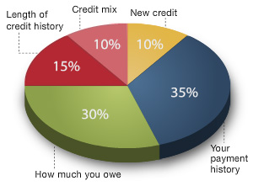
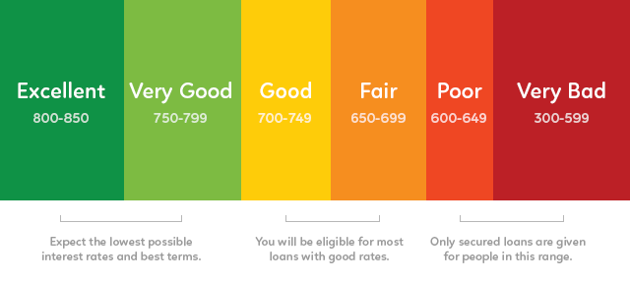

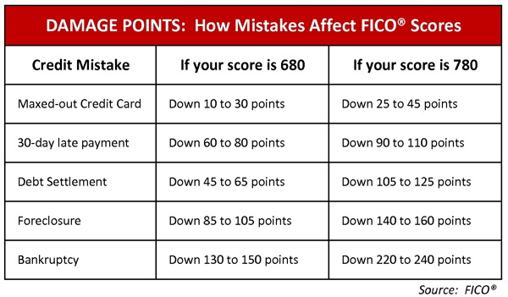
b. Compare interest rates on loans and credit cards from different institutions.

Wise potential borrowers shop for the best interest rates on loans. While the exact rate offered to a borrower will vary with the borrower’s character, capacity, and collateral, the internet allows borrowers to compare the best rates offered by different financial institutions. The table below looks at a snapshot of rates for a variety of loan products available from different lenders in April 2017.

Lender | 30 year fixed rate mortgage | 5 year fixed rate auto loan | Home equity lump sum fixed rate loan | Credit Card (no annual fee)
Institution A | 4.0%  4.081% APR | 3.24% | 4.79% | 13.74-23.74% variable APR
Institution B | 4.125%  4.2182%APR | 2.49% | 4.49% | 11.99%-21.99% variable APR
Institution C | 4.125%  4.186%APR | 3.12% | 4.75% | 17.90%-26.74% variable APR

Assuming the borrower qualified for the best rates available, a wise decision would be Lender A for the mortgage and Lender B for the three remaining products.

c. Define annual percentage rate and explain the difference between simple and compound interest rates, as well as fixed and variable interest rates.

*Annual percentage rate (APR) is the annual rate charged for borrowing funds. Expressed as a percentage, APR represents the actual yearly cost of the borrowed funds over the full term of the loan. In the table for SSEPF4b, although the stated interest rates for Lender B and C were the same for mortgages, Lender C had a higher APR making it a more expensive loan. Interest rates on loans are fixed or variable.

*Fixed interest rate on a loan will not rise or fall during the term of the loan. Obtaining a fixed interest rate when rates are low is usually desirable. When rates are high, borrowers may choose a variable interest rate in the hope that rates will fall in the future. Sometimes, lenders will only offer fixed rates to their best customers. Lenders sometimes offer risky borrowers variable rates. If the borrower proves the ability to make the payments, the person can refinance for a fixed rate in the future. Interest is also simple or compound.
*Simple interest applies only to the original amount borrowed called the principal.
*Compound interest applies to both the principal of the loan as well as accrued interest on the principal. Compound interest makes a loan more expensive and is less desirable for borrowers than simple interest loans.

SSEPF5 Describe how insurance and other risk-management strategies protect against financial loss.

*Insurance is a product purchased to guard oneself against life’s risks, specifically the financial losses associated with these risks. One may not be able to avoid dying, but one can avoid leaving loved ones in financial ruin by purchasing life insurance. The law requires people to buy certain type of insurance while other types are voluntary.

a. List and describe various types of insurance such as automobile, health, life, disability, and property.

*Automobile/Liability Insurance: Most states in the U.S. require automobile owners to maintain a certain level of automobile insurance coverage. The required coverage is liability insurance. Liability insurance covers the other vehicle(s) when you are at fault in a car accident. If an owner wants coverage for their own vehicle, then they need to purchase collision insurance as well. Vehicles purchased with a loan from a financial institution require collision insurance until paid in full. It is important for vehicle owners to know the level of insurance required by law may not adequately cover all damages in an accident. The other driver can sue the at fault driver for any additional damages.
*Health insurance: pays for medical services. As of April 2017, federal law required people to have a certain level of health insurance or pay an annual penalty when filing federal taxes. Health insurance plans vary widely from those protecting against catastrophic care to plans paying for routine wellness visits.
*Life insurance: provides a monetary payment to a designated beneficiary when the insured person dies. The beneficiary is one who experiences financial harm from the death of the person covered by the policy such as a spouse, a parent, or a child.
*Disability insurance: provides people with income in case they become injured or are unable to work at a job. Many employers offer disability insurance as an option in worker benefits packages. Short-term disability covers temporary work restrictions such as the period of recovery from childbirth or surgery.
*Property insurance takes a variety of forms. The most common types are homeowners and renters insurance. Homeowners insurance pays for damages sustained to your real estate property and for injuries to others that happen on your property. Renters insurance protects your personal property assets when you live in a rental property instead of a home you own.

b. Explain the costs and benefits associated with different types of insurance, including deductibles, premiums, shared liability, and asset protection.

In general, all insurance policies allow a person or business to pay a relatively small amount of money (a premium) in the present to purchase asset protection against the possibility of a future financial loss caused by an unforeseen event. Assets protected range from one’s home to one’s health. Most insurance policies include a deductible stipulating the amount of money the insured must pay when filing a claim with the insurance company. In most cases, the higher the premium is, the lower the deductible is. This is true in reverse as well. Purchasing insurance involves shared liability between the insurer and the insured. This means that the insurance company assumes a pre-determined amount of financial liability for a claim that the insured might file. The insurance company is obligated to pay for the loss since the insured has paid premiums for the financial protection. In some cases, people pay insurance premiums for years and never file a claim. However, most people know they would be unable to cover a catastrophic loss themselves and are willing to pay for the peace of mind insurance provides.

SSEPF6 Describe how the earnings of workers are determined in the marketplace.

In the United States, supply and demand determine the earnings of workers. The exception is minimum wage laws at the federal, state, and local level. Minimum wage is a price floor. If equilibrium wage falls below the price floor, employers are bound to paying the legal wage. In most cases, minimum wage affects only markets for the least skilled workers. The labor market is a resource market. Employers demand workers and workers supply their labor. The intersection of the labor demand and supply curves indicated the equilibrium wage in the market. Like a product market, changes in the economy shift the supply of and demand for labor altering the equilibrium wage.

a. Identify skills that are required to be successful in the workplace, including positive work ethic, punctuality, time management, teamwork, communication skills, and good character.

Work ethic refers to how seriously one pursues the expectations associated employment. People with good work ethic practice all the soft skills listed above. When at work, people with good work ethic spend their time pursuing the goals of the job and producing excellent results to the best of their ability. Examples of poor work ethic include spending work hours pursuing personal interests, finding ways to avoid work, letting coworkers perform one’s assigned job functions, doing the minimum amount of work required to get by, and/or not following the rules outlined by the employer. Actor Woody Allen once said, “Ninety percent of success is just showing up.” Punctuality means arriving on time and ready to work at the established time. Many employers of young workers lament how many lose their jobs due to lack of punctuality. Most workers divide their work time among many different tasks and responsibilities. Workers with good time management skills efficiently organize their work hours to accomplish all objectives with minimal stress. Today’s workplace is increasingly flat. This means rather than many layers of managers, many people work on teams lead by peers or lead teams of peers. These teams are often cross-functional meaning they are composed of people with different skill sets. Teamwork is part of most jobs. Team members need to work well with each other, support each other, and perform their assigned tasks well. Excellent verbal and written communication skills help workers perform their jobs well. This means knowing how to get your ideas across to someone else and using appropriate style, grammar, and/or spelling. These skills help everyone understand what is expected and keep people motivated. Poor verbal and written communications skills cause workers to be viewed negatively and can cause conflict. In dangerous or high-risk environments, poor communication skills could put lives at risk. Good character refers to doing the right thing every time. Today’s workers often enjoy a lot of freedom in how and where they work. Working remotely requires discipline to stay on task and meet goals. Employers need workers who behave ethically. Poor character traits include stealing from an employer, lying, plagiarizing the work of others, and treating coworkers or customers poorly.

b. Explore job and career options and explain the significance of investment in education, training, and skill development as it relates to future earnings.

Since societies are constantly changing, and their economies— and marketplace demands— change as well. At some point in the 20th century, people who excelled at selling typewriters could probably have demanded a high salary for their work. Today, this expertise is no longer in demand, so work would be hard to get and at a much lower wage than it once was. In general, the three factors determine the wage a worker can expect. The strength of demand for workers in the market, the number of workers supplying their labor in the market, and the amount of specialized knowledge, skills, training, and licenses are required to do the job. As a rule, the more knowledge, skills, education, and training a worker has, the higher the wage the worker can expect assuming their education applies to a field with strong employer demand. The chart below from the Bureau of Labor Statistics shows the correlation between level of education and median weekly wages. It also shows how likely people in each education level are to be unemployed.

