Name__________________________
Test/Due Date: _______________
APUSH Period 3 Study Guide:
American Revolution – 1754-1800
Overview
British imperial attempts to reassert control over its colonies and the colonial reaction to these attempts produced a new American republic, along with struggles over the new nation’s social, political, and economic identity.
Must Know Dates
- 1756-1763: French and Indian War  - 1763: Proclamation Line established  - 1763-1764: Pontiac's Rebellion  - 1764-1765: Sugar Act and Stamp Act Controversies  - 1766: Declaratory Act  - 1767: Townshend Act, New York Assembly suspended  - 1770: Boston Massacre  - 1772: Committees of Correspondence formed  - 1773: Boston Tea Party  - 1774: Coercive Acts, First Continental Congress convenes  - 1775: Revolution begins with fighting at Lexington and Concord  - 1776: Declaration of Independence  - 1777: British defeated at Saratoga  - 1778: French join the war against the British  - 1781  - Battle of Yorktown  - Articles of Confederation ratified  - 1783: Peace signed in Paris  - 1784-1787: Northwest Ordinance of 1784, 1785, and 1787 | - 1786: Annapolis Convention  - 1787  - Shays' Rebellion  - Constitutional Convention  - 1788  - Federalist Papers written  - Constitution ratified  - 1789  - George Washington inaugurated as President of the United States  - French Revolution begins  - 1790: Capital placed on the Potomac River  - 1793: Citizen Genet  - 1794  - Whiskey Rebellion  - Indians defeated at Fallen Timbers  - 1795: Jay Treaty, Pinckney Treaty  - 1798  - Un-declared war with France  - Alien and Sedition Acts  - Kentucky and Virginia Resolutions
Key Terms
Use bullet points/phrases. Include dates where applicable. The key terms are intended to help you understand the material for the quizzes, test, and the AP Exam in May. If you do a good job now, reviewing in May will be much easier.
Term | Significance
- French and Indian War
- Albany Plan of Union
- Treaty of Paris, 1763
- Pontiac’s Rebellion
- Paxton Boys
- Proclamation of 1763
- Sugar Act
- “No taxation without representation”
- Stamp Act
- Stamp Act Congress
- Townshend Act
- Committees of Correspondence
- Boston Massacre
- Boston Tea Party
- Intolerable Acts
- First Continental Congress
- Second Continental Congress
- Olive Branch Petition
- Common Sense
- George Washington
- Declaration of Independence
- Tories/Loyalists
- Whigs/Patriots
- Thomas Jefferson
- Battles of Lexington/Concord
- Battle of Bunker Hill
- Valley Forge
- Battle of Saratoga
- Treaty of Alliance, 1778
- Battle of Yorktown
- Treaty of Paris, 1783
- Articles of Confederation
- Land Ordinance of 1785
- Northwest Ordinance (1787)
- Shay’s Rebellion
- “Republican Motherhood”
- Annapolis Convention
- Constitutional Convention
- James Madison
- Great Compromise
- Three-Fifths Compromise
- Federalist Papers
- Federalists
- Anti-Federalists
- Bill of Rights
- Alexander Hamilton
- Jay Treaty
- Pinckney Treaty
- Bank of the United States
- Whiskey Rebellion
- Washington’s Farewell Address
- John Adams
- XYZ Affair (Quasi-war)
- Alien & Sedition Acts
- Kentucky/Virginia Resolutions
- Revolution of 1800

Map
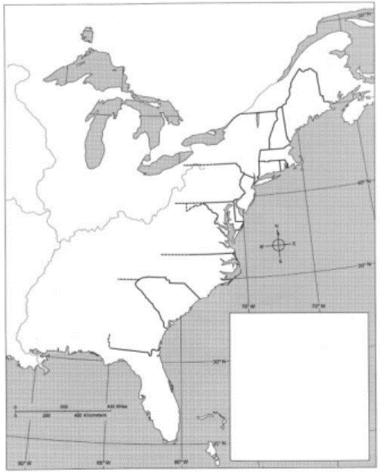
Identify the following:
- Proclamation Line of 1763
- Shay’s Rebellion
- Whiskey Rebellion
- Boston
- Lexington/Concord
- Saratoga
- Yorktown
- Northwest Territory
Key Concepts
3.1: Britain’s victory over France in the imperial struggle for North America led to new conflicts among the British government, the North American colonists, and American Indians, culminating in the creation of a new nation, the United States.
Key Concepts | At Least One Piece of Evidence to  Support the Concept
I. Throughout the second half of the 18th century, various American Indian groups repeatedly evaluated and adjusted their alliances with Europeans, other tribes, and the new United States government.
II. During and after the imperial struggles of the mid-18th century, new pressures began to unite the British colonies against perceived and real constraints on their economic activities and political rights, sparking a colonial independence movement and war with Britain.
III. In response to domestic and international tensions, the new United States debated and formulated foreign policy initiatives and asserted an international presence.
I Can… (circle all that apply) | Connect to Another Time Period | Provide Supporting Evidence | Explain the Main Idea | Identify the Key Terms

3.2: In the late 18th century, new experiments with democratic ideas and republican forms of government, as well as other new religious, economic, and cultural ideas, challenged traditional imperial systems across the Atlantic World.
Key Concepts | At Least One Piece of Evidence to  Support the Concept
I. During the 18th century, new ideas about politics and society led to debates about religion and governance, and ultimately inspired experiments with new governmental structures.
II. After experiencing the limitations of the Articles of Confederation, American political leaders wrote a new Constitution based on the principles of federalism and separation of powers, crafted a Bill of Rights, and continued their debates about the proper balance between liberty and order.
III. While the new governments continued to limit rights to some groups, ideas promoting self-government and personal liberty reverberated around the world.
I Can… (circle all that apply) | Connect to Another Time Period | Provide Supporting Evidence | Explain the Main Idea | Identify the Key Terms

3.3: Migration within North America, cooperative interaction, and competition for resources raised questions about boundaries and policies, intensified conflicts among peoples and nations, and led to contests over the creation of a multiethnic, multiracial national identity.
Key Concepts | At Least One Piece of Evidence to  Support the Concept
I. As migrants streamed westward from the British colonies along the Atlantic seaboard, interactions among different groups that would continue under an independent United States resulted in competition for resources, shifting alliances, and cultural blending.
II. The policies of the United States that encouraged western migration and the orderly incorporation of new territories into the nation both extended republican institutions and intensified conflicts among American Indians and Europeans in the trans-Appalachian West.
III. New voices for national identity challenged tendencies to cling to regional identities, contributing to the emergence of distinctly American cultural expressions.
I Can… (circle all that apply) | Connect to Another Time Period | Provide Supporting Evidence | Explain the Main Idea | Identify the Key Terms

