AP American Imperialism 7.1

Key Concept 7.3: Participation in a series of global conflicts propelled the United States into a position of international power while renewing domestic debates over the nation’s proper role in the world.
- In the late 19th century and early 20th century, new U.S. territorial ambitions and acquisitions in the Western Hemisphere and the Pacific accompanied heightened public debates over America’s role in the world.

AP 7.3.I.A Imperialists cited economic opportunities, racial theories, competition with European empires, and the perception in the 1890s that the Western frontier was “closed” to argue that Americans were destined to expand their culture and institutions to peoples around the globe.
Document 1
…Therefore, in this campaign, the question is larger than a party question. It is an American question. It is a world question. Shall the American people continue their march toward the commercial supremacy of the world? Shall free institutions broaden their blessed reign as the children of liberty wax in strength, until the empire of our principles is established over the hearts of all mankind? …
Shall we be as the man who had one talent and hid it, or as he who had ten talents and used them until they grew to riches? And shall we reap the reward that waits on our discharge of our high duty; shall we occupy new markets for what our farmers raise, our factories make, our merchants sell-aye, and please God, new markets for what our ships shall carry? …
… Hawaii is ours; Puerto Rico is to be ours; at the prayer of her people Cuba finally will be ours; in the islands of the East, even to the gates of Asia, coaling stations are to be ours at the very least; the flag of a liberal government is to float over the Philippines, and may it be the banner that Taylor unfurled in Texas and Fremont carried to the coast.
~March of the Flag, Albert Beveridge (1898)
American Imperialism
Toward the end of the nineteenth century, a growing number of citizens believed that the United States needed to look beyond its own borders and acquire more territory, such an attitude is known as imperialism. Many business leaders and politicians believed that US expansion was important because it would provide the country with more economic markets and greater potential for economic growth. Others backed imperialism because they felt that the United States needed to expand (or at least be capable of expansion) in order to maintain its national security. Still, others believed it was part of the country's destiny and crucial to maintaining a nationalist spirit (feeling of national
pride). Additionally, as European countries started to grab up colonies in both Asia as well as in Africa, there was a concern that America would ‘fall behind’ the rest of the world if we did not get colonies on our own. Finally, the closing of the western frontier, as articulated by Fredrick Jackson Turner’s Frontier Thesis, suggested that America needed to look for new outlets for its growth and industrial production.
Initially, most expansionists turned their attention towards the Pacific. Both political leaders and businessmen in the US wanted to trade with China and other nations in Southeast Asia. They saw the Pacific Ocean as the pathway to these markets. To promote unthreatened access to Southeast Asia, Secretary of State William Seward negotiated the purchase of Alaska from Russia in 1867 for $7.6 Million. Roughly thirty years later, the US annexed Hawaii as well. Not only was Hawaii home to Pearl Harbor (a potentially important naval base), it was also economically important. By acquiring Alaska and Hawaii, the US believed it helped open trade routes across the Pacific while, at the same time, gaining valuable territory.

AP 7.3.I.B Anti-imperialists cited principles of self-determination and invoked both racial theories and the U.S. foreign policy tradition of isolationism to argue that the U.S. should not extend its territory overseas.
Debate over Territorial Expansion
Yet, while more and more US citizens were advocating imperialism, Anti-Imperialists preached Isolationism. They believed that it was not in the best interest of the United States to acquire and exercise control over foreign territories. They felt that such acquisitions would inevitably pull the US into foreign conflicts. While some pointed to domestic concerns and believed that it was not economically nor politically wise to expand, others made the case that expansion contradicted the very principles of freedom and self-government on which the United States was founded. Still others voiced racial ideologies and were concerned that American expansion would lead to the inclusion of more non-white groups into the United States.

AP 7.3.I.C The American victory in the Spanish–American War led to the U.S. acquisition of island territories in the Caribbean and the Pacific, an increase in involvement in Asia, and the suppression of a nationalist movement in the Philippines.
Spanish-American War
In the late 1800s, the island of Cuba was still under Spanish rule. In 1895, the Cuban people rebelled, and Spain sent 150,000 troops to restore order. As part of their strategy, the Spanish relocated thousands of Cuban citizens to concentration camps. These camps had miserable conditions and many Cubans died. As pressure mounted for the US to intervene, competing newspapers printed stories about the Spanish abuses against the Cubans. Often exaggerated and untrue, these stories, called Yellow Journalism, were meant to sell papers rather than accurately report the facts. They also served to ignite the emotions of the US public and contributed to calls for war with Spain. One of the many voices calling for war was that of Assistant Secretary of the Navy Theodore Roosevelt. When war finally came, Roosevelt resigned his position to become a Lt. Colonel and command a group of volunteers known as the Rough Riders.
Document 2
DESTRUCTION OF THE WAR SHIP MAINE WAS THE WORK OF
AN ENEMY
Assistant Secretary Roosevelt Convinced the Explosion of the War
Ship Was Not an Accident.
The Journal Offers $50,000 Reward for the Conviction of the
Criminals Who Sent 258 American
Sailors to Their Death.
Naval Officers All Agree That the Ship Was Destroyed on Purpose.
NAVAL OFFICERS THINK THE MAINE WAS DESTROYED BY A
SPANISH MINE.

Source: New York Journal and Advertiser: February 17, 1898
The Spanish-American War officially began as a result of what happened on February 15, 1898. A US battleship, the USS Maine, exploded while anchored in a Cuban harbor. Immediately, the newspapers blamed Spain and US citizens demanded war. Although it was later determined that the explosion was most likely an accident, Congress adopted a resolution declaring war on Spain in April 1898. Upon hearing of the declaration of war, US Commodore George Dewey set sail for another Spanish colony, the Philippines. Destroying the Spanish fleet there, Dewey quickly seized control of the Philippine Islands. Meanwhile, in Cuba, Roosevelt won praise for leading the Rough Riders in bold charges up Kettle and San Juan Hills. This became the most famous incident of the war and helped the United States achieve victory over the Spanish. In less than three months, the United States had defeated Spain in both Cuba and the Philippines. To people in the US it seemed like a relatively easy victory. John Hay, the future secretary of state and good friend of Theodore Roosevelt, captured what most felt regarding the entire conflict when he referred to the taking of the Philippines as "a splendid little war."
The Spanish-American War officially ended with the signing of the Treaty of Paris (1898). Attached to Congress' 1898 war resolution with Spain was the Teller Amendment, which promised that the United States would allow Cuba to be independent and not annex the territory. However, to protect US business interests, President William McKinley installed a US military government for three years to restore stability. In 1900, when the Cubans began drafting their own constitution, the United States continued to exercise its influence by insisting that the document include the Platt Amendment. This amendment put limits on what the Cuban government could do, gave the US two naval bases in Cuba, and allowed for US intervention in the region whenever the United States believed it was necessary. The Platt Amendment stayed in effect until the early 1930s. Meanwhile, Puerto Rico, Guam, and the Philippines became US territories.
In the Philippines many had greeted the Americans as liberators and has assisted American forces in fighting the Spanish. However, when it became clear that the American forces were there to stay a Nationalistic Movement in the Philippines began led by Emilio Aguinaldo. The American military brutally suppressed this movement during the Philippine-American War which lasted from 1899-1902.
During this time there was much debate if citizenship followed the flag to now territories. The issue was resolved in favor of the imperialists in a series of Supreme Court cases (1901—1903) known as the insular (island) cases. The Court ruled that constitutional rights were not automatically extended to territorial possessions and that the power to decide whether or not to grant such rights belonged to Congress
Creation of the Panama Canal
Following the assassination of President William McKinley in 1901, Theodore Roosevelt became the 26th president of the United States, in order to increase trade between the Atlantic and Pacific Oceans, Roosevelt envisioned a canal across the Isthmus of Panama. This canal would serve US military and economic interests by allowing ships to travel back and forth between US territories in the Pacific and Atlantic without having to go around South America. Unfortunately for the president, the Colombian government which controlled the territory refused to sell or lease the land necessary for the project. Then, in 1903, the Panamanian people revolted against the Colombians. Roosevelt responded by providing US naval support that helped the Panamanians win their independence. In return, the Panamanians allowed the US to lease the land needed for the canal. Construction got underway in 1905, and, in 1914, workers completed the Panama Canal. The US continued to control the canal until President Jimmy Carter signed a treaty in 1977 authorizing the transfer of the canal to the Panamanians. Panama finally took full control of the Panama Canal in December 1999.

Roosevelt Corollary to the Monroe Doctrine
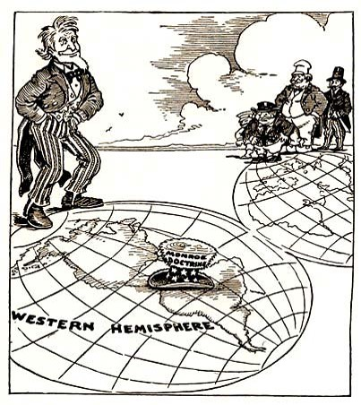
Document 3 Document 4
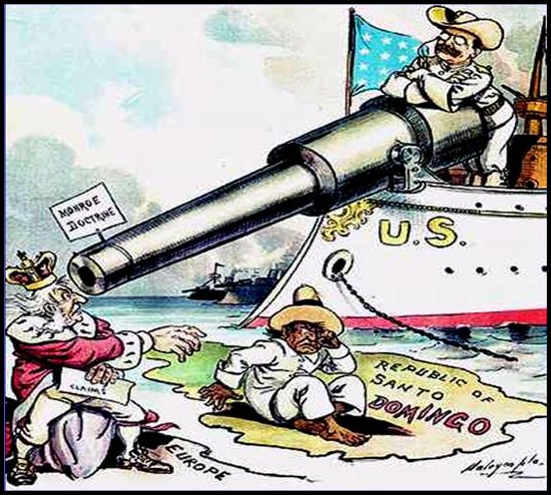
By the 1900s, the United States was becoming a major player in world affairs. In 1904, President Roosevelt issued Roosevelt's Corollary. It was a statement which expanded upon the Monroe Doctrine. Monroe had said that the US would not allow European powers to colonize newly independent nations in the Western Hemisphere, nor would the US interfere with such nations. Roosevelt modified this by saying that the US had the right to intervene in the region if a nation had trouble paying its debts. Roosevelt wanted to make sure that imperialist nations did not use debt collection as an excuse to occupy territories in the Caribbean or Latin America. This doctrine came to be known as Roosevelt's "big stick diplomacy.” The name came from a West African proverb which said, "Speak softly and carry a big stick." It meant that the US did not intend to be a threatening presence in the Western Hemisphere, but neither would it hesitate to forcefully protect its own interests.
Asian Foreign Policy
In the 1890s, Russia, Japan, Great Britain, France, and Germany had all established spheres of influence in China, meaning that they could dominate trade and investment within their sphere (a particular port or region of China) and shut out competitors.
To prevent the United States from losing access to the lucrative China trade, the US dispatched a diplomatic note in 1899 to nations controlling spheres of influence. It declared the concept of an Open Door Policy, by which all nations would have equal trading privileges in China.
As the 19th century ended, nationalism and xenophobia (hatred and fear of foreigners) were on the rise in China. In 1900, a secret society of Chinese nationalists—the Society of Harmonious Fists, or Boxers—attacked foreign settlements and murdered dozens of Christian missionaries. To protect American lives and property, U.S. troops participated in an international force that marched into Peking (Beijing) and quickly crushed the Boxer Rebellion. The countries forced China to pay a huge sum in indemnities, which further weakened the imperial regime.

