AP 7.3 World War I
World War I and its aftermath intensified ongoing debates about the nation’s role in the world and how best to achieve national security and pursue American interests.
A) After initial neutrality in World War I, the nation entered the conflict, departing from the U.S. foreign policy tradition of noninvolvement in European affairs, in response to Woodrow Wilson’s call for the defense of humanitarian and democratic principles.

U.S. Neutrality
At first, the United States did not get involved in World War I. In fact, in 1914, President Woodrow Wilson officially declared the United States neutral (not backing either side). Many in the United States believed in isolationism (the philosophy that the United States should stay out of international conflicts) and did not see a war in Europe as being of any concern to the US. Many citizens became peace activists during this period. Others supported a policy of "preparedness", which advocated neutrality while taking steps to prepare for war just in case it became necessary. US policy towards the war became the key issue in the 1916 election. Wilson narrowly won a second term running on the slogan, "He kept us out of war!"
Document Analysis 1
Property can be paid for; the lives of peaceful and innocent people cannot be. The present German submarine warfare against commerce is a warfare against mankind. The German policy has swept every restriction aside. Ships of every kind, whatever their flag, their character, their cargo, their destination, their errand, have been ruthlessly sent to the bottom of the ocean without warning. American ships have been sunk (The Lusitania), American lives taken.
I advise that the Congress declare the recent actions of the Imperial German Government to be, in fact, nothing less than war against the Government and people of the United States. Neutrality is no longer
Source: President Woodrow Wilson, in a speech before Congress, April 2, 1917.
Reasons for Entering World War I
Despite Wilson's original desire for neutrality, a number of factors eventually led to US involvement in the war. One of Germany's fiercest weapons in WWI was their dreaded U-boats. These were submarines that traveled under water and wreaked havoc in the Atlantic during the war. The Germans warned all nations that they would attack any ships entering or leaving British ports. President Wilson rejected the warning, arguing that no warring party could be allowed to disrupt neutral shipping on the high seas. In reality, however, the US was not entirely neutral. Unknown to passengers, the US had begun shipping military supplies to Great Britain aboard commercial cruise liners. One of these liners, the Lusitania, was torpedoed by a German U-boat in 1915. Twelve hundred people died in the attack, including 128 US citizens.
Unrestricted Submarine Warfare
People in the US were furious. A wave of anti-German feeling swept across the country. Not wanting to pull the United States into the war, Germany agreed not to attack anymore US passenger ships. However, in 1917, Germany resumed their attacks on merchant and commercial ships, moving the United States closer to war. The German's policy of attacking all ships was known as unrestricted submarine warfare. Although the Germans knew such a policy would encourage the US to enter the war against them, the fact that the Russians had dropped out of the fighting to deal with their own revolution led Germany to believe that it could rapidly defeat its remaining enemies before any US troops could reach Europe. They were wrong.
The Zimmerman Telegram
It was also in 1917 that the US intercepted the Zimmerman telegram. Arthur Zimmerman, the German Foreign Minister, sent a telegram to the German embassy in Mexico. In his telegram, Zimmerman told embassy officials to ask Mexico to attack the US if it declared war on Germany. In return, Germany promised to help Mexico win back land the US had acquired as a result of the Mexican-American War. As you might imagine, news of this communication did not go over well in the United States. Anti-German sentiment increased even more, and President Wilson broke off diplomatic relations with Germany. Likewise, more sinking of US ships meant that the United States could no longer stay neutral. In March 1917, Wilson made an idealistic case for war and proclaimed
that the world "must be made safe for democracy." Wilson wanted the US public to see the war as a battle between good and evil; he wanted the people to view it as a fight between democracy and tyranny. His appeals were well received. Congress passed a war resolution soon afterwards, and in April 1917, the United States officially entered World War I.

The increased demand for war production and labor during World War I and World War II and the economic difficulties of the 1930s led many Americans to migrate to urban centers in search of economic opportunities.

Document Analysis 2
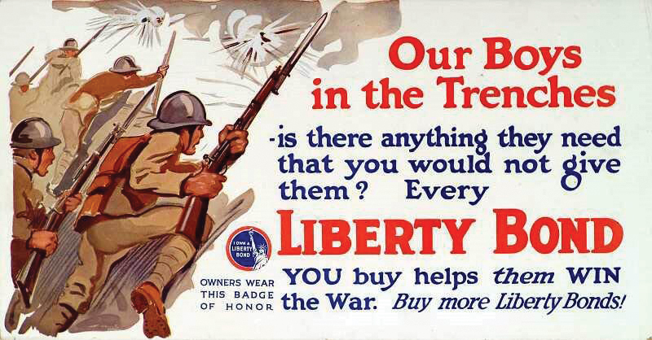

Domestic Impact of World War I
Mobilization
U.S. mobilization for war in 1917 was a race against time. Germany was preparing to deliver a knockout blow to end the war on German terms. Could the United States mobilize its vast economic resources fast enough to make a difference? That was the question Wilson and his advisers confronted in the critical early months of U.S. involvement in war. The Wilson administration, with Progressive efficiency, created hundreds of temporary wartime agencies and commissions staffed by experts from business and government.
Paying for the costly war presented a huge challenge. Wilson's war government managed to raise $33 billion in two years by a combination of loans and taxes. It conducted four massive drives to convince Americans to put their savings into federal government Liberty Bonds. Congress also increased both personal income and corporate taxes and placed an excise tax on luxury goods.
In a Great Migration during and after World War I, African Americans escaping segregation, racial violence, and limited economic opportunity in the South moved to the North and West, where they found new opportunities but still encountered discrimination.
Document Analysis 3
One-Way Ticket
I pick up my life and take it with me and I put it down in Chicago, Detroit, Buffalo,
Scranton, Any place that is North and East- and not Dixie.
I pick up my life and take it on the train to Los Angeles, Bakersfield, Seattle, Oakland,
Salt Lake, any place that is North and West-and not South.
I am fed up with Jim Crow Laws, people who are cruel and afraid.
By: Langston Hughes
The Great Migration
There was also an important social impact of the war. The nation's enlarged army needed supplies. The demand for products (weapons, supplies, uniforms, equipment, etc.), combined with the fact that many young men left their jobs to fight in the war meant that there were more jobs in northern cities where most of the nation's factories existed. As a result, many African Americans began leaving the South in growing numbers to pursue better economic opportunities and in hopes of escaping southern racism. This mass movement of African Americans from the predominantly rural South to northern cities continued for several decades. It became known as the Great Migration. (Migration is when people move from one part of a country to another).

Official restrictions on freedom of speech grew during World War I, as increased anxiety about radicalism led to a Red Scare and attacks on labor activism and immigrant culture.
The Espionage and Sedition Acts
Although the fighting took place overseas, World War I had a huge effect on life in the US. For starters, the war in Europe meant an increased role for government in the United States. Many (but not all) progressives embraced the war because it finally gave government the support and justification it needed to seize more control. The federal government also passed a number of laws limiting freedom. In the name of protecting national security, Congress passed the Espionage and Sedition Acts. These acts made it illegal to interfere with the draft, obstruct the sale of Liberty Bonds, or make statements considered disloyal to, or critical of, the government, the Constitution, or the US military. Socialist leader, Eugene Debs, was actually sentenced to ten years in prison under these laws for criticizing the US government.

Although the American Expeditionary Forces played a relatively limited role in combat, the U.S.’s entry helped to tip the balance of the conflict in favor of the Allies.

Fighting the War

By the time the first U.S. troops were shipped overseas in late 1917, millions of European soldiers on both sides had already died in trench warfare made more murderous in the industrial age by heavy artillery, machine guns, poison gas, tanks, and airplanes. A second revolution in Russia by Bolsheviks (or Communists) took that nation out of the war. With no Eastern Front to divide its forces, Germany concentrated on one all-out push to break through Allied lines in France.

American Expeditionary Force
Unable to imagine the grim realities of trench warfare, U.S. troops were eager for action. The American Expeditionary Force (AEF) was commanded by General John J. Pershing. The first U.S. troops to see action were used to plug weaknesses in the French and British lines, but by the summer of 1918, as American forces arrived by the hundreds of thousands, the AEF assumed independent responsibility for one segment of the Western Front. Offensive Enough U.S. troops were in place in spring 1918 to hold the line against the last ferocious assault by German forces. At Château-Thierry on the Marne River, Americans stopped the German advance (June 1918) and struck back with a successful counterattack at Belleau Wood.

In August, September, and October, an Allied offensive along the Meuse River and through the Argonne Forest (the Meuse—Argonne offensive) succeeded in driving an exhausted German army backward toward the German border. U.S. troops participated in this drive at St. Mihiel—the southern sector of the Allied line. On November 11, 1918, the Germans signed an armistice in which they agreed to surrender their arms, give up much of their navy, and evacuate occupied territory.

After only a few months of fighting, U.S. combat deaths totaled nearly 49,000. Many more thousands died of disease, including a flu epidemic in the training camps, bringing total U.S. fatalities in World War I to 112,432.

Despite Wilson’s deep involvement in postwar negotiations, the U.S. Senate refused to ratify the Treaty of Versailles or join the League of Nations.
Wilson’s Fourteen Points
In January 1918, President Wilson spoke to Congress about the war aims of the nation. His plan ultimately became known as the Fourteen Points and was designed to create a lasting peace in the world. Once negotiations for the Treaty of Versailles were completed in June 1919, the United States was divided over whether to join the League of Nations –( Nations joining together to keep the peace).
Wilson’s Fourteen Points became a guide for the negotiations at Versailles to secure peace after World War I. Some of Wilson's suggestions were accepted, some modified, and some rejected by the countries represented at the peace conference. The Fourteen Points included the following:
- Open diplomacy (no more secret treaties
- Freedom of the seas
- End international trade barriers
- Reduce armaments
- Impartial dealing with colonies and their natives
- Create an international organization, the League of Nations, to help keep the peace (THIS WAS POINT 14 of the plan)
Document Analysis 3
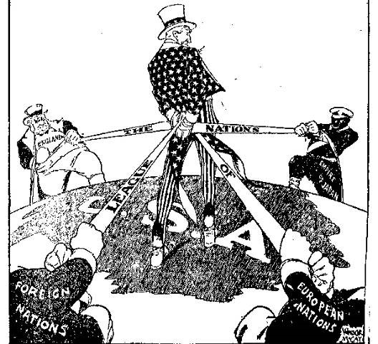
Wilson’s Fourteen Points (Continued)
During the postwar treaty negotiations, Wilson worked hard to get as many of his Fourteen Points as possible included in the treaty. The Fourteenth Point, which proposed a League of Nations, was one that President Wilson was particularly committed to securing for world peace. After much negotiation, the League of Nations was included in the final provisions of the Treaty of Versailles. The treaty drafted at Versailles had to be ratified by the United States Senate as the final step for implementation in the United States.
Although Wilson believed strongly in the League of Nations, there was significant opposition to the concept among many Americans. Public opposition to the League of Nations ultimately led the Senate to vote against ratification of the treaty. Isolationists in the Senate believed that by joining the League of Nations, the United States would be obligated to get involved in future European conflicts.
One of the most vocal critics of the League was Senator Henry Cabot Lodge. Lodge was a Republican and Wilson was a Democrat. They held different ideas about the role the United States should take in world affairs. Lodge was a powerful and respected Senator who served as his party’s majority leader and was on the Senate Foreign Relations Committee. Lodge, and others from his party, believed that he should have been involved in the treaty’s negotiations.
After the War
As millions of American men returned from Europe, American still faced many problems at home. Many of the African American and Women who had found work in wartime factories soon found that they had been laid off as white male workers returned home from abroad. The migration of African Americans to northern cities during the war increased racial tensions. Whites resented the increased competition for jobs and housing. During the war, race riots had erupted, the largest in East St. Louis, Illinois, in 1917. In 1919, racial tensions led to violence in many cities. The worst riot was in Chicago, where 40 people were killed and 500 were injured. Conditions were no better in the South, as racial prejudice and fears of returning African American soldiers led to an increase in racial violence and lynchings by whites.
In 1919, the country suffered from a volatile combination of unhappiness with the peace process, fears of communism fueled by the Communist takeover in Russia, and worries about labor unrest at home. The anti-German hysteria of the war years tumed quickly into anti-Communist hysteria known as the Red Scare. These anti-radical fears also fueled xenophobia that resulted in restrictions on immigration in the 1920s.
A series of unexplained bombings caused Attorney General A. Mitchell Palmer to establish a special office under J. Edgar Hoover to gather information on radicals. Palmer also ordered mass arrests of anarchists, socialists, and labor agitators. In the Palmer Raids from November 1919 through January 1920, over 6,000 people were arrested, based on limited criminal evidence. Most of the suspects were foreign born, and 500 of them, including the outspoken radical Emma Goldman, were deported.

