Kennedy and Johnson Administration 11.1

SSUSH21 Analyze U.S. international and domestic policies including their influences on technological advancements and social changes during the Kennedy and Johnson administrations
a. Analyze the international policies and actions taken as a response to the Cold War including U.S. involvement in Cuba and the escalation of the war in Vietnam as a result of the Gulf of Tonkin Resolution.
Cold War: US. Involvement in Cuba
During the 1950s, a young revolutionary named Fidel Castro rose to fame as the leader of the Cuban Revolution. The revolution overthrew the Cuban government led by Fulgencio Batista in 1959 and made Castro the communist leader of the country. Castro executed more than 700 of his opponents and jailed many more. His government also seized control of much of the land and property in the country. Discovering that Castro had ties to the Soviet Union and that he had seized US property in Cuba, President Eisenhower refused to support the new dictator and broke off diplomatic relations. With US support lacking, Castro allied himself with the Soviet Union. Eisenhower then authorized the CIA (Central Intelligence Agency) to begin training anti-Castro Cuban exiles for an invasion of Cuba. When John F. Kennedy succeeded Eisenhower as president in 1961, he approved the operation and authorized the CIA to continue as planned. The Bay of Pigs Invasion began on April 17, 1961. It turned out to be a terrible failure and a huge embarrassment for the Kennedy administration. It also left many around the world wondering if the young president was up to the task of defending democracy against communism.
Document Analysis 1
Although the Bay of Pigs had been a failure, Castro still feared a future invasion by US forces. Knowing he needed a strong ally, Castro allowed the Soviets to secretly put nuclear missiles in Cuba, just 90 miles off the coast of Florida. When US spy planes spotted these missiles in October 1962, Kennedy responded by authorizing a naval blockade of the island. For 13 days, the world watched as the Cuban Missile Crisis brought the two superpowers to the brink of nuclear war. Finally, after heated arguments in the UN and much diplomatic maneuvering, Khrushchev agreed to withdraw the missiles in exchange for a US pledge not to invade Cuba, in addition, the US also offered the Soviets a secret assurance that it would eventually remove US missiles stationed in Turkey as well.
Vietnam War
The Vietnam War was a struggle for control of Vietnam. While the conflict originally began during the French colonial rule in the region, the United States became involved in the 1950s by providing economic and limited military aid. Following French withdrawal in 1954, Vietnam was divided, with communist forces in the North and a pro-Western regime in control of the South. Then, in the early 1960s, U.S. involvement began to increase; it lasted until the early 1970s. The democratic government of South Vietnam, supported by the United States, battled communist North Vietnam and a military organization called the Vietcong. U.S. policymakers believed that if Vietnam came to be ruled by a communist government, communism would spread throughout Southeast Asia and perhaps beyond.
In early August 1964, two U.S. destroyers stationed in the Gulf of Tonkin in Vietnam radioed that they had been fired upon by North Vietnamese forces. In response to these reported incidents, President Lyndon B. Johnson requested permission from the U.S. Congress to increase the U.S. military presence in Indochina. On August 7, 1964, Congress passed the Gulf of Tonkin Resolution, authorizing President Johnson to take any measures he believed were necessary to retaliate and to promote the maintenance of international peace and security in southeast Asia. This resolution became the legal basis for the Johnson and Nixon Administrations prosecution of the Vietnam War.
Document Analysis 2
“I was in Vietnam when I first heard about the thousands of people protesting the war in the streets of America. I didn’t want to believe it at first-people protesting against us when we were putting our lives on the line for our country. The men in my outfit used to talk about it a lot. How could they do this to us? Many of us would not be coming back and many others would be wounded or maimed. We swore they would pay, the hippies and draft card burners. They would pay if we ever ran into them.
But the hospital had changed all that. It was the end of whatever belief I’d still had in what I’d done in Vietnam. Now I wanted to know what I had lost my legs for, and why others had gone at all. But it was still very hard for me to think of speaking out against the war, to think of joining those I’d once called traitors.”
Source: Ron Kovic, Born on the Fourth of July
The Vietcong continually frustrated U.S. forces with its ability to use the region’s thick jungles to conduct guerrilla warfare. In 1968, the Vietcong and North Vietnamese army started the eight-month-long Tet Offensive. It was the Vietcong’s largest and most damaging campaign of the entire war. Ultimately, the Tet Offensive failed to achieve its goal of driving the Americans out of Vietnam, but it did lead many people in the United States to question why Johnson had told them America was winning the war. This led some Americans who had been quiet up until then to raise their voices in protest against the war. Many college campuses were home to groups formed to protest American involvement in Vietnam. The goals of these groups differed, but most favored ending the draft and removing all American troops from Vietnam.

b. Connect major domestic issues to their social effects including the passage of civil rights legislation following the assassination of John F. Kennedy, and Johnson’s Great Society.
Assassination of John F. Kennedy
The assassination of President Kennedy in Dallas, Texas, in November 1963, was a tragic event with a twofold political impact.
1. The assassination showed Americans just how strong their government was because, although the president could be killed, the U.S. government would live on.
2. The assassination gave the new president, Lyndon Johnson, the political capital to force Kennedy's Civil Rights and Voting Rights Acts through Congress.
Document Analysis 3
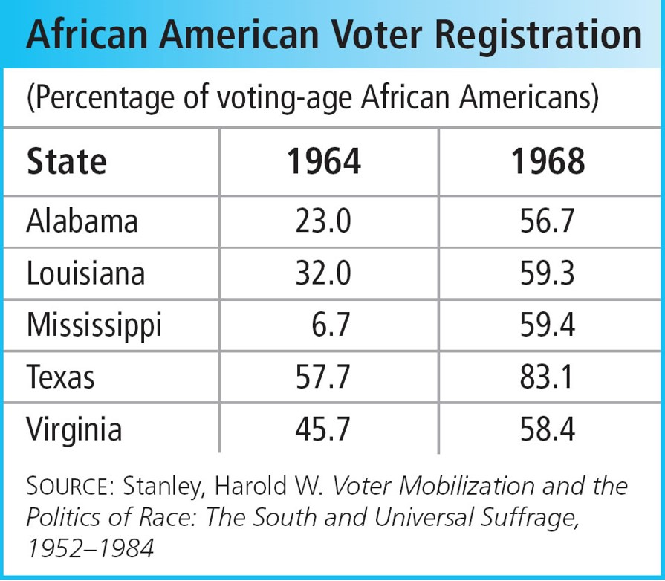
John F. Kennedy's Civil Rights Legislation
After the Martin Luther King March on Washington, President John F. Kennedy proposed new civil rights laws. However, on November 22, 1963, an assassin by the name of Lee Harvey Oswald shot and killed the president in Dallas as he rode in an open car with the first lady and the governor of Texas. The death of the young president left the nation stunned and in mourning. The new president, Lyndon B. Johnson, strongly urged the House and Senate to pass the civil rights legislation proposed by Kennedy. Despite fierce opposition from southern members of Congress, Johnson pushed through the Civil Rights Act of 1964. The act prohibited segregation in public accommodations (hotels, restaurants, theaters) and discrimination in education and employment. It also gave the president the power to enforce the new law. 1964 was also the year that the states ratified the Twenty-fourth Amendment to the Constitution. This amendment served to protect blacks' voting rights by making the poll tax illegal. Congress passed another key piece of legislation in 1965. That year, protesters in Selma, Alabama decided to bring national attention to the cause of civil rights by marching 50 miles to the state's capital in Montgomery. The march occurred on March 7, 1965. When the 500 marchers reached Selma's city limits, 200 state troopers and sheriff's deputies beat them with clubs and whips, released dogs on them, and showered them with tear gas. Televised scenes of the violence shocked people nationwide and increased support for the civil rights movement. The event became known as "Bloody Sunday" and was called an "American tragedy" by President Johnson. Thousands of whites and blacks descended on Selma to continue the march. Two weeks after "Bloody Sunday, "Martin Luther King, Jr. led more than 3,000 marchers out of Selma, including a core of 300 people who walked the entire journey. Four days later, they arrived in Montgomery, where King addressed a rally of nearly 40,000 people in front of the capitol building. Soon after, on August 6, 1965, President Johnson signed the Voting Rights Act of 1965. It authorized the president to suspend literacy tests for voter registration and to send federal officials to register voters in the event that county officials failed to do so. This new law led to a huge increase in African American voter registration, as well as an increase in the number of African-American candidates elected to public office
Lyndon B. Johnson's Great Society
Following John Kennedy's assassination, Lyndon Johnson became the country's thirty-sixth president. In addition to pushing Kennedy's proposed civil rights legislation through Congress, Johnson also set out to implement what he called the "Great Society." In addition to civil rights, it consisted of various proposed social programs and centered greatly around Johnson's declared "War on Poverty." Thanks to decades in Washington and years as the Democratic leader in the Senate, Johnson was more gifted at political dealings and had more success pushing his programs through Congress than his predecessor. The Economic Opportunity Act combated poverty and set aside money to establish VISTA (Volunteers in Service to America). VISTA mobilized volunteers to work in poorer communities within the United States. It also established Job Corps for the purpose of educating and training inner city youth for gainful employment. Other "Great Society" programs included Head Start to help ensure better education for children of low-income families; the National Endowment for the Humanities, which gives grants and funding for the arts and scholarships; and establishment of the Department of Housing and Urban Development (HUD). HUD oversees housing needs, rehabilitates urban communities, and provides rent assistance to those living in low-income housing. It was initially headed by Robert C. Weaver, the first African American ever appointed to a presidential cabinet.
Finally, Medicare and Medicaid were two of Johnson's most important innovations. Medicare is a program funded by the federal government and is meant to provide medical coverage for the elderly. Meanwhile, Medicaid is health care partially funded by the federal government and partially funded by the states. Its purpose is to ensure medical care for lower-income families. While the Great Society had noble intentions and some successes, it also required large amounts of money. Many came to resent these programs because of what they saw as excessive costs and limited returns. As a result, political conservatism began to increase towards the latter half of the 1960's.

