World War II 10.1

SSUSH19 Examine the origins, major developments, and the domestic impact of World War II, including the growth of the federal government.
a. Investigate the origins of U.S. involvement in the war including lend-lease and the Japanese attack on Pearl Harbor.
U.S. Enters World War II: Lend-Lease Act
On March, 11, 1941––Nine months before Pearl Harbor, Congress passed the Lend-Lease Act and amended the Neutrality Acts so the United States could lend military equipment and supplies to any nation the president said was vital to the defense of the United States. Roosevelt approved $1 billion in Lend-Lease aid to Great Britain in October 1941. When the United States entered World War II, $50 billion worth of equipment and supplies had already been sent to Britain, France, the Soviet Union, and China.
Document Analysis 1
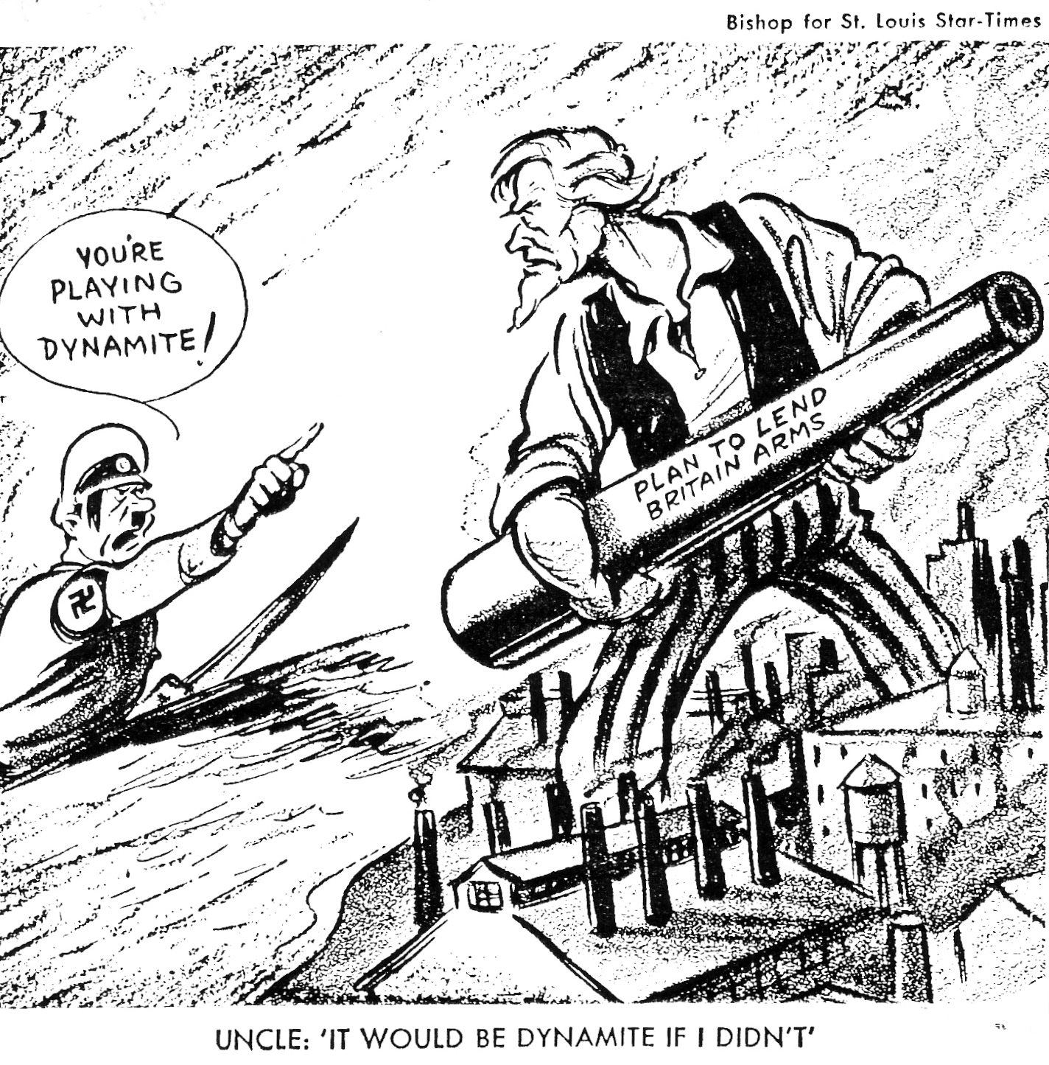
U.S. Enters World War II: Japanese Attack on Pearl Harbor
While Adolf Hitler steamrolled through Europe, the United States also had one eye on Japan. In response to Japan's military actions in the Pacific, the US imposed an embargo (refusal to ship certain products to a country) on oil and steel. Japan's leaders then set their sights on the rich natural resources of the Dutch East Indies. Before Japan could after the territories it wanted, however, it had to deal with one major problem: the US naval fleet anchored at Pearl Harbor, Hawaii. Although he doubted Japan's ability to win a war with the United States, Japanese Admiral Isoroku Yamamoto knew that his country was determined to expand. He developed an all but impossible plan to sail six aircraft carriers (huge ships that carry war planes) across the Pacific undetected and launched a surprise attack on Pearl Harbor. Maintaining radio silence the entire way, the Japanese ships reached their destination as planned. U.S. intelligence knew that the Japanese were planning an attack of some kind; they just didn't know where. Believing that the waters of Pearl Harbor were too shallow for planes to drop torpedoes (explosive devices that hit the water and then are propelled towards a target), they focused on the Philippines and the threat of sabotage (people trying to damage US military equipment, such as planes parked in hangers). A few minutes before 8 a.m. on December 7, 1941, Japanese airplanes began the first wave of bombings on the Pacific fleet at Pearl Harbor. United States military personnel actually detected the incoming planes on radar but ignored them because they thought they were US planes flying in from the mainland. In less than two hours, the Japanese air attack sank or seriously damaged a dozen naval vessels, destroyed almost 200 warplanes, and killed or wounded nearly 3,000 people. The next day, President Roosevelt emotionally described December 7 as "a day which will live in infamy!" Both houses of Congress approved a declaration of war against Japan and later against Germany and Italy as well. Suddenly, the US was plunged into the middle of World War II.
b. Examine the Pacific Theater including the difficulties the U.S. faced in delivering weapons, food, and medical supplies to troops, the Battle of Midway, the Manhattan Project, and the dropping of the atomic bombs.
Pacific Theater: The Battle of Midway
Within hours of the attack on Pearl Harbor, Japan also attacked the Philippines, destroying nearly half of the US airplanes stationed there. A few days later, Japanese forces invaded and eventually took the islands. More than 75,000 U.S. soldiers and Filipinos became prisoners of war as a result. Forced to walk roughly 60 miles to trains waiting to carry them to prisoner of war camps, many of these prisoners died from injuries, sickness, and harsh treatment along the way. The horrid event was labeled the Bataan Death March and those held responsible for it were eventually tried as criminals after the war. The war in the Pacific had gotten off to a disastrous start for the United States. Not only was one of its most gifted military leaders, General Douglas MacArthur, forced to abandon the Philippines, but the attack at Pearl Harbor badly damaged its Pacific Fleet. Fortunately for the U.S., the aircraft carriers that the Japanese had hoped to destroy in the attack were not in port on December 7 and were still functioning. This proved to be crucial as the United States tried to turn the tide of the war in the Pacific.
Japanese General Admiral Yamamoto, considered a military genius for orchestrating the attack on Pearl Harbor, felt that the remainder of the US Pacific Fleet must be destroyed if Japan had any hope of winning the war. He hoped to meet the U.S. Navy in a decisive battle before it could fully recover from Pearl Harbor. The Battle of Midway in June 1942 proved to be a turning point in the war. This time, it was the Japanese who failed to detect the location of its enemy's aircraft carriers and US planes were able to attack the Japanese as they were still attempting to load bombs onto their planes. Midway greatly boosted the morale of the United States' Pacific forces and allowed the US to finally go on offense in its war with Japan. The United States decided to advance on Japan from two directions. The first path was across the central Pacific under Admiral Chester Nimitz. The second was from the south under General MacArthur and Admiral William Halsey and involved an invasion of the Philippines. MacArthur argued strongly for such an invasion because he had publicly sworn he would return to liberate the islands after being ordered to abandon them at the war's outset. The United States then began a process of island hopping, in which it attacked and conquered one group of islands, then moved on to the next as its forces made their way to Japan. In the South, MacArthur reached the Philippines and, in dramatic fashion, waded ashore before rolling news cameras to proclaim, "People of the Philippines, I have returned." As US troops fought their way inland, the largest naval battle in history raged off shore in the Battle of Leyte Gulf. In desperation, the Japanese turned to the use of kamikaze pilots to try and avoid defeat. Kamikazes were pilots who committed suicide by intentionally crashing their planes into US ships in an attempt to sink them. Meanwhile, Nimitz's forces won key battles at Guadalcanal, Iwo Jima, and Okinawa. Each battle was extremely fierce and bloody. Although overpowered, Japanese soldiers often preferred fighting to the death rather than surrendering.
Pacific Theater: The Manhattan Project
The capture of Okinawa cleared the way for an invasion of Japan that would end the war. The invasion never happened. Soon after entering the war, the U.S. began work on developing the atomic bomb. The top secret endeavor was called the Manhattan Project. J. Robert Oppenheimer headed the project and most of the development took place in laboratories at Los Alamos, New Mexico. On July 16, 1945, scientists tested the new weapon in the New Mexico desert. The flash was blinding and the explosion so great that it shattered windows 125 miles away. Meanwhile, the new president, Harry S. Truman, was at the Potsdam Conference discussing postwar policies with Prime Minister Winston Churchill and Joseph Stalin. Among the conditions of the Potsdam Declaration, the allied leaders restated their policy of "unconditional surrender." In other words, the Allies would only accept a surrender in which the Allies dictated the terms of peace without the defeated Japanese insisting on any conditions. When the Japanese refused to surrender unconditionally, but instead insisted that they be given a guarantee that the position of the Emperor would be protected, Truman authorized the use of the bomb. On August 6, 1945, a specially equipped B29 bomber called the Enola Gay, dropped the first atomic bomb on Hiroshima, Japan. The blast leveled the city and killed thousands of civilians and military personnel. Many more died later from radiation released in the blast. Two days later, the Soviet Union declared war on Japan and invaded Manchuria. When Japan delayed in issuing its surrender, the U.S. dropped another bomb on August 9 on the city of Nagasaki. In the face of the massive death and destruction caused by these attacks, and with the Soviet Union now involved in the fighting, Japan finally surrendered on August 14, 1945. World War II was over. The next day the US celebrated V-J Day (Victory over Japan Day). Although the world was shocked by the power of the atomic bomb, Truman defended his decision to use it. He pointed out that by dropping the bomb, an invasion of Japan had been avoided, thereby saving the lives of
Allied soldiers.
c. Examine the European Theater including difficulties the U.S. faced in delivering weapons, food, and medical supplies to troops, D-Day, and the Fall of Berlin.
European Theater: D-Day
Three days after Pearl Harbor, Germany and Italy also declared war on the United States. By this time, Hitler had attacked the Soviet Union and was at war with Stalin as well. The United States, Great Britain, and the Soviet Union now stood together as the Allied Powers along with several other nations. After driving the Axis forces out of North Africa and taking parts of Italy, the Allies launched plans for a massive invasion of Western Europe.
The three leaders, Roosevelt, Churchill, and Stalin finally met in December 1943. Because the Soviets had lost millions of lives fighting Germany in Eastern Europe, Stalin desperately wanted the Allies to launch an invasion of France and create a second front against Hitler in Western Europe. After initially being reluctant, the US and Britain finally agreed. They appointed US General Dwight D. Eisenhower to serve as the supreme allied commander in charge of planning Operation Overlord. The operation involved hundreds of thousands of troops and called for the largest amphibious invasion (invasion in which soldiers invade from the sea rather than by crossing borders over land) in military history. The date of the invasion, June 6, 1944, became known as D-Day. Hitting the beaches at Normandy, France, the first soldiers ashore received overwhelming gunfire. Despite suffering heavy losses, it took the Allies less than a week to get over 500,000 troops ashore. From their established foothold, these forces were able to advance further into France. From France, the U.S. and allied forces could supply European theater troops with weapons, food, and medical supplies. On August 25, 1944, the Allies fought their way into Paris, liberating the city from four years of German occupation.
European Theater: Fall of Berlin
The Fall of Berlin lasted from April–May 1945. The Fall of Berlin was one of the final battles of the European theater during World War II. Two Soviet army groups attacked Berlin from the east and south, while a third attacked German forces north of Berlin. The Soviets lost 81,116 men taking the city, while the Germans lost 458,080 trying to defend it. It was one of the bloodiest battles in history. Adolf Hitler was in Berlin during the battle and, before it ended, he and many of his followers committed suicide. The city’s defenders surrendered on May 2, but fighting continued outside the city until the war ended on May 8. On May 8, 1945 Allied forces celebrated V-E Day (victory in Europe) to mark the formal acceptance by Allies of World War II and Nazi Germany's unconditional surrender of its armed forces. Much of the continued fighting was due to the Germans trying to move westward so they could surrender to the Americans or British instead of to the Soviets.
d. Investigate the domestic impact of the war including war mobilization as indicated by rationing, wartime conversion, and the role of women and blacks.
Document Analysis 2
Document A | Document B | Document C
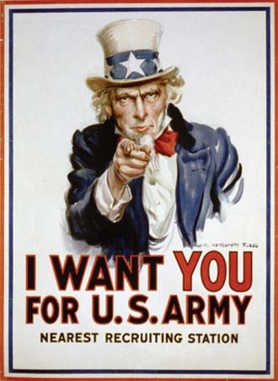 | 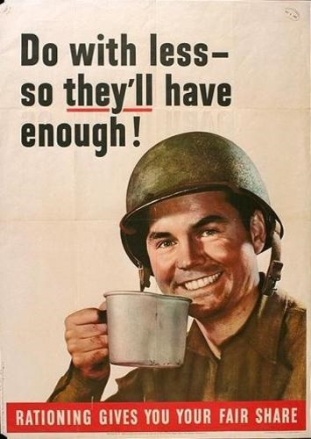 | 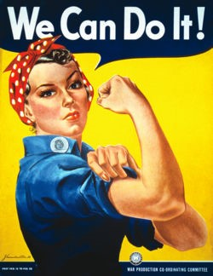
War Mobilization
The government realized that it needed to maintain strong public support for the war in order to successfully defeat the Axis nations. It recognized that a sense of patriotism and high national morale would be crucial. The government paid artists to design patriotic war posters, and movie theaters began playing newsreels depicting the US war effort in a positive light. Ads depicting patriotic themes in magazines and on radio broadcasts also became common. War meant that the United States' economy had to switch from peacetime to wartime as quickly as possible. To oversee this transformation, President Roosevelt established the War Production Board (WPB). This board redirected raw materials and resources from the production of civilian consumer goods to the production of materials needed for waging war against Germany and Japan. The economic result of the war was that the US economy boomed and people's standard of living increased. Unemployed men, women and African Americans now found themselves employed either as soldiers or in industries producing goods needed for the war effort. Others began migrating to northern cities and out west to fill the jobs needed for wartime production. As a result, the population of states like California, Arizona, Nevada, Texas, and Washington increased rapidly during the war.
Wartime Conversion and Rationing
In addition to money, the government also called on people to ration their resources. People started growing victory gardens of their own so that more food could be sent to feed the soldiers. The government also started a program of rationing (conserving resources) by which it could control how certain resources were distributed. In 1941, the government began rationing tires. Two years later, certain items were assigned points values. Once a citizen used up all their points, they could no longer obtain these items until they acquired more. In this way, the government forced the public to conserve resources that were needed to support the war effort.
Role of Women
With so many U.S. men going off to fight, women became an important part of the workforce at home. Women of all cultural and racial backgrounds stepped forward to take on jobs traditionally held by men. A popular song of the day was called Rosie the Riveter. It described a woman who worked in the factory as a riveter while her boyfriend served in the marines. Rosie the Riveter became the symbol of those women who entered the workforce to fill the gap left vacant by men serving in the war.
e. Examine Roosevelt’s use of executive powers including the integration of defense industries and the internment of Japanese-Americans.
Document Analysis 3
The Call to Negro America to March on Washington (1941), A. Philip Randolph
we propose that ten thousand Negroes MARCH ON WASHINGTON FOR JOBS IN NATIONAL DEFENSE AND EQUAL INTEGRATION IN THE FIGHTING FORCES OF THE UNITED STATES.
An "all-out" thundering march on Washington, ending in a monster and huge demonstration at Lincoln's Monument will shake up white America.
It will shake up official Washington.
It will give encouragement to our white friends to fight all the harder by our side, with us, for our righteous cause.
It will gain respect for the Negro people.
It will create a new sense of self-respect among Negroes. But what of national unity?

We believe in national unity which recognizes equal opportunity of black and white citizens to jobs in national defense and the armed forces, and in all other institutions and endeavors in America. We condemn all dictatorships, Fascist, Nazi and Communist. We are loyal, patriotic Americans all.
Source: From A. Philip Randolph, "Call to Negro America to March on Washington for Jobs and Equal Participation in National Defense," Black Worker 14 (May 1941)
Roosevelt’s Use of Executive Power: Integration of Defense Industries
In 1941, A. Philip Randolph, the founder of the Brotherhood of Sleeping Car Porters, proposed a march on Washington, D.C., to protest discrimination in the military and in industry. He called on African Americans from all over the United States to come to Washington and join him. President Roosevelt, afraid the march might cause unrest among whites, summoned Randolph to the White House and asked him to call off the march. When Randolph refused, Roosevelt issued Executive Order 8802 that called on employers and labor unions to cease discrimination in hiring practices in industries related to defense. As a result of Roosevelt’s actions, the march was canceled.
Roosevelt’s Use of Executive Power: Internment of Japanese-Americans
The Japanese attack on Pearl Harbor fueled suspicion and fear among US citizens. Many suspected that Japanese, German, and Italian Americans would end up supporting the Axis Powers. As a result, thousands of such citizens were forced to relocate to internment camps. These camps tended to be located in remote areas and were meant to keep potentially threatening citizens in an isolated location where the government could keep an eye on them. Although many German and Italian Americans were unjustly interned as well, Japanese Americans suffered the most. Roosevelt then issued Executive Order 9066, this US military order forced more than 100,000 Japanese Americans from their homes and businesses during the war and placed them in one of the various camps. A great number of these Japanese Americans lost everything as a result. Many of them were US citizens who had lived in the United States for several generations. Others had been born in the US to parents who had immigrated from Japan. In 1944, the US Supreme Court ruled that the government internment of Japanese Americans was lawful and justified due to "...the military urgency of the situation." Eventually, in 1983, the United States government formally recognized the injustice that had been done and authorized payments of $20,000 each to all living Japanese Americans who had suffered under this policy.

