The New Deal 9.3

SSUSH18 Evaluate Franklin D. Roosevelt’s New Deal as a response to the Great Depression and compare how governmental programs aided those in need.
a. Describe Roosevelt’s attempts at relief, recovery, and reform reflected in various New Deal programs.
Document Analysis 1
Relief: immediate action taken to halt the economies deterioration.
Recovery: “Pump-priming” temporary programs to restart the flow of consumer demand
Reform: Permanent programs to avoid another depression and insure citizens against economic disasters
Source: The 3r's of Franklin Roosevelt's New Deal Plan
The New Deal
In 1932, the nation elected Democrat Franklin Delano Roosevelt (FDR), president of the United States by an overwhelming majority. With a broad smile and optimistic demeanor, FDR was a much-needed image of hope for a nation battered by the Great Depression. He became the first president to effectively use radio to his advantage. Speaking directly to the nation in a series of "fireside chats," Roosevelt helped instill confidence and even succeeded in getting many people to redeposit their money in banks. Unlike his predecessors, he was also ready to experiment with government actions to deal with the nation's crisis. Roosevelt believed that the country needed the government to provide direct relief (federal help to those hurting from the financial crisis). Many economists and politicians argued that the economy would eventually be OK if government left it alone. Roosevelt believed that this policy had already proven to be a failure and was willing to engage in deficit spending (government spending of borrowed money) to help get the US economy moving in the right direction. To do this, Roosevelt introduced new legislation and a number of programs known collectively as the New Deal. The period from FDR's inauguration in March 1933 through the following June became known as the first hundred days. During this time, Roosevelt pushed program after program through Congress in an effort to provide economic relief and recovery.

b. Explain the passage of the Social Security Act as a part of the second New Deal.
Second New Deal
After showing cautious restraint through much of 1934, FDR chose to launch a bold new set of programs that came to be called the Second New Deal. One of the most significant Second New Deal programs was the Social Security Act. Social Security Act passed in 1935, this act established old age insurance (retirement income) for all workers once they reach the age of 65. It also provided benefits to certain unemployed workers (unemployment insurance). The act also provide disability insurance for citizens who are unable to work. Today, Social Security is the only New Deal program still around today. It continues to pay retirement benefits to those over the official age of retirement. One of its architects was Frances Perkins. As Roosevelt's secretary of labor, she was the first woman in history to be appointed to a US president's cabinet. Revenue Act of 1935, this law raised taxes on those making above $50,000/year as well as corporate and estate taxes. It won the favor of many on the left and was nicknamed the "soak the rich tax."

c. Analyze political challenges to Roosevelt’s leadership and New Deal programs.
New Deal Challenges: Huey Long
Document Analysis 2
Now, my friends, when this condition of distress and suffering among so many millions of our people began to develop in the Hoover administration (Great Depression), we knew then what the trouble was and what we would have to do to correct it. I was the first man to say publicly -- but Mr. Roosevelt followed in my tracks a few months later and said the same thing. We said that all of our trouble and woe was due to the fact that too few of our people owned too much of our wealth. We said that in our land, with too much to eat, and too much to wear, and too many houses to live in, too many automobiles to be sold, that the only trouble was that the people suffered in the land of abundance because too few controlled the money and the wealth and too many did not have money with which to buy the things they needed for life and comfort.
So I said to the people of the United States in my speeches which I delivered in the United States Senate in the early part of 1932 that the only way by which we could restore our people to reasonable life and comfort was to limit the size of the big man's fortune and guarantee some minimum to the fortune and comfort of the little man's family
Source: Huey Long’s “Share the Wealth” Speeches Part One, March 1935
While many US citizens applauded FDR's New Deal as a sign of hope, Roosevelt's reforms also created controversy. Many criticized Roosevelt for giving government too much control over business and the economy. Some even called him a socialist. Others, however, felt that the president had not been radical enough in using government to control the Great Depression. One of his harshest critics in Congress was Senator Huey P. Long of Louisiana. As governor of his state, Huey P. Long became the head of a ruthless political machine and built much of his support through working to help the poor and underprivileged. As a US Senator, he advocated a redistribution of wealth (taking money away from the rich and giving it to the poor) and a guaranteed income of $2000 per year for every US family. He also proposed legislation that would limit the income of any US citizen to 1 million dollars per year, with the government taking the rest in taxes. Long gathered a large following and many believed he would run for president in 1936. Any presidential hopes he may have had, however, ended abruptly in September 1935, when the son-in-law of one of his political enemies assassinated him in Baton Rouge.
Leadership Challenges: U. S. Neutrality
As Roosevelt and Congress battled the Great Depression at home, the US kept a watchful eye on events overseas as well. In Europe, militaristic dictators rose to power in Germany and Italy and threatened to lead the entire continent back into war. Meanwhile, across the Pacific, Japan seized parts of China and threatened to continue expanding their Southeast Asian empire by military force. Despite these concerns, however, the United States continued to practice isolationism. The devastation of WWI left many in the US unwilling to become involved in another international conflict, while the economic effects of the Great Depression meant many US citizens wanted their government concerned with fixing problems at home rather than abroad. Responding to this isolationist sentiment, Congress passed the Neutrality Act in 1935. This act prohibited the sale of weapons to warring nations and was meant to keep the US from forming alliances that might drag the nation into war. Anti-war feeling was so strong that Congress introduced an amendment to the Constitution requiring a national vote before the US could declare war. It failed by a narrow margin. Meanwhile, Roosevelt became more and more convinced that the United States could not continue to stay out of international conflicts much longer.
Leadership Challenges: Court-Packing Bill
Another source of resistance to Roosevelt's programs was the United States Supreme Court. The Court frustrated FDR by striking down a number of his New Deal ideas. In February 1937, just a few months after winning reelection, Roosevelt proposed his "court-packing scheme." Since the Constitution did not specify the number of US Supreme Court justices, the president proposed enlarging the Court from nine to as many as fifteen judges. Fierce opposition to the measure arose as politicians drew comparisons between Roosevelt and the dictators that were beginning to come to power in Europe. In the end, political pressures forced Roosevelt to withdraw his request. However, his boldness in even attempting such a move helped encourage the Court to reverse its position on a few New Deal policies.
Document Analysis 3
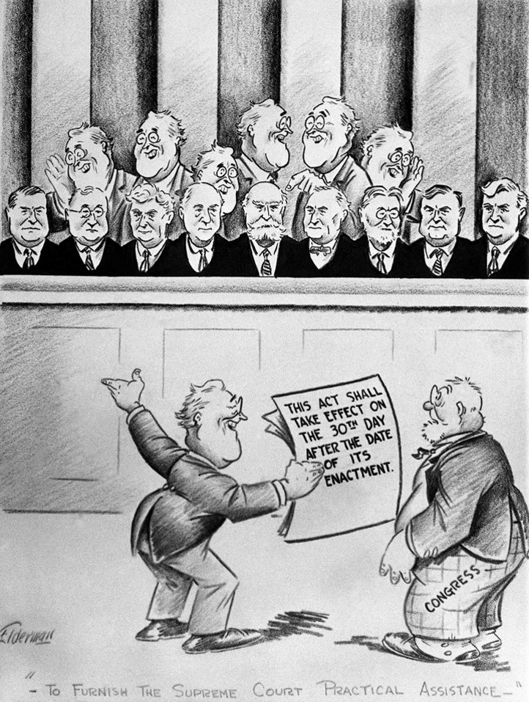
d. Examine how Eleanor Roosevelt changed the role of the First Lady including development of New Deal programs to aid those in need.
Role of Eleanor Roosevelt
Franklin Roosevelt's wife, Eleanor Roosevelt, was one of the most important first ladies in US history. (The title "first lady" is given to the wife of the president of the United States.) She was the niece of former president, Theodore Roosevelt, and a distant cousin of her husband, Franklin. Even before moving to Washington, Eleanor was a social activist. In New York she worked for reforms in state government, campaigned for legislation regarding public housing, fought for the rights of working women, and supported the distribution of information about birth control. Once she became first lady, Eleanor presented herself as a supporter of the "common citizen." She won the hearts and affections of many when she personally visited military veterans who marched in Washington to demand payment for their services in World War I. Her visit relieved fears about "radical" protests and communicated to the public that the Roosevelt's truly cared about the nation's problems. Eleanor Roosevelt was also not shy about her husband’s New Deal programs and women's rights. Thanks to her efforts, New Deal programs like the CCC eventually provided programs for women as well as men. Unknown too much of the country, President Roosevelt was partially paralyzed as a result of contracting polio as a young man. He spent most of his time in a wheelchair. Since politicians did not have to appear on television back then the way they do now, Roosevelt was able to keep his condition relatively secret. Today, society understands that people with physical disabilities can still lead effectively and do most of the things anyone else can do. However, in the 1930s, things were different. Therefore, Roosevelt felt it was important to hide his disability in order to maintain his image as a strong leader. Due to his physical limitations, Eleanor often traveled in his place. She visited workers in coal mines and factories, as well as low-income families living in poorer neighborhoods. She had her own staff, gave press conferences, and was not shy about making public speeches. At times she caused controversy, such as when she refused to obey Jim Crow laws in Alabama and chose to sit with both blacks and whites at an interracial gathering. Thanks to her visibility, activism, and occasional willingness to take stands even the president wouldn't, Eleanor Roosevelt revolutionized the role of first lady and became a formidable historical figure alongside her husband.

