Industrial Era 7.1

SSUSH11 Examine connections between the rise of big business, the growth of labor unions, and technological innovations.
a. Explain the effects of railroads on other industries, including steel and oil.
Document Analysis 1
. . . Like information technology [IT] today, railroads in the second half of the 19th century promised to revolutionize society—shrinking distances, dramatically lowering costs, opening new markets, and increasing competition. Railroads were the great transformational technology of the age and promised to change everything. Like IT today, railroads sucked up the bulk of the world’s investment capital, creating a speculative bubble that ultimately burst—blowing away much of the capital that investors had poured into the industry. While many investors lost their shirts, railroads did, in the end, deliver the revolution promised. Costs came down, living standards rose, markets expanded, and geography shrank. In fact, the railroad infrastructure, built with so much sweat, blood, and money a century ago, is still serving us today. . . .
Source: Barry Sheehy, “Train Wrecks: Why Information Technology Investments Derail,” CPC Econometric
Effects of the Railroads
Following the Civil War, the US continued to expand and become more and more industrialized. Railroads played a major role in this industrial growth and expansion. Railroads also contributed to rise of the steel industry and big business. In the 1850s, a man named Henry Bessemer developed a new method for making steel known as the Bessemer Process. Using this process, manufacturers could make steel much cheaper than ever before. As a result, steel became more affordable, leading to faster expansion of railroads and more construction. Thanks to steel, buildings could be constructed taller than ever before. By building taller buildings, cities like New York could hold more people and industry even though land was limited. Thus, steel became very important to the nation's economy. Before railroads, most goods had to be transported by water. You couldn't load something like steel beams on wagons and transport it over land very easily. Even if you tried, you would not be able to haul very much. Therefore, water was the only way. Unfortunately, shipping products by water meant that you had to follow the route of the river you were navigating and greatly limited what areas had access to your goods. Railroads, however, changed this. Since railroads were much larger and faster than wagons, they became a practical and economical way to ship sizeable products over land. As a result, resources necessary for manufacturing things like steel could be transported to the factories where they were produced, while finished goods could reach the people and places that demanded them more easily. Because of their ability to carry goods and resources great distances in a timely fashion, railroads became a major contributor to the growth of big business.
b. Examine the significance of John D. Rockefeller and Andrew Carnegie in the rise of trusts and monopolies.
Significance of John D. Rockefeller
A few men got rich developing the railroad industry. Because some of them were known to be crooked in their dealings, they collectively came to be called "robber barons" (a name that soon came to be identified with wealthy entrepreneurs in other industries as well). Of all the names associated with the rise of big business, none is more important than John D. Rockefeller. Rockefeller made it big in the oil business and his company, Standard Oil, was the nation's first trust. A trust is a business arrangement under which a number of companies unite into one system. In effect, trusts serve to destroy competition and create monopolies (a market in which there is only one supplier of a product and no market competition). Through the trust, Rockefeller was able to dictate prices, eliminate competition, and control the US oil industry. Much of Rockefeller's success was due to his masterful use of vertical integration (a business strategy in which one corporation owns not only the company that produces the finished product, but also the companies that provide the materials necessary for production). Rather than pay other producers to supply the materials he needed, Rockefeller's company made what it needed itself (i.e., its own barrels, cans, etc.). In the words of Rockefeller, he was determined to "pay nobody a profit."
Document Analysis 2
“It will be a great mistake for the community to shoot the millionaires, for they are the bees that make the most honey, and contribute most to the hive even after they have gorged themselves full.”
Source: Andrew Carnegie, Wealth and its Uses
Significance of Andrew Carnegie
Another successful big business owner of the late 19th century was Andrew Carnegie. As a boy, his family immigrated to the United States from Scotland. The family worked hard to barely scrape by as they settled in Pennsylvania. Andrew began working in a textile mill at age thirteen. He later began working in the railroad industry and progressed through the ranks to superintendent of the Pennsylvania Railroad. With good investments, his wealth began to build. By the 1860s, Carnegie had moved to the ironworks industry.
The Carnegie Steel Company used the latest technology of the Bessemer process to forge steel more efficiently. The increased production of steel and the use of vertical integration allowed Andrew Carnegie to amass the first billion dollar company. Carnegie's use of vertical integration is similar to that of J.D. Rockefeller (but Carnegie isn’t known for buying out companies and undercutting prices). He controlled the entire production process from resource to finished product, which included mining the raw materials, industrial production of steel, and transportation for both resources and finished products.
A feature that distinguishes Andrew Carnegie from other big business entrepreneurs is the level of philanthropy he supported with his wealth. The others certainly contributed huge sums to charity but it was Andrew Carnegie that made a mark with his investments in society. He was devoted to educational opportunities for the masses - not just the wealthy. To this end, Carnegie funded over 3,000 libraries across the United States. In addition, he gave millions of dollars to finance higher education universities in the United States and in Scotland. At the time of his death, Carnegie had given over $350 million to charitable causes. The value of his charitable donations today would be in the billions of dollars.
c. Examine the influence of key inventions on U.S. infrastructure including but not limited to the telegraph, telephone, and electric light bulb.
Key Invention of the late 1800’s
Telegraph
In the early 1800, Americans used the Pony Express to communicate with people in other regions of the country. Then the railroads helped to better connect the quickly expanding West with the industrializing East. The transfer of information, resources, and marketable goods connected all regions of the United States. Telegraph communication was the first nationwide information transmitter. Samuel Morse invented the technology in 1832. The telegraph machine received coded messages across electric wires connecting long distances. Morse Code is the system of dots and dashes that correspond to letters of the alphabet. Telegraph operators decoded the messages sent instantaneously across the telegraph wires. With the development of telegraph technology, business could be more efficiently conducted between industrial centers in the East and their sources for raw materials in the South and West. The Civil War was the first war conducted with the use of widespread telegraph connectivity. Abraham Lincoln and his Secretary of War Edwin Stanton received almost daily updates at the Washington DC telegraph office from various fighting fronts and were able to coordinate the entire war based on real time information from the field.
Telephone
In 1876, Alexander Graham Bell further expanded on the telegraph's capability for instant communication. He invented the telephone, which allowed for voice - to - voice communication over electric wires. As was true for the telegraph, the telephone impacted the United States by allowing instant communication. With the invention of the telephone, conversations were more efficient and true discussion between individuals in distant locations was made possible.
Electric Light Bulb
Thomas Edison was one of the most famous and successful American inventors. He invented a wide variety of technologies and held over 1,000 patents. Edison established the concept of industrial research, which allowed him to develop and expand his wide-ranging ideas. He founded a research laboratory in Menlo Park, New Jersey that was staffed by engineers and technicians under his direction.
One of Edison's most revolutionary inventions was the electric light bulb. Not only did this development allow factories to be lit and operate twenty-four hours a day, but the light bulb also illuminated buildings, streets, and neighborhoods across the United States. The light bulb was developed in the 1870s and quickly replaced the more dangerous and expensive lamp oils that burned for illumination.
With greater technological innovation, such as the telegraph, telephone, and electric light bulb came greater connectivity and productivity for the development of industry in the United States. The late nineteenth century was a time of great change in the way people lived and conducted business in part because of these inventions. Communities invested in the technology that in turn cut costs to individuals. The United States became a contending industrial producer during the same period in part because of the efficient production of products and ease of communication for business across great distances.
d. Describe Ellis and Angel Islands, the change in immigrants’ origins, and their influence on the economy, politics, and culture of the United States.
Immigration
The second half of the nineteenth century also saw a dramatic increase in immigration to the United States. In the East, most of these new arrivals came from Europe, while on the west coast; many immigrated from China in hopes of making money working on US railway lines. Some immigrants came seeking a better life, others fled hardships like famine, and still others hoped to escape political persecutions. By the end of the 1880s, nearly 80% of New Yorkers were foreign born. Industrialization was largely responsible for the flow of immigrants. As industry grew and the need for labor increased, the US became a land of promise much like it had been for the first colonists nearly 300 years before. Most immigrants (Asian and European) took jobs in manufacturing and mines.
Document Analysis 3
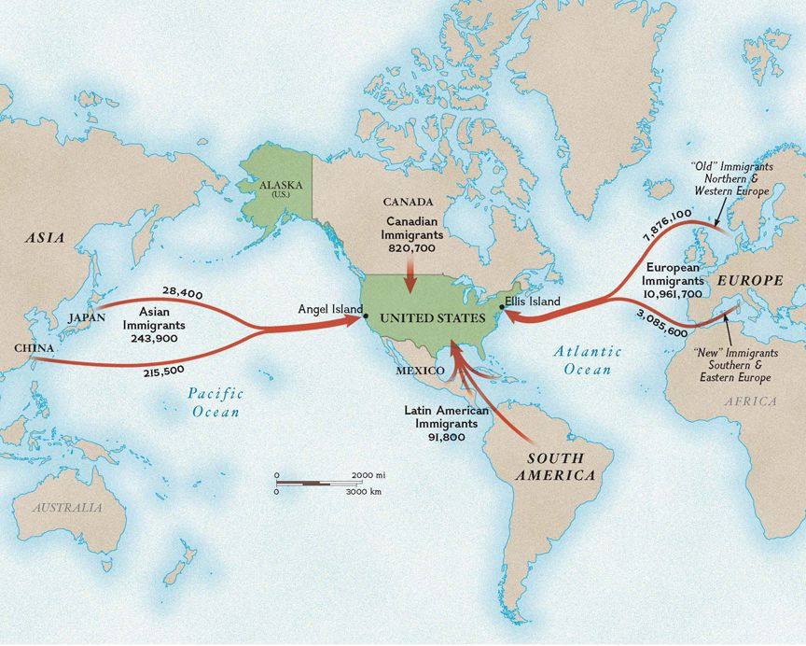Ellis Island and Angel Islands
To handle the large numbers of people arriving in the country, the federal government opened Ellis Island in 1892. A tiny island near the Statue of Liberty in New York, it became a well known reception center for immigrants arriving by ship. As more and more people immigrated to the US, the nation's population became very diverse. Such diversity inspired the phrase, "melting pot." In a melting pot, people mix different ingredients together as they cook and prepare an appetizing final product. In the same way, many envisioned the United States as a place where people of all backgrounds could come and assimilate into American society. In reality, however, most immigrants did not want to fully assimilate (become like the US mainstream). They wanted to maintain many of their traditional ways. The nation, particularly the large cities, began to experience a great deal of cultural pluralism (presence of many different cultures within one society).
Angel Island Immigrant Station was quite different from Ellis Island. Approximately 1 million Asian immigrants were processed at Angel Island between 1910 and 1940. There was strong resistance to Chinese immigrants in the late 1800s, which resulted in the passage of the Chinese Exclusion Act in 1882. Chinese immigrants had been hired as workers to complete construction of the Transcontinental Railroad in the 1860s. They were discriminated against and taken advantage of by railroad companies. The Chinese workers were paid half of what European workers earned and were required to do the most dangerous jobs of blasting and laying rail ties over the treacherous terrain of the high Sierra Mountains. Once the railroad was complete, the hostility toward Chinese immigrants escalated.
As a result of this open discrimination and Nativist opposition, Chinese immigrants wanting entry into the United States spent weeks, months, and sometimes years on Angel Island awaiting approval for entry into the United States. Approximately 18% of immigrants to Angel Island were rejected, of which the vast majority were from China. The interrogation process at Angel Island was much more lengthy and specific than at Ellis Island. Immigrants had to have American witnesses or family members come to Angel Island to vouch for the accuracy of their answers.
Problems and Concerns Caused by Immigration
While immigration had positive effects, such as providing much needed labor for the nation's factories, it also presented problems. Many US citizens looked on immigrants negatively. They felt that immigrants took jobs away from natives (people born in the US) and they often mistrusted foreigners whose cultural ways they could not understand. They also tended to be suspicious of the ethnic ghettos within the inner cities. Ghettos were neighborhoods where immigrants from a certain region or country tended to live together due to their common culture, language, and religion. Many natives saw this as a sign of disloyalty to the United States. Religious differences were also a source of tension. Most US citizens were Protestants, while many of the arriving immigrants were Catholics. As a result, an immigrant's religious practices often conflicted with those of native-born citizens. Towards the end of the nineteenth century and into the early twentieth, however, more and more immigrants arrived from eastern and southern Europe (places like Poland, Russia, and Italy). In addition, the number of Jewish immigrants increased. Such immigrants often had to deal with more racism and faced even greater opposition once they arrived due to their ethnic differences.

e. Discuss the origins, growth, influence, and tactics of labor unions including the American Federation of Labor.
Document Analysis 4
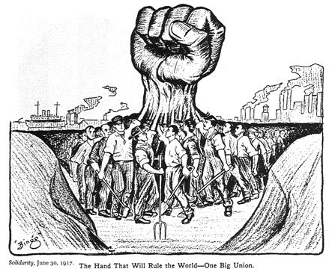

Labor Unions and the American Federation of Labor
Out of the challenging working and living conditions that faced industrial workers arose the labor unions. Labor Unions are organizations of workers formed to protect the interests of its members. During this period, a number of notable unions and union leaders arose. Perhaps the most influential of the era was the American Federation of Labor (AFL), led by Samuel Gompers. The AFL focused on such issues as wages, working hours, and working conditions. The AFL used the economic pressures of strikes (refusal of employees to work until employers meet certain demands) and boycotts (refusal to buy or pay for certain products or services in the hopes of forcing producers to change their policies or actions). The AFL also believed in collective bargaining and mediation. Collective bargaining is a process through which employees negotiate as a united group rather than individuals, thereby increasing their bargaining power. To increase their ability to negotiate with business owners, the AFL pressed for closed shop workplaces in which employers could hire only union members. "Closed shops" forced employers to deal with the union because they could not look elsewhere for workers.
Strikes and Confrontations
At times, employers and striking workers even turned to violence. Eventually, numerous strikes and protests, some more violent than others, began to break out. Although there were numerous strikes that received national attention, perhaps none was more drastic than the Pullman Strike. In 1894, a delegation of employees went to railroad car industrialist, George Pullman, to protest the laying off of workers. Pullman responded by firing three of the labor representatives, leading the local union to go on strike. Pullman then closed the plant rather than negotiating with union leaders. Led by Eugene Debs, the American Railway Union called for a boycott of Pullman cars nationwide. By June, roughly 120,000 workers had rallied to the strike. Because the strike affected shipment of the US mail, the federal government responded with a court injunction against the union, and President Cleveland sent in federal troops to make sure that it was enforced. Days later, the strike was over. The Pullman Strike established precedence for factory owners appealing to the courts to end strikes.

