Creating a Nation 4.2

SSUSH7 Investigate political, economic, and social developments during the Age of Jackson.
a. Explain Jacksonian Democracy including expanding suffrage, the Nullification Crisis and states’ rights, and the Indian Removal Act.
Presidency of Andrew Jackson
One great supporter of Manifest Destiny (Westward Expansionism) was Andrew Jackson. He was a war hero who had defeated the British at New Orleans in 1814 and forced concessions from the Spanish that led to Florida becoming a US territory in 1819 (it became a state in 1845). In addition, Jackson was a "common man." He was not born into the rich, upper class, but, instead, achieved his success despite growing up relatively poor and uneducated. As a result, he was very popular with western frontier settlers and "common folk." In 1824, he decided to take advantage of his popularity and ran for president.
Jacksonian Democracy (Universal Suffrage and Indian Removal Act)
Jackson's brand of politics and the changes he inspired came to be called Jacksonian Democracy. Jackson believed strongly in western expansion and the rights of white, frontier settlers. He, like many westerners, resented "eastern elites" and political leaders who seemed to favor the upper class and passed laws Jackson believed helped the wealthy over small landowners. As a result, Jackson favored universal suffrage. In other words, he believed that all white men should be free to vote, not just those who owned property. With the support of men like Jackson, all but a few states dropped property requirements for voting. Expanding suffrage made the nation more democratic and enabled "simpler men" like Jackson to win public office, rather than simply those from the upper class. (It is important to remember, however, that even Jacksonian Democracy did not attempt to extend the right to vote to women, blacks, or Native Americans.)
Document Analysis 1
As mentioned earlier, Jackson believed in Manifest Destiny and westward expansion. He saw the Native Americans that occupied territories to the west as an obstacle to be removed. As a result, he supported Indian Removal Act. Under this policy, the US government forced Native Americans off lands it wanted for white settlement. Perhaps the most famous example of Jackson's support for this policy was his refusal to help the Cherokee in north Georgia and the western Carolinas. Despite the fact that the Cherokee had helped Jackson defeat his enemies at the battle of Horseshoe Bend during the War of 1812, Jackson supported Georgia's efforts to remove the tribe from their lands during the 1830s. Jackson's policies ultimately led to the forced removal of the Cherokee in 1838. Their march west to Oklahoma became known as the Trail of Tears because of the many Cherokee who suffered and died along the way.
The Nullification Crisis
Southerners also responded to the political struggle over slavery by advocating states' rights. Supporters of state's rights believed that the federal government should restrict itself to powers specifically stated in the Constitution, and that all else should be left to the states. This was in large part because they did not trust northern politicians whom they believed were out to end slavery.
The conflict between state's rights and federal authority reached a boiling point in the early 1830s. President Andrew Jackson experienced a serious test when South Carolina began protesting high tariffs on British goods. Southerners often opposed such measures because they believed the national government used tariffs to help rich, northern businessmen at the expense of small landowners and southern planters. One of South Carolina's senators, John C. Calhoun, took center stage when he wrote a pamphlet entitled Exposition and Protest. Calhoun argued for states' rights and believed strongly in the doctrine of nullification (to reject). He asserted that any state could refuse to enforce a law it saw as unconstitutional. In 1832, South Carolina threatened to invoke this right and secede (leave the Union) if the offensive tariffs were not repealed. Enraged, President Jackson threatened to hang Calhoun personally and prepared to call up federal troops if necessary to force South Carolina's compliance. Fortunately, Senator Henry Clay proposed a compromise that both sides could accept. Clay's compromise ended the South Carolina Nullification Crisis, but the issues of states' rights and secession remained alive until the end of the Civil War. The crisis also served to harden the sectionalism (regional differences that divide different parts of the country) between the North and South. Northerners began to call more and more on the national government to limit, if not end, slavery. Meanwhile, the South rallied around the banner of state's rights, making men like John C. Calhoun regional heroes.
b. Explain how the North, South, and West were linked through industrial and economic expansion; including Henry Clay and the American System.
Significance of Henry Clay
After the War of 1812, Americans felt good about themselves. That had beaten the British once again, and they were feeling strong. One of the areas of American life that began to expand was business. British companies had begun to send huge amounts of inexpensive goods to America after the war. American mill owners wanted to sell their goods to Americans rather than have them buy them from Britain, but they were having a hard time competing with the British prices. Henry Clay, a member of the United States House of Representatives, had a plan to aid American businesses. He called it the American System. It included the following:
1.) A tariff – A tariff is a tax on imported goods. It made European goods more expensive and encouraged Americans to buy cheaper products made in America. The tariff also made the country money, which would be used to improve things.
2.) A National Bank - The establishment of a national bank that would promote a single currency (money), making trade easier.
3.) Roads and Canals – Improve the transportation system in the country. Henry Clay though that many more roads and canals should be built. These roads and canals would make trade easier between merchants and farmers in the North, South, and West.
Henry Clay hoped the American System would help the United States be able to become independent from Europe and Make America Great Again.
Source: http://mrkash.com/activities/americansystem.html
c. Explain the influence of the Second Great Awakening on social reform movements, including temperance, public education, and women’s efforts to gain suffrage.
Second Great Awakening
A number of social reform movements began during the 1800s. These movements were called the Second Great Awakening, which aimed to transform society in beneficial ways. Many of those who participated in such movements were inspired by religious movements like the Second Great Awakening. As part of the "Awakening" many zealous Christian preachers traveled from revival to revival preaching the Gospel and calling on believers to become socially active and impact society through good works. As a result, religion motivated many to become social reformers. Others without strong religious beliefs became active simply to try and improve the world they lived in educational reform.
Horace Mann was an influential American educator who advocated public education reforms. He wanted both men and women to have access to public education and believed that education was essential to the success of democracy. He helped to create the state Board of Education in Massachusetts, the first of its kind in the United States. Such efforts in Massachusetts inspired other states to make reforms in education as well.
Document Analysis 2
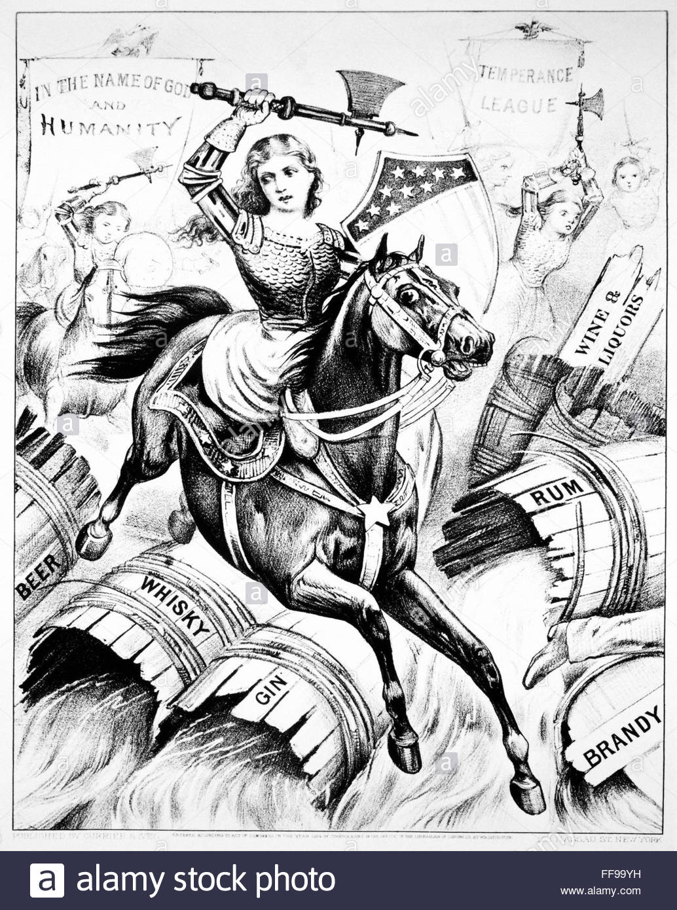
During the early nineteenth century, the temperance movement began gaining popularity. Members of this movement wanted to moderate the use of alcohol. Later, they advocated total abstinence from alcohol and succeeded in convincing several states to pass laws prohibiting its sale. The temperance movement owed much of its success to the efforts of women and church leaders in the US.

Women had participated in the temperance movements, only to face discrimination from the men with whom they'd served. The offense these women suffered led to the birth of the Women's Rights Movement. Women such as Elizabeth Cady Stanton helped organize the first women's rights convention, known as the Seneca Falls Conference, in 1848. Stanton used the occasion to call for women's suffrage (women having the right to vote). Such boldness shocked many of her fellow activists. Although some felt Stanton went too far by demanding suffrage, the conference went a long way in drawing attention to the issue of women's rights. Another key figure was Susan B. Anthony. A supporter of both the temperance and abolitionist movements, Anthony is best known for joining with Elizabeth Cady Stanton to fight for women's rights. An active supporter of women's suffrage, Anthony would often deliver speeches written by Stanton while Stanton was busy with her young children. She continued to be a leader in the women's suffrage movement until her death in 1906.
d. Explain how the significance of slavery grew in American politics including slave rebellions and the rise of abolitionism.
Document Analysis 2
“As a Southerner, I feel that it is my duty to stand up here tonight and bear testimony against slavery. I have seen it! . . . I know it has horrors that can never be described. I was brought up under its wing. I witnessed for many years its demoralizing influences and its destructiveness to human happiness. I have never seen a happy slave.”

Source: This is a quote from Angelina Grimké (1805-1879), She gave this speech in Philadelphia, Pennsylvania, in 1838:
Rise of Abolitionism
While some in the North sought merely to limit slavery's expansion into new territories, others were determined to end the institution completely. They advocated the abolition of slavery and became known as abolitionists. Among key white figures in this movement were William Lloyd Garrison and the Grimke sisters. Garrison founded an influential, anti-slavery newspaper called The Liberator in 1831 and helped establish the American Anti-Slavery Society. Meanwhile, Sarah and Angelina Grimke were members of a prominent slaveholding family in South Carolina who became abolitionists and won national acclaim for their passionate anti-slavery speeches.
Important African American abolitionists included men like Frederick Douglass. After escaping slavery in Maryland, Douglass educated himself and became the most prominent African American speaker for the abolition of slavery. He even helped John Brown plan the Harper's Ferry. In addition to Douglass, many other African American men and women played key roles in the abolitionist movement.
Slave Rebellion
As the abolitionist movement began to gather momentum, southern attitudes about slavery hardened even more after a failed slave uprising in Virginia. It was led by a slave named Nat Turner and became known as Nat Turner's Rebellion. Turner, a preacher as well as a slave, believed that he had a divine mission to deliver his people from slavery. In August 18 31, he organized a revolt in which 160 people (both black and white) were killed. As a result, the few abolitionist societies that had existed in the South came to an end and slave codes (laws restricting the conduct and activities of slaves) were made tighter and strictly enforced. Turner and nineteen others were hanged for their role in the uprising, and slaves were no longer allowed to become ministers. The rise of the abolitionist movement and the increase in slave rebellion cause slavery to become a major political issue in the United States.

