Creating a Nation 4.1

SSUSH6 Analyze the challenges faced by the first five presidents and how they were resolved.
a. Examine the presidency of Washington, including the precedents he set.
Presidency of George Washington
The whiskey tax was very unpopular among farmers in the western regions of Pennsylvania, Maryland, Virginia, and North Carolina. Many of these farmers made their living converting grain into whiskey. Their protest eventually resulted in the Whiskey Rebellion. Pennsylvania farmers refused to pay the tax and resorted to violence. The uprising ended when President Washington organized a military force that marched into Pennsylvania and halted the resistance. The event led many farmers and frontiersmen to see Alexander Hamilton's form of government as tyrannical. More of them flocked to Thomas Jefferson as a defender of states' rights and a champion of their cause.
Document Analysis 1
. . . The [whiskey] rebellion has long been interpreted as a milestone in the creation of federal authority, and in most respects that is its chief significance. Certainly to the Federalists, who had long been striving for a strong national government, it was a major test: the new government successfully crushed organized and violent resistance to the laws. As Hamilton put it, the rebellion “will do us a great deal of good and add to the solidity [stability] of everything in this country.”. . .
Source: Richard H. Kohn, “The Washington Administration’s Decision to Crush the Whiskey Rebellion,” The Journal of American History, December 1972
While the new U.S. government tried to establish itself, European powers, Great Britain and France, were once again at war with one another. President Washington, recognizing that the country could not afford a fight with either side, made a Proclamation of Neutrality, in which he stated that, the U.S. would not take sides. The conflict still had consequences for the United States, however. The British began intercepting U.S. ships they believed bound for France and impressing sailors (taking U.S. sailors captive and forcing them to serve the British). These actions were intended to injure the French, but they also hurt the United States' ability to trade and operate on the high seas. In response, Chief Justice John Jay went to London to broker an agreement with the British. To the disappointment of many in the U.S., Jay returned with a treaty that primarily benefited Great Britain and did little to further the interests of the United States.
There were a few other important precedents and policy perspectives George Washington felt very strongly about that did not survive beyond his administration. Shortly before leaving office, President George Washington gave a farewell address in 1796 in which he emphasized three key points. First, Washington expressed his view that the United States should stay neutral and avoid permanent alliances with other nations. Second, he believed that good government is based on religion and morality. Third, he spoke about the dangers of forming political parties. He warned that political parties would cause people to work for their special interests rather than for the public good. Despite Washington's warnings, opposing political parties did indeed form.
The Federalist Party was created even prior to the ratification of the Constitution. Alexander Hamilton, James Madison and John Adams were among its leaders. The Federalists supported ratification of the U.S. Constitution because they supported a strong national government. They also supported large landowners, merchants, and the interests of business over agriculture. Therefore, they supported tariffs and other measures meant to help U.S. businesses. Most New Englanders were Federalists. Meanwhile, the Republicans arose in opposition to the Federalists. Their leader was Thomas Jefferson. For this reason, they are sometimes referred to as "Jeffersonian Republicans" to distinguish them from today's Republican Party. The Jeffersonian Republicans favored stronger state governments and a weaker national government. For this reason, many of them originally opposed the Constitution because they feared it made the national government too strong. In addition, the Republicans tended to favor the interests of small farmers and debtors, rather than those of business. Therefore, they opposed many Federalist policies and saw them as an attempt by the wealthy upper class to limit economic opportunities for small landowners. Most Southerners were Jeffersonian Republicans.
b. Explain the presidency of John Adams including the Sedition Acts and the influence on the election of 1800.
Presidency of John Adams
Document Analysis 2
They have brought into the lower House (of Representatives) a sedition bill, which, among other enormities, undertakes to make printing of certain matters criminal, though one of the amendments to the Constitution has so expressly taken religion, printing presses, & out of the coercion (ability to limit them). Indeed this bill, and the alien bill are both so palpably (obviously) in the teeth of the Constitution as to show they mean to pay no respect to it (the Constitution).

Source: Thomas Jefferson, from Jefferson Cyclopedia
The Federalists in Congress passed several laws during John Adams' administration that alarmed Jeffersonian Republicans. The Naturalization Act required foreign immigrants to live in the United States for fourteen years before they could be US citizens. The Alien Act allowed the government to arrest, detain or remove foreigners deemed untrustworthy. Of even greater concern was the Sedition Act that severely limited free speech and expression. Federalists often used the Alien and Sedition Acts to silence critics (usually Republicans). These acts tended to help the Federalists because immigrants who had been in the country for only a short time were usually poorer and often drawn to the Republicans who represented the "common man." Under these laws, such people could not vote in elections. Jefferson and others saw these acts as abuses of power. He and James Madison (a former Federalist) produced a response to the Alien and Sedition Acts in the form of the Virginia and Kentucky Resolutions. These resolutions stated that if a state believed a federal law to be unconstitutional, then it did not have to obey or enforce it. The resolution was so named because the state legislatures of Virginia and Kentucky adopted it. The idea that individual states have such a right came to be known as the doctrine of nullification, because it claims that states can nullify a national law that they believe violates the Constitution. The debate surrounding states' rights versus federal authority ultimately played a major role in events leading up to the Civil War.
Election of 1800
In the United States Presidential election of 1800, sometimes referred to as the "Revolution of 1800," Vice President Thomas Jefferson defeated incumbent president John Adams. Central issues included opposition to the tax imposed by Congress to pay for the mobilization of the new army and the navy in the Quasi-War against France in 1798, and the Alien and Sedition acts, by which Federalists were trying to stifle dissent, especially by Republican newspaper editors. The Sedition Act and the Election helped usher in Thomas Jefferson and a generation of Republican Party rule.
c. Explore Jefferson’s expansion of presidential power including the purchase and exploration of the Louisiana Territory.
Presidency of Thomas Jefferson
Once in office, President Thomas Jefferson wanted to secure United States trading on the Mississippi River. For this reason, he sent representatives to France to negotiate the purchase of New Orleans. Initially, Napoleon was not interested in selling New Orleans because he hoped to revitalize the French colonial empire in the Western Hemisphere. However, when slaves in the French colony of Saint-Domingue (later known as Haiti) revolted and Britain resumed its war with France, the French emperor surprised Jefferson by offering to sell not only New Orleans, but the entire Louisiana region. Jefferson was unsure if the Constitution gave him the authority to purchase the Louisiana Territory. The Louisiana Purchase of 1803 was the United States' largest land purchase, roughly doubling the country's size. It gave America control over the Mississippi River and the port city of New Orleans. It marked a turning point for the new nation economically as it began to pursue prosperity within its own borders rather than from foreign nations.
Document Analysis 3
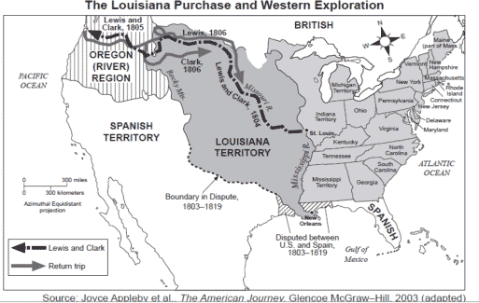
d. Explain James Madison’s presidency in relation to the War of 1812 and the war’s significance on the development of a national identity.
Presidency of James Madison
As US settlers attempted to move west, they encountered Native American resistance. Many settlers blamed the British for encouraging such resistance in order to protect their own interests. They also felt threatened by the British presence in Canada. This, combined with the British navy's policy of impressment (taking U.S. seamen captive and forcing them to serve on British ships), led many in the United States to demand war. Finally, on June 18, 1812 Congress declared war on Great Britain. The War of 1812 began with many in the US hoping to win land from the British in Canada and the Spanish in Florida (Spain had ties to the British). At times, it appeared that the US was in trouble, especially when the British invaded and burned Washington, DC. The US persevered, however, winning an inspiring victory at the battle of Fort McHenry. The bravery of the US soldiers who held the fort despite intense British fire inspired Francis Scott Key to write his initial draft of the Star Spangled Banner (today's US national anthem). Eventually, with Andrew Jackson's victories at the battles of Horseshoe Bend and New Orleans, the US secured the signing and ratification of a treaty ending the war (the Battle of New Orleans actually occurred after the treaty, but the US victory ensured that the British would honor its terms). The Treaty of Ghent did not grant any official land gains to the US, but it did keep the Mississippi River and the frontier open, thereby encouraging further western migration. It also showed that the United States could defend itself and assert its interests in North America against foreign powers. Meanwhile, due to its opposition to the war the Federalist Party lost its credibility and faded from importance in national politics.
Perhaps most importantly, the War of 1812 helped produce a stronger sense of nationalism (pride in ones country) among US citizens. People felt a great deal of pride after standing up to the mighty British again. As a result, US manufacturing and agriculture improved and grew prosperous. Northern manufacturers sold more and more of their products to other regions of the country, while the South's plantation economy exploded as the nation's only major supplier of cotton. By the time the war ended, US citizens had a new sense of national pride and both US manufacturers and planters had established themselves as respectable players in domestic and international trade.
e. Explain James Monroe’s presidency in relation to the Monroe Doctrine.
Presidency of James Monroe
Document Analysis 4
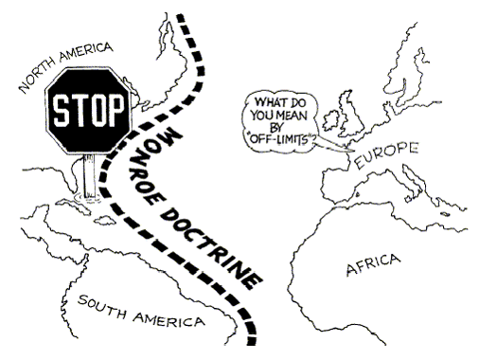
With the end of the War of 1812 and the Federalist Party, the United States entered a period of national pride and political unity known as the Era of Good Feelings. It was during this period that President James Monroe issued the Monroe Doctrine in 1823. The United States would not tolerate European intervention in the affairs of any independent nation in the Americas, nor were the American continents open to European colonization any longer. The US would view any future attempts to colonize them as acts of aggression. Finally, the president promised that the United States would not interfere in the internal affairs of other American countries, or in those of European nations.

