The Constitution 3.1

SSUSH5 Investigate specific events and key ideas that brought about the adoption and implementation of the United States Constitution.
a. Examine the strengths of the Articles of Confederation including but not limited to the Land Ordinance of 1785, the Northwest Ordinance of 1787, and their influence on westward migration, slavery, public education, and the addition of new states.
Document Analysis 1
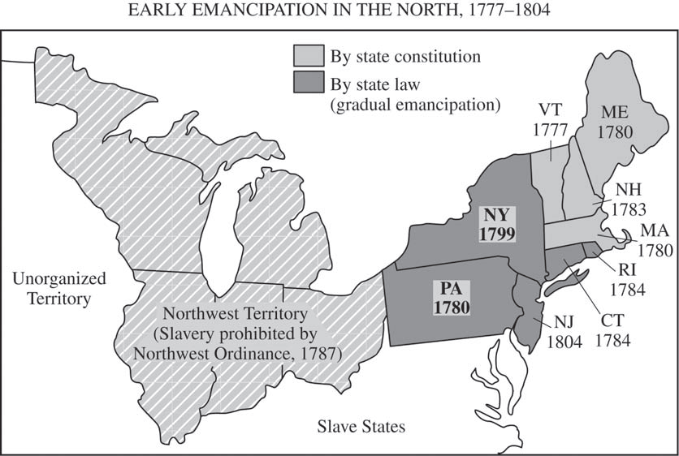
Strengths of The Articles of Confederation
Following the adoption of the Declaration of Independence, the newly independent states were cautious about giving too much authority to a central (national or federal) government. They preferred a confederation, in which each state would maintain its sovereignty while being loosely unified as a nation. For this reason, Congress drafted the Articles of Confederation. The Articles of Confederation became the first national government in America. Two of the strengths of this new national government were the Land Ordinance of 1785 and the Northwest Ordinance in 1787.
As the population of the early colonies grew, settlers began pushing west. As a result, they discovered the richness and resources of new lands. They also faced conflicts with Native Americans and French settlers who already lived in these territories. Such conflict eventually resulted in the French and Indian War between Great Britain and France. With victory over the French and their Native American allies, Britain took possession of the Northwest Territory (the area lying north of the Ohio River and east of the Mississippi River). Following the American Revolution, Congress passed the Land Ordinance of 1785 and the Northwest Ordinance in 1787. The Land Ordinance of 1785 set forth how the government of the United States would measure, divide and distribute the land it had acquired from Great Britain north and west of the Ohio River at the end of the American Revolution. The Northwest Ordinance of 1785 divided the area into smaller territories and provided guidelines under which new states could be admitted to the union. It eventually resulted in the formation of five states: Ohio, Indiana, Illinois, Michigan, and Wisconsin.
Benefits of the Northwest Ordinance of 1785
Government encouraged westward migration (Manifest Destiny)
Emancipated (freed) the slaves in the new territory
Made laws for admitting new states into the union
Mandated the establishment of public schools in the Northwest Territory.
b. Evaluate how weaknesses in the Articles of Confederation and Daniel Shays’ Rebellion led to a call for a stronger central government.
Document Analysis 2
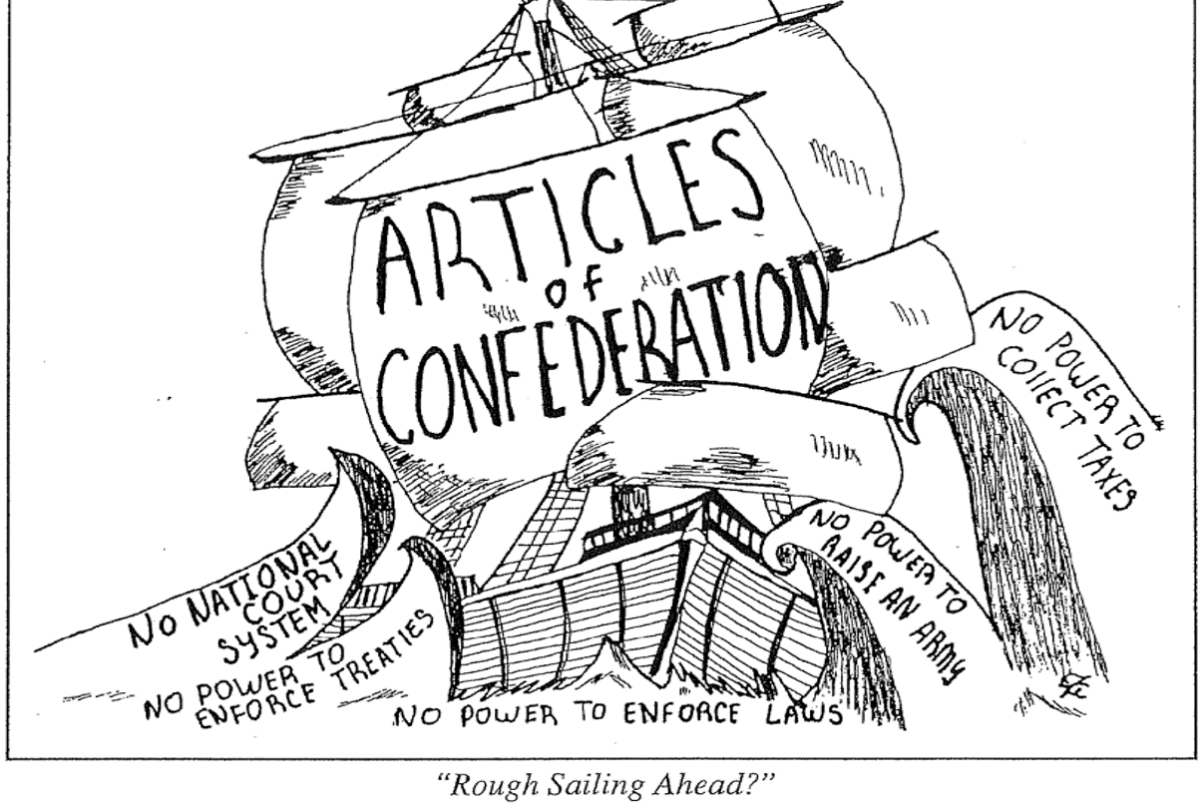 Weaknesses of the Articles of Confederation
Following the adoption of the Declaration of Independence, the newly independent states were cautious about giving too much authority to a central (national or federal) government. They preferred a confederation, in which each state would maintain its sovereignty while being loosely unified as a nation. For this reason, Congress drafted the Articles of Confederation. Finally ratified in 1781, this document failed because it did not give enough power to the federal (national) government to lead effectively. In order for any law passed by Congress to be final, at least nine of the thirteen states had to agree. Since the states often had different interests, such agreement was rare. Also, the Articles did not grant Congress the power to impose taxes. The federal government had to ask the states for money. As you might imagine, this was not very effective and made it practically impossible to administer the government or provide for a national defense. Foreign countries quickly realized the glaring weaknesses in the Articles of Confederation as well. As a result, Britain refused to withdraw troops from the Ohio Valley despite the Treaty of Paris and Spain closed its port at New Orleans, cutting off the Mississippi River. Unable to raise a formidable army, the United States was in no position to oppose such actions.
Change finally came as a result of Daniel Shay's Rebellion in 1786. After the American Revolution, the United States experienced an economic crisis. The nation was experiencing a depression in which the value of US currency was very low and falling farm prices left many farmers unable to repay outstanding loans. At the same time, in order to pay war debts, the state of Massachusetts raised taxes (the national government could not impose taxes, but state governments could). Outraged, a Massachusetts farmer and Revolutionary War veteran named Daniel Shay led a number of farmers in rebellion. Without a strong national government, Massachusetts was forced to deal with the revolt on its own. The event made it evident that a stronger central government was needed to deal with the nation's problems. In 1787, leaders called a convention to revise the Articles of Confederation.
c. Explain the key features of the Constitution including the Great Compromise, limited government, and the Three-Fifths Compromise.
Document Analysis 3
The diversity of opinions turns on two points. If a proportional (population) representation takes place, the small states contend that their liberties will be in danger. If an equality of votes is to be put in its place, large states say that their money will be in danger. . . . When a broad table is to be made and the edges of a plank do not fit, the artist takes a little from both sides and makes a good joint. In like manner, both sides must part with some of their demands, in order that they both join in some accommodating position.
Source: Ben Franklin on the Great Compromise
Key Features of the Constitution (Great Compromise, Three-Fifth Compromise and Limited Government)
In 1787, a delegation met in Philadelphia to revise the Articles of Confederation. Soon after the convention began, however, the delegates decided to do away with the document altogether and write a new set of laws. The result was the United States Constitution. All the delegates in attendance (only Rhode Island did not send representatives) agreed that change was necessary. However, how the national government should be reorganized was a matter of much debate. As a result, a number of compromises (decisions reached as a result of disagreeing parties being willing to give up a little of what they want) emerged. Edmund Randolph and James Madison of Virginia introduced the Virginia Plan. They proposed a federal government made up of three branches: a legislative branch to make the laws, an executive branch to enforce the laws, and a judicial branch to make sure that the laws were administered fairly. For the legislative branch, the Virginia Plan called for two houses with representatives from each state. In each house, the number of representatives per state would be determined by population. The greater a state's population, the more representatives it would have. Larger states loved the idea; but smaller states hated it because they would be left with less representation. As a result, one of New Jersey's delegates proposed the New Jersey Plan. Like the Virginia Plan, it also called for three branches of government, but it wanted the legislative branch to consist of only one house with each state getting a single vote. In the end, the delegates decided on a compromise. It became known as the Great Compromise, or the Connecticut Plan, because it was proposed by Roger Sherman of Connecticut. It established a legislative branch with two houses. One house, called the House of Representatives, would be elected directly by the people and each state granted a certain number of seats based on population. The other house, called the Senate, would be elected by state legislatures with each state having two senators, regardless of population. Together, the two houses would comprise Congress.
Slavery also proved to be a point of contention. Northern states had fewer slaves and argued that, since slaves were not voting citizens, they should not be counted as part of the population. Southern states, however, had far more slaves and wanted to count them. The answer to this question was important because it affected how many representatives each state would have in Congress. Again, a compromise was reached. It was known as the Three fifths Compromise because it stated that each slave would count as "three-fifths of a person." In other words, for every five slaves, a state would be credited for having three people. Meanwhile, debate about the slave trade resulted in a slave trade compromise. Under this agreement, Northerners and delegates from the Upper South (Maryland and Virginia) who opposed the slave trade agreed to allow it to continue for twenty years, after which time Congress could impose regulations. This was important to delegates from the Deep South who insisted that their economy could not survive without the slave trade. US involvement in the Atlantic slave trade finally ended in 1808. Slavery, however, continued until 1865.
The Constitution establishes a government based on limited government, separation of powers, and checks and balances. Limited government is the principle that even governments must obey a set of laws and respect the rights of citizens. They are "limited" in what powers they have and what they can do. The Founding Fathers intended the Constitution to provide just such limitations. They wanted a government that respects and upholds the natural rights of citizens. By comparison, separation of powers divides authority to govern between different branches of government. Under the Constitution, the federal government divides its power between three branches: legislative, executive, and judicial. The legislative branch consists of Congress and is responsible for making the laws of the country. The executive branch is responsible for enforcing the laws and is headed by the president of the United States. Finally, the judicial branch is made up of the federal court system, with the US Supreme Court serving as the highest court in the land. Its role is to make sure the laws are applied fairly and appropriately. Checks and balances are included in the Constitution which allows each branch to check the powers of the other two. By dividing power between different branches and allowing each to check the others, the Founding Fathers put in place a model of government designed to keep any one branch from becoming to authoritative.
d. Evaluate the major arguments of the Anti-Federalists and Federalists during the debate on ratification of the Constitution, The Federalist Papers, and the roles of Alexander Hamilton and James Madison.
Ratification of the Constitution
Although the new document was an amazing improvement from the Articles of Confederation, it was not without controversy. A number of states refused to ratify (accept) it, claiming it did not do enough to guarantee the rights of citizens. Finally, in late 1788, the last of the nine states needed approved the Constitution once Congress agreed to consider a number of amendments protecting civil liberties (Georgia was the fourth state to ratify the Constitution). Only North Carolina and Rhode Island held off until after these amendments had actually been submitted to Congress. When Congress met in 1789, one of its first orders of business was to pass the Bill of Rights. It consists of the first ten amendments (additions) to the Constitution and its purpose is to protect citizens' rights and maintain limited government.
Federalist vs. Anti-Federalist
Controversy also surrounded the new Constitution concerning what role and powers the national government should have. Many favored the Constitution because they believed that the United States needed a strong federal government with a powerful president at its head. Others opposed the Constitution because they feared that a powerful federal government would trample on their rights. Because of the debate, political leaders split into opposing factions. A faction is a group of people who are bound by a common belief/cause, usually against another group bound by an opposing belief/cause. The Federalists favored a strong central government and supported the Constitution. Among their leaders were Alexander Hamilton and James Madison. Madison played a key role in drafting the Constitution and is often referred to as the "Father of the Constitution." Long before leaders decided to call a convention to revise the Articles of Confederation, Madison believed that a new framework for government would eventually be needed. He spent years prior to 1787 developing the model for a more effective system. The delegates to the Constitutional Convention adopted many of his proposals, such as having three branches of government. Since many of the ideas that framed the Constitution were introduced by Madison, it is not surprising that he was a Federalist who supported ratification. Federalists also tended to have a "loose interpretation" of the Constitution. They believed that the Constitution allowed the federal government to take certain actions not specifically stated so long as such actions were deemed necessary for carrying out the government's constitutional responsibilities.
Anti-federalist had a different view. Thomas Jefferson and Patrick Henry were to famous Anti federalist. They were more suspicious of the Constitution and feared that it gave too much power to the central government. Anti-federalists held to a "strict interpretation." They believed the federal government could only do what the Constitution specifically said. Anti-federalists did not want a small faction of leaders becoming too powerful and using the national government to trample on the rights of citizens.
To make their case for the Constitution, Hamilton and Madison helped author a series of essays known as the Federalist Papers. The essays were written to persuade New York's legislature to ratify the Constitution by easing fears that the document left the government susceptible to any one faction seizing too much power. Eventually, with the support of men like George Washington, Alexander Hamilton, and John Adams, the Federalist view won. Anti-federalists did succeed, however, in securing the Bill of Rights.
e. Explain how objections to the ratification of the Constitution were addressed in the Bill of Rights.
Document Analysis 4
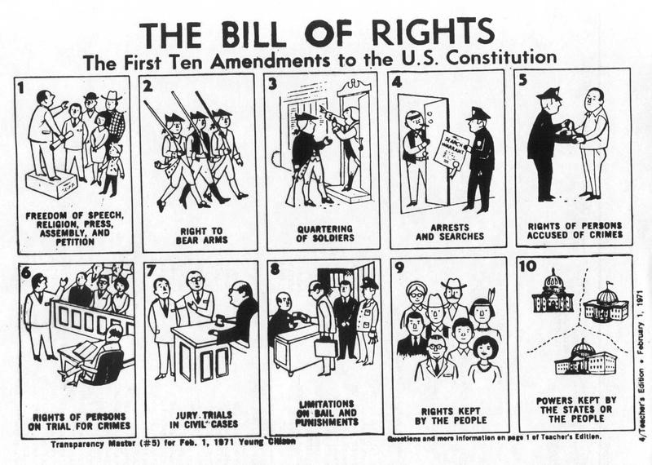
Bill of Rights
The Bill of Rights was passed in 1789 for the purpose of protecting individuals and states, the states chose to ratify ten. These ten amendments are known as the U.S. Bill of Rights.
First Amendment guarantees citizens' freedom of speech, freedom of the press, freedom to petition the government, and freedom to assemble. It also protects freedom of religion and establishes the principle of separation of church and state through the free exercise clause and the establishment clause. The free exercise clause forbids Congress from making any law prohibiting the free exercise of one's religious beliefs. The establishment clause forbids Congress from establishing a religion.
Ninth Amendment simply states that the rights specifically mentioned in the Bill of Rights are not necessarily the only ones enjoyed by the people. Tenth Amendment says that those powers not restricted by the Constitution, nor delegated to the US government, are reserved for the states. In other words, the Constitution grants the states the authority to decide certain matters of law.

