American Revolution 2.2

SSUSH4 Analyze the ideological, military, social, and diplomatic aspects of the American Revolution. Endeavors
b. Explain the reason for and significance of the French alliance and other foreign assistance including the diplomacy of Benjamin Franklin and John Adams.
French Alliance
The US relied heavily on an alliance with the French to defeat the British. Although the colonists had a great amount of desire for independence and the willingness to fight, they had no navy, barely an army, and very little money for supplies and weapons. France, however, could supply all these things. Shortly after signing the Declaration of Independence, the Continental Congress sent John Adams and Benjamin Franklin to Paris to try to convince the French to form an open alliance with the US. After the American victory at Saratoga, the French finally agreed. France promised money, troops, and the support of the French navy. Following the US-French treaty, Great Britain and France were soon at war with each other in Europe as well, forcing the British to fight on two continents.
c. Analyze George Washington as a military leader including but not limited to the influence of Baron von Steuben, the Marquis de Lafayette, and the significance of Valley Forge in the creation of a professional military.
Role of Military Leaders
George Washington was a Virginian and former surveyor who eventually became a soldier, wealthy landowner, and respected delegate to the Continental Congress. As a young military officer, he served with the British during the French and Indian War. Because of his military experience, the Continental Congress chose him to command its new army after declaring independence from Great Britain (a decision that infuriated John Hancock, the Congress' president, because he wanted the position).
Washington faced many challenges to building an army. Not only was he fighting one of the most powerful military forces in history, but he also had to form an army out of a band of undisciplined farmers, frontiersmen, and volunteers. Many of his men enlisted for only short periods and planned on returning home after only a few weeks of service. Washington was constantly short of men and begging soldiers to remain longer than they were obligated. In addition, he normally found himself short of supplies and money. As a result, his men usually had to camp in cold and wet conditions with very few clothes and often no pay. Many times, his soldiers did not have shoes, even in the dead of winter. Still, Washington turned out to be an amazing leader. His willingness to ride into the heat of battle, risking his own life to lead his men, greatly inspired and won the loyalty of his soldiers. Although leaders in Congress often criticized him and questioned his judgment for not winning more of his early battles, Washington's ability to hold his army together and frustrate the British allowed the Continental Army the time it needed to grow its ranks and become better trained. His ability to lead the American forces to victory in light of the obstacles he faced and the enemy that opposed him makes George Washington one of the greatest military leaders of all time.

Document Analysis 1
"The unfortunate soldiers were in want of everything; they had neither coats nor hats, nor shirts, nor shoes. Their feet and their legs froze until they were black, and it was often necessary to amputate them."
Source: Marquis de Lafayette on the Conditions at Valley Forge
Following the victory at Saratoga, the Continental Army (official name given the US forces) endured a harsh winter at Valley Forge, Pennsylvania. Poorly supplied and lacking warm clothes, many of Washington's men proved too sick to serve. A number of them even died. Fortunately, thanks to the efforts of Washington and a Prussian named Baron Friedrich Von Steuben, the army effectively used its time at Valley Forge to become better trained. Once the warm weather returned, Washington's army returned to battle more determined and better prepared to meet the British in battle.
A Frenchman known as the Marquis de Lafayette made his way to America to fight for the revolution. Although only 19 years old, he proved to be a talented and valiant soldier who quickly won the confidence of General Washington. Congress eventually gave Lafayette his own command. He finally asked to return to France in 1778 in order to fight for his homeland against the British following France's treaty with the US. He and Washington remained lifelong friends and Washington even served as godfather to Lafayette's son: George Washington Lafayette.
d. Investigate the role of geography at Battles of Trenton, Saratoga, and Yorktown.
American Revolution
The American Revolution actually began long before the Declaration of Independence was ever written. By the time delegates to the Second Continental Congress signed the document in the summer of 1776, colonists and British forces had been fighting for over a year. King George III of England did not expect a long war. After all, the British possessed one of the world's most formidable armies and its mightiest navy. How could a disorganized band of untrained colonists possibly defeat them? The colonists, however, enjoyed one advantage that the British did not; they were fighting for their homeland and the right to govern themselves. This made them more determined, if not more prepared, to win the war. In addition, many colonists had fought alongside the British in the French and Indian War and were familiar with their tactics. Colonial leaders also knew that, if they failed, they would all hang for treason. In short, the American colonists had no option but victory.
Document Analysis 2
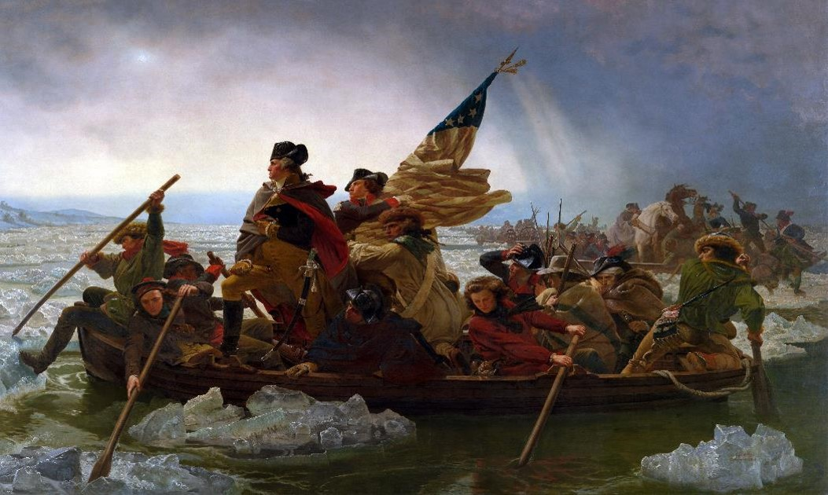

Battle of Trenton
A month later, General George Washington arrived, after being appointed by the Continental Congress to command the American army. In March, 1776, the British left Boston and eventually made their way to New York. There, despite his best efforts, the British forced Washington to abandon the city and start a long and humiliating retreat. Plagued by a lack of supplies, undisciplined soldiers, and the desertion of many of his troops (either illegally or because their enlistments had expired), Washington and his army seemed on the brink of defeat. Then, in December 1776, Washington made a daring move. He surprised his enemy by crossing the Delaware River on Christmas night and attacking the Hessians (Germans hired to fight for the British) and subsequent Battle of Trenton (New Jersey).
Having finally tasted victory at the Battle of Trenton, Washington's troops did not let up. Leaving their camp fires burning so as to make the enemy think they were still there, Washington's army slipped away in the middle of the night to launch another surprise attack at Princeton. Washington's victories in New Jersey greatly lifted American morale and gave people hope that, perhaps, the revolution could actually succeed.
Battle of Saratoga
The Battle of Saratoga is another critical battle from the Revolutionary War in which geography contributed to the American victory. The British plan to defeat the rebellious Americans was to take control of New York, which would drive a wedge between New England and the rest of the colonies. If the colonies were divided, the British believed the Americans would have no choice but to end the war. British commander General John Burgoyne was leading his forces south from Canada down Lake Champlain to the Hudson River. British General William Howe was to lead another force toward the north from New York City. The coordinated movements of the British was intended to secure the entire New York region. Howe, instead of trekking north as part of the plan to assist Burgoyne, pursued control of Philadelphia. Burgoyne subsequently was trapped by the Americans at Saratoga, New York and forced to surrender his forces.
The American commander who faced Burgoyne as the British moved south from Canada was General Horatio Gates. The British force was slowed because of the large supply convoy that traveled with Burgoyne. While Burgoyne slowly made his way from Canada toward the south, the Americans were steadily building fortifications on the high ground around Saratoga. Bemis Heights is a ridge that overlooks the Hudson River Valley where Burgoyne’s British forces were headed. Having cannon on top of the ridge and fortified walls at the base gave the Americans control of the area.
When Burgoyne’s British forces approached the fighting ensued. After a number of weeks of intense fighting, the British were surrounded and Burgoyne was forced to surrender on October 17, 1777. Controlling the high ground at Bemis Heights with fortifications at the Hudson River geographically contributed to the American victory at Saratoga. This victory is considered a turning point in the American Revolution because it signaled to France that the Americans had a chance of winning. The French had been reluctant of openly agree to an alliance with the Americans for fear that victory was not possible. The victory at Saratoga was just what Benjamin Franklin needed in his European negotiations for alliance and support of the American cause.
Battle of Yorktown
Eventually, British General Charles Cornwallis regrouped and invaded North Carolina. He pursued the southern US forces, now under the command of Nathanael Greene, hoping to force them into a decisive battle that would crush the revolution in the South. After leading the British on a long chase that extended into Virginia and forced Cornwallis to exhaust many of his supplies, Greene eventually engaged the British forces at the Battle of Guilford Courthouse at what is today Greensboro, NC. Cornwallis won, but at a heavy cost. To win the battle, he had to fire his cannons into the midst of the battle, killing many of his own men. In need of supplies, he marched his forces north to the coastal town of Yorktown, Virginia, where he hoped to receive what he needed from British ships. Realizing that Cornwallis was now trapped on the Virginia peninsula, Washington marched south to pin him between the Continental Army and the Atlantic Ocean. Meanwhile, the French navy provided a blockade that prevented British ships from coming to Cornwallis' rescue. On October 19, 1781, Cornwallis surrendered to Washington at Yorktown. So humiliated was the British general that he could not even deliver his sword in person. (In those days, the losing general gave his sword to the victorious general as part of a formal ceremony of surrender.)
e. Examine the roles of women, American Indians, and enslaved and free blacks in supporting the war effort.
Role of Women
Document Analysis 3
Despite their low positions in society, women did participate. On the home front, they sewed uniforms and knitted stockings for the soldiers. With their husbands away fighting, some women had to take over as weavers, carpenters, blacksmiths, or shipbuilders. Others transformed their homes into hospitals for the wounded.

Both men and women fought on the battlefield. Hundreds of women served as nurses, laundresses, cooks . . . there were some that actually engaged in battle . . . Deborah Sampson put on men’s clothing and called herself Robert Shirtliffe in order to enlist in the Army. “Robert Shirtliffe” fought courageously; “his” company defeated marauding Indians north of Ticonderoga.
Source—Tina Ann Nguyen, “American Athenas: Women in the Revolution”
Role of American Indians
American Indians found themselves in a difficult position as the colonists were fighting the British over control of North American lands. Most of the western American Indians sided with the British in an effort to try to prevent further settlement in the region by American colonists- as was the policy of the British Proclamation of 1763. Other American Indian groups in the east were divided over which side to support. The six tribes of the longstanding Iroquois League were divided. Two tribes, the Oneidas and the Tuscaroras, supported the Patriots in the Revolutionary War. The other four tribes- the Mohawks, Seneca, Cayuga, and Onondaga- sided with the British. The Cherokee tribe in the South also split its loyalty between the Patriot cause and the British. The allegiance of the small numbers of American Indians to the colonists had minimal impact on the outcome of the war. Those who did help to fight on the side of the victorious Americans were dismayed when the negotiations for the Treaty of Paris did not include American Indian representatives and their lands were not protected from colonial settlement.
Role of Free Blacks
Document Analysis 4
The Militia Act of the summer of 1775 had required that “all free male persons, hired servants, and apprentices between the ages of 16 and 50 years . . . be enrolled or forced into companies.” This excluded slaves by definition, but free blacks were registered to serve, though “without arms.” . . . Many a runaway told the nearest recruiter that he was a freeman, anxious to fight. More often than not, he was accepted without too many questions; the army was always short of men. During the winter of 1777–78, dozens of black Virginians served in every one of the state regiments, freezing, starving, and dying at Valley Forge. By February 1778, the survivors were marching with white comrades through the snow, practicing Baron von Steuben’s . . . drill. Eight weeks later, an army report listed 755 blacks in the Continental Army, including 138 Blacks in the Virginia Line.

Source—Robert A. Selig “The Revolution’s Black Soldiers,” 1997
f. Explain the significance of the Treaty of Paris, 1783.
Significance of Treaty of Paris, 1783
The United States sent three negotiators to represent the new nation in peace talks held in Paris. John Adams who had been representing the United States in the Netherlands, John Jay who had been representing the United States in Spain, and Benjamin Franklin who had secured the French alliance were the three Americans at the peace talks. After extended discussions beginning in April 1782, a peace agreement was reached in September of 1783. Adams, Jay, and Franklin had secured an exceptionally favorable agreement for the United States.
The Provisions of the 1783 Treat of Paris include:

Great Britain recognized its former American colonies as an independent nation.
The western boundary of the new United States was to be the Mississippi River.

Fishing rights off the coast of Newfoundland were guaranteed to the United States.
Pre-war debts owed by Americans to British merchants would be paid.
States would be encouraged by the Continental Congress to restore the homes, land and confiscated possessions back to Loyalists.

